Supplementary information

Fig. S1. FESEM micrographs of the cross section of all PVSi membrane samples.

Fig. S2. Raman mapping of siloxene distribution on the surface of all PVSi membrane samples

Fig. S3. AFM micrographs of the surface of all PVSi membrane samples.

Fig. S4. FTIR spectra of all PVSi membrane samples.

Fig. S5. UV-Vis calibration curves for dyes: (a) Rose Bengal (RB); (b) Reactive Black 5 (RB5); (c) Brilliant Blue G (BB); (d) Direct Red 23 (DR23); (e) Congo Red (CR); (f) Acid Red 1 (AR1) and (g) Methyl Orange (MO).

Fig. S6. The correlation between the CAA and hydrated radius of several dyes with known hydrated radii obtained from Table S3. This correlation was used to estimate hydrated radius of the dyes [1, 2]

Fig. S7. Schematics for the structures of (A) CaSi₂ and (B) deintercalation of Ca from CaSi₂

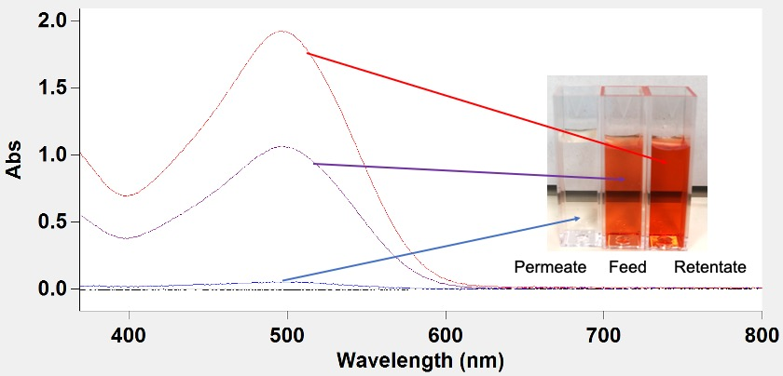
Fig. S8. UV-Vis spectra of the feed (purple), permeate (blue) and retentate (red) of Congo red dye rejection for PVSi-075 membrane sample.

Table S1. XRD pattern analysis of PVSi membranes.
Sample  Name | (020) |  |  |  |  | (110) |  |  |  |  | (021)
 | 2θ  (°) | d-spacing  (Å) | W^{a)}  (°) | H^{b)}  (CPS) | HW/H^{c)} | 2θ  (°) | d-spacing  (Å) | W  (°) | H  (CPS) | HW/H | 2θ  (°) | d-spacing  (Å) | W  (°) | H  (CPS) | HW/H
PVSi-0 | 18.31 | 4.84 | 1.851 | 120 | 0.008 | 19.94 | 4.44 | 1.489 | 181 | 0.004 | 26.54 | 3.38 | 2.571 | 101 | 0.012
PVSi-025 | 18.31 | 4.84 | 1.853 | 127 | 0.007 | 19.94 | 4.44 | 1.485 | 185 | 0.004 | 26.65 | 3.34 | 2.151 | 103 | 0.010
PVSi-050 | 18.32 | 4.84 | 1.833 | 151 | 0.006 | 19.94 | 4.44 | 1.487 | 201 | 0.004 | 26.72 | 3.33 | 2.155 | 121 | 0.009
PVSi-075 | 18.32 | 4.83 | 1.751 | 169 | 0.005 | 19.95 | 4.43 | 1.483 | 299 | 0.002 | 26.97 | 3.30 | 2.511 | 167 | 0.007
PVSi-100 | 18.32 | 4.83 | 1.853 | 181 | 0.005 | 19.95 | 4.43 | 1.485 | 213 | 0.003 | 26.78 | 3.32 | 2.171 | 160 | 0.007
PVSi-150 | 18.32 | 4.83 | 1.851 | 183 | 0.005 | 19.95 | 4.43 | 1.483 | 241 | 0.003 | 26.81 | 3.32 | 2.593 | 189 | 0.007
^{a)}: peak width; ^{b)}: peak height, unit of counts per second; ^{c)}: ratio of half-width to height

Table S2. Summary of separation performance of PVSi-075 in water including molecular weights, rejections and mass balances for various dyes and salts.
Dyes / Salts | Molecular Weight (Da) | Rejection (%) | Mass Balance (%)
RB | 1017.64 | 94 ± 3 | 99 ± 1
RB5 | 991.82 | 94 ± 1 | 99 ± 1
BB | 854.02 | 94 ± 2 | 99 ± 1
DR23 | 813.72 | 95 ± 2 | 95 ± 1
CR | 696.66 | 98 ± 2 | 99 ± 1
AR1 | 509.42 | 87 ± 2 | 99 ± 1
MO | 327.33 | 68 ± 1 | 99 ± 1
Na₂SO₄ | 142.04 | 44 ± 1 | 96 ± 1
MgSO₄ | 120.37 | 39 ± 1 | 95 ± 1
MgCl₂ | 95.21 | 28 ± 1 | 96 ± 1
NaCl | 58.44 | 15 ± 1 | 96 ± 1

Table S3. 3D chemical structures with CAA and hydrated radii of several dyes from the literature [1, 2].
Dyes | 3D Chemical Structure^{a)} | CAA (Å²) | Hydrated Radii (Å)
Methyl Red | 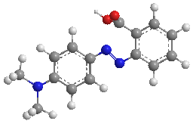 | 501.11 | 4.87
Methyl Orange | 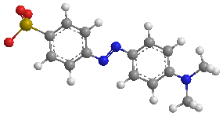 | 515.87 | 4.96
Methylene Blue | 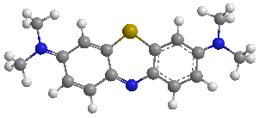 | 530.26 | 5.04
Orange G | 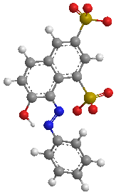 | 563.01 | 5.21
Rose Bengal | 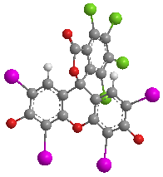 | 697.21 | 5.88
Rhodamine B | 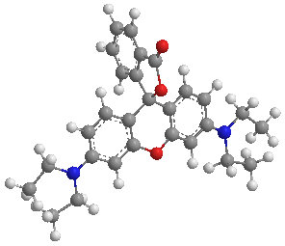 | 757.02 | 6.15
Methyl Blue | 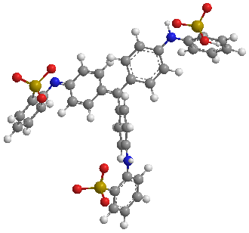 | 1026.64 | 7.29
Brilliant Blue G | 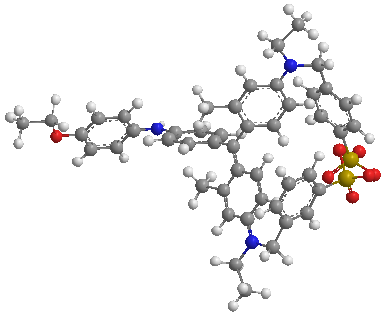 | 1211.60 | 7.98
^{a)}: Colours for atoms: dark grey (carbon), white (hydrogen), blue (nitrogen), red (oxygen), yellow (sulphur), green (chlorine) and pink (iodine).

Table S4. 3D chemical structures and the hydrated radii of the dyes estimated from CAA
Dyes | 3D Chemical Structure^{a)} | CAA (Å²) | Hydrated Radii (Å)
RB |  | 712.84 | 5.87
RB5 | 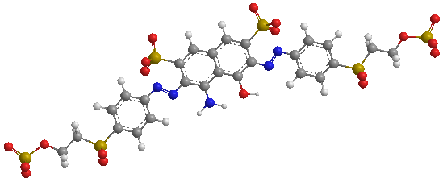 | 1250.91 | 8.23
BB |  | 1198.92 | 8.00
DR23 | 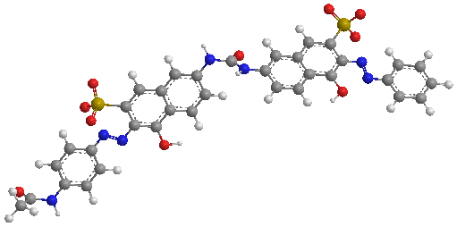 | 1057.01 | 7.38
CR | 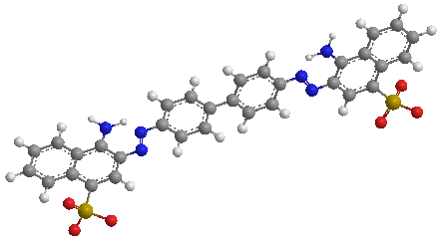 | 970.77 | 7.00
AR1 | 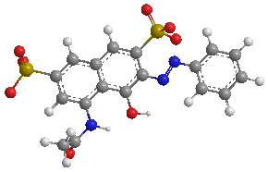 | 635.74 | 5.53
MO |  | 536.54 | 5.03
^{a)}: Colours for atoms: dark grey (carbon), white (hydrogen), blue (nitrogen), red (oxygen), yellow (sulphur), green (chlorine) and pink (iodine).

Table S5. Summary of dyes and salts used in this work
Dyes / Salts | Molecular Weight  (Da) | Dye Content  / Salt Purity | Supplier
Rose Bengal (RB) | 1017.64 | 95% | Sigma Aldrich
Reactive Black 5 (RB5) | 991.82 | ≥ 50%
Brilliant Blue G (BB) | 854.02 | ~ 30%
Direct Red 23 (DR23) | 813.72 | 30%
Congo Red (CR) | 696.66 | ≥ 35%
Hexaphenylbenzene (HPB) | 534.69 | 98%
Acid Red 1 (AR1) | 509.42 | 60%
Sudan IV (SB) | 380.44 | ≥ 80%
Methyl Orange (MO) | 327.33 | 85%
Sodium Sulphate (Na₂SO₄) | 142.04 | > 99%
Magnesium Sulphate (MgSO₄) | 120.37 | > 99.5%
Magnesium Chloride (MgCl₂) | 95.21 | > 98% | Acros Organics
Sodium Chloride (NaCl) | 58.44 | ≥ 99% | Sigma Aldrich

References
[1] A. Akbari, P. Sheath, S.T. Martin, D.B. Shinde, M. Shaibani, P.C. Banerjee, R. Tkacz, D. Bhattacharyya, M. Majumder, Large-area graphene-based nanofiltration membranes by shear alignment of discotic nematic liquid crystals of graphene oxide, Nat Commun, 7 (2016).
[2] P. Liu, C. Milletto, S. Monti, C.T. Zhu, A.P. Mathew, Design of ultrathin hybrid membranes with improved retention efficiency of molecular dyes, Rsc Adv, 9 (2019) 28657-28669.

