Supporting Information
Continuous Production of Cellulose Microbeads by Rotary Jet Atomization
Ciarán Callaghan, Janet Scott, Karen Edler, Davide Mattia
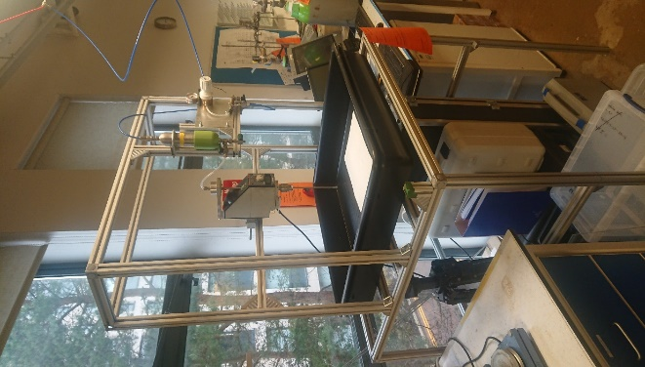
Figure S1. Rotary Jet Atomization rig used in this work. 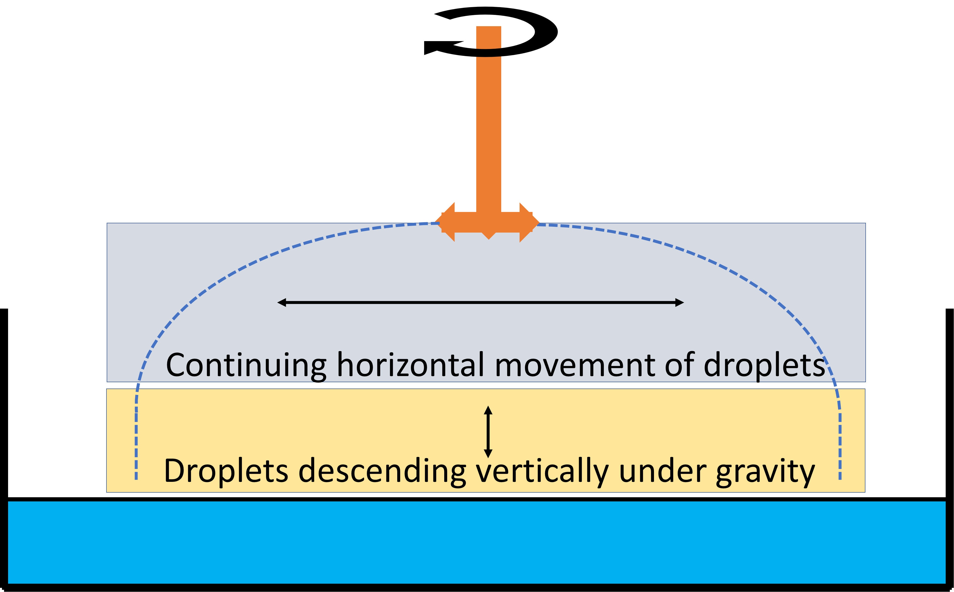
Fig. S2 Horizontal and vertical path of droplets ejected from rotary rig above anti-solvent bath

Table S1: Full results of DOE work in this study
Exp No | Nozzle diameter (mm) | Rotational speed (RPM) | Pressure (bar) | Volume span | Volume distribution Dx10 | Volume distribution Dx50 | Volume distribution Dx90 | Number span | Number distribution Dx10 | Number distribution Dx50 | Number distribution Dx90
1 | 0.234 | 1000 | 0.1 | 0.43 | 290 | 363 | 447 | 0.48 | 260 | 328 | 417
2 | 0.334 | 1000 | 0.1 | 0.52 | 275 | 350 | 461 | 0.59 | 237 | 311 | 419
3 | 0.435 | 1000 | 0.1 | 1.02 | 193 | 361 | 562 | 2.21 | 46 | 64 | 188
4 | 0.234 | 2000 | 0.1 | 1.58 | 45 | 188 | 342 | 0.74 | 10 | 14 | 41
5 | 0.334 | 2000 | 0.1 | 1.52 | 65 | 121 | 248 | 1.00 | 46 | 67 | 113
6 | 0.435 | 2000 | 0.1 | 1.33 | 68 | 162 | 284 | 1.32 | 7 | 10 | 20
7 | 0.234 | 1000 | 0.5 | 0.67 | 225 | 329 | 446 | 0.63 | 32 | 47 | 85
8 | 0.334 | 1000 | 0.5 | 1.40 | 123 | 314 | 563 | 1.64 | 56 | 89 | 202
9 | 0.435 | 1000 | 0.5 | 0.58 | 143 | 190 | 253 | 0.59 | 125 | 164 | 221
10 | 0.234 | 2000 | 0.5 | 1.32 | 64 | 118 | 220 | 1.09 | 42 | 65 | 113
11 | 0.334 | 2000 | 0.5 | 1.71 | 86 | 155 | 351 | 0.95 | 61 | 88 | 144
12 | 0.435 | 2000 | 0.5 | 0.92 | 111 | 172 | 270 | 0.80 | 89 | 126 | 190
13 | 0.334 | 1500 | 0.3 | 1.81 | 72 | 129 | 305 | 0.95 | 52 | 75 | 123
14 | 0.334 | 1500 | 0.3 | 1.41 | 79 | 128 | 259 | 0.85 | 61 | 87 | 135
15 | 0.334 | 1500 | 0.3 | 1.63 | 89 | 185 | 389 | 1.12 | 59 | 88 | 158

Table S2. Approximate values for Reynolds, Weber and Ohnesorge numbers using nozzle diameter as initial jet diameter
Nozzle diameter (mm) | Rotational speed (RPM) | Reynolds number | Weber number | Ohnesorge number
0.437 | 1000 | 0.10 | 8.0 | 9
0.437 | 1500 | 0.11 | 9.1 | 9
0.437 | 2000 | 0.12 | 12.2 | 9
0.335 | 1000 | 0.05 | 2.5 | 10
0.335 | 1500 | 0.05 | 2.8 | 10
0.335 | 2000 | 0.06 | 4.3 | 10
0.234 | 1000 | 0.05 | 3.7 | 12
0.234 | 1500 | 0.06 | 4.7 | 12
0.234 | 2000 | 0.07 | 7.0 | 12

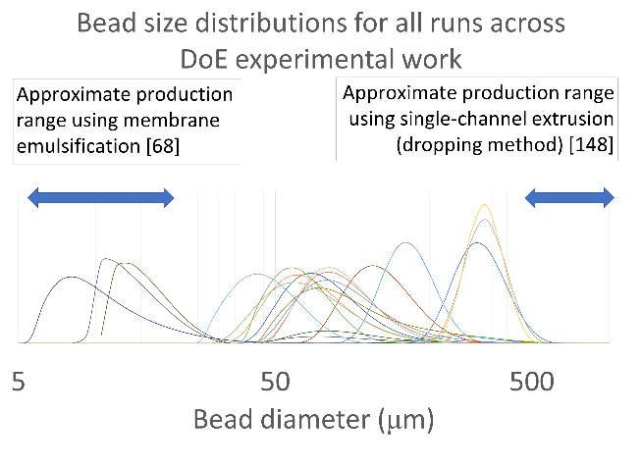
Fig. S3 Overlay of all bead size distributions produced across the DOE work, along with distribution for beads produced using 50μm nozzle. Also highlighted are existing size ranges made possible by other cellulose microbead production methods.

