Original micrographs in the manuscript

Figure 3: FESEM micrographs of ZnO foam (dand e) sintered at 950 ºC for 0.5 h and 900 ºC for 12 h at 5 ºC min⁻¹.

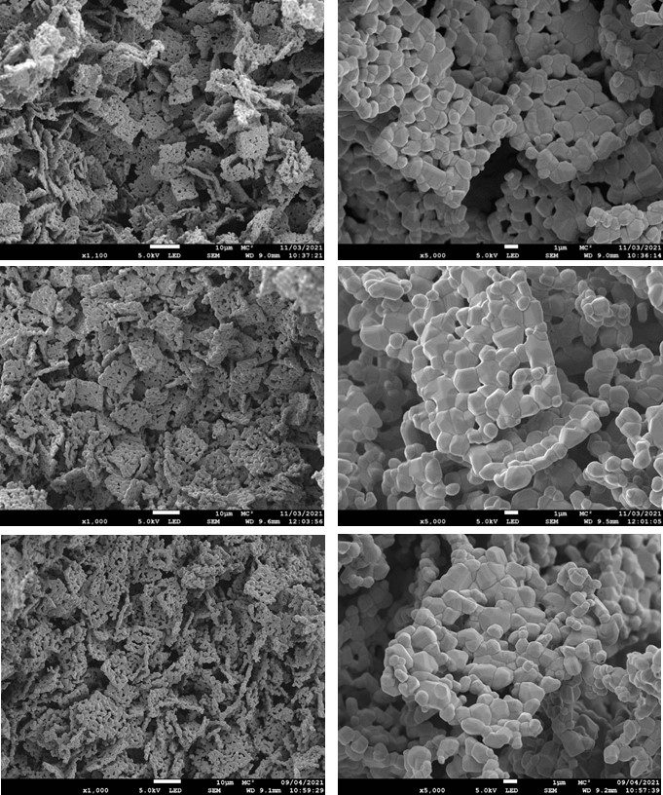
Fig. S3. FESEM micrographs of photocatalytic foams (a,b) before degradation experiments and after (c,d) 1 and (e,f) 5 cycles.

