Supplementary Information for

Direct Evidence for Solid-like Hydrogen in a Nanoporous Carbon Hydrogen Storage Material at Supercritical Temperatures

Valeska P. Ting, Anibal J. Ramirez-Cuesta, Nuno Bimbo, Jessica E. Sharpe, Antonio Noguera-Diaz, Svemir Rudic, Timothy J. Mays

Correspondence to: v.ting@bath.ac.uk

**This PDF file includes:**

Materials and Methods

Supplementary Text

Figs. S1 to S9

Tables S1 to S3

Full reference list

Materials and Methods

Characterization of carbon reference material

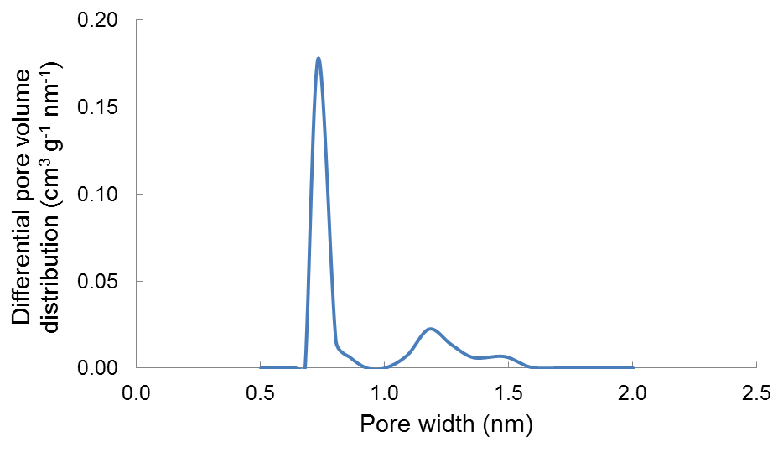

**Fig. S1.** Differential pore size distribution for the TE7 beads determined from density functional theory analysis of N2 sorption at 77 K measured using a Micromeritics ASAP 2020 volumetric adsorption analyzer. The mean micropore width from Dubinin-Radushkevich analysis is ~0.7 nm.

Modeling the excess H2 uptake to estimate the adsorbed H2 density

Excess isotherms for the MAST TE7 carbon beads were analyzed and modeled using a modification of our previously reported methodology19,20. This modification consists of distinguishing between excess, absolute and total masses of adsorbed H2 in the pore. The absolute corresponds to the amount of densified adsorbed H2, with the total uptake comprising of the absolute as well as the bulk quantity of the gas within the pore. The model includes an adsorbate volume, (which is not necessarily equal to the pore volume), which represents the volume occupied by an adsorbed H2 phase with a higher density than the bulk H2. A fractional filling term, which represents the the ratio between the adsorbate volume and pore volume (θA = *V*A/*V*P) is modeled using a Type I isotherm. The excess isotherm is fitted using (1) and with the fitted parameters from the excess, we can determine the absolute (2) and the total (3) isotherm.

*m*E A BA*V*P (1)

*m*A AA*V*P *m*E BA*V*P (2)

*m*P AA*V*P B*V*P 1A *m*E B*V*P (3)

In equations (1), (2) and (3), *m*E, *m*A and *m*P are the excess, the absolute and the total adsorbed amounts in wt.%, respectively. The densities ρA and ρB are the adsorbate and bulk density, respectively, in kg m-3. The fractional filling is a ratio of the adsorbed and pore volume *V*P and it is modeled using a Type I equation.

The Type I isotherm used in the analysis was the Tóth21 (a variation of the Langmuir that account for adsorption heterogeneity), which according to our previous studies, resulted in the best fit to the experimental data. The parameters in the fit (see Fig. S2) are ρA (in kg m–3), *b* (in MPa–1), *c* (dimensionless) and *Vp*(in cm3 g–1), with *An* (*n* = 1, 2, 3, 4) being the parameters from the rational function approximation for the compressibility factor *Z* of the Leachman equation of state for H21as a function of pressure and *Temp* being the temperature in K. The density of the adsorbate comes from the fitting and is ρA, *b* and *c* are the Tóth affinity and heterogeneity parameters respectively and *VP* is the specific (open) pore volume. The absolute amount (2) represents the adsorbate in the pore with a higher density than the bulk.

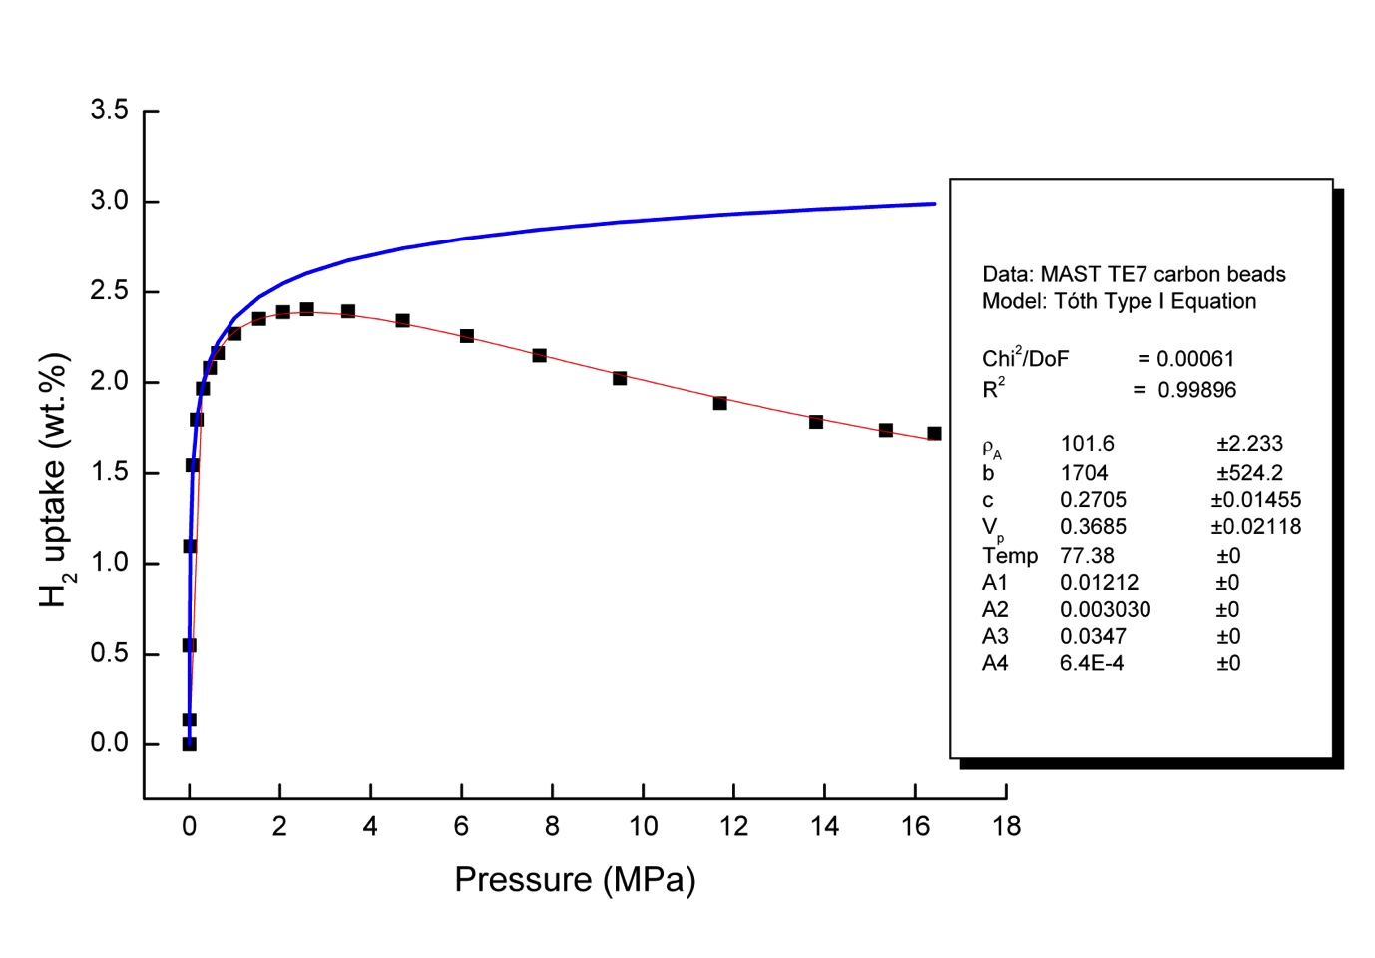

**Fig. S2**. Excess H2 uptake as a function of pressure (up to 17 MPa) for MAST Carbon TE7 activated carbon beads obtained from a Sieverts-type volumetric gas dosing analyzer (Hiden Isochema HTP-1) (black squares). The excess isotherm was fit (red line) using (1) with the Tóth as the Type I equation for the absolute isotherm. Least-squares best fit parameters from the fit, and their standard errors, are displayed in the legend. The blue line indicates the absolute amount adsorbed in wt.%, as calculated using the parameters from the fit and (2), and results in an estimated density of the adsorbed H2 phase (ρA) of 101 ± 2 kg m–3.

Evidence for solid-like hydrogen

**Elastic line**: Dense phases of hydrogen will show an elastic peak contribution at ~0 meV. See the below backgound-subtracted spectrum from bulk solid normal hydrogen at 10 K. Note that at 30 K (gaseous hydrogen) the elastic peak is absent.

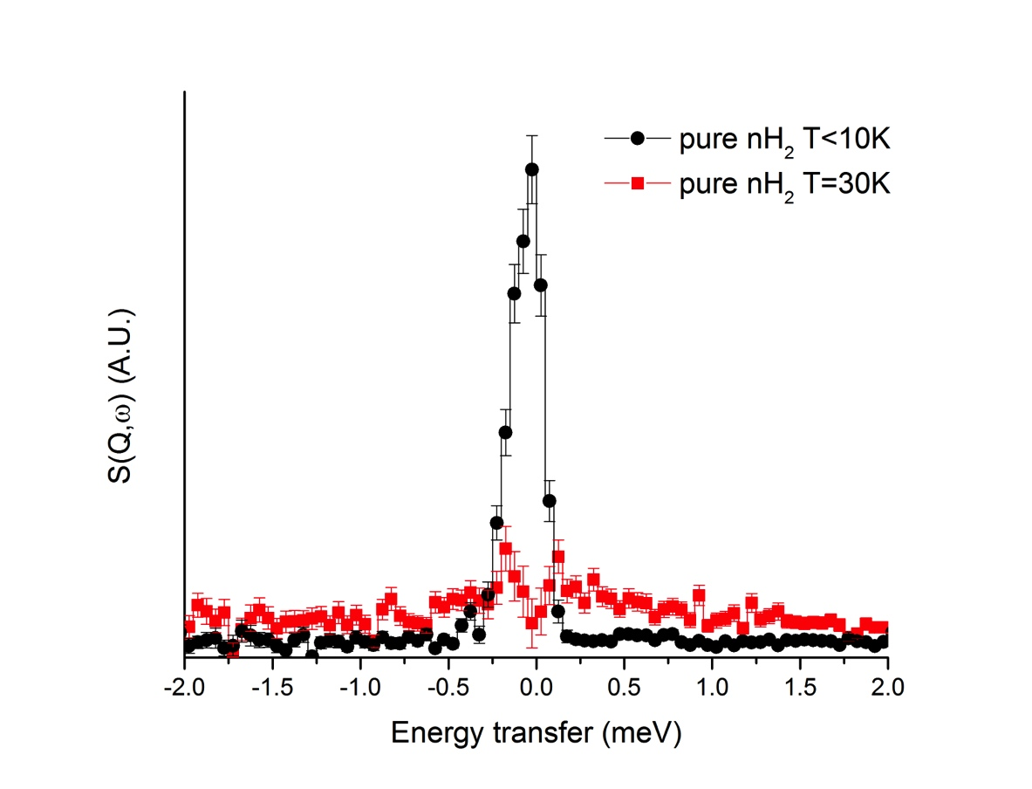

**Fig S3:** Spectra of the elastic contribution from bulk normal H2 at the elastic line at *T* < 10 K (solid), showing a FWHM of 0.23 meV (achieved using an annular sample can with a thickness of 0.1 mm, to minimise multiple scattering effects) and at *T* = 30 K with the background subtracted. Note that there is no elastic peak present for bulk hydrogen at 30 K.

While both solid and dense liquid phases will show an elastic contribution, the elastic line from a liquid will be typically broadened due to quasielastic interactions. At low loading (0.016 MPa H2), the full-width at half-maximum of the elastic peak (~0.3 meV) from the hydrogen in our carbon sample approximated the instrumental peak resolution, indicating that all of hydrogen present had limited mobility.

**Note:** The excess width in the elastic line for the sample is a result of self-shielding and multiple scattering effects from the large (>10 cm3) amount of sample in the beam and thick walled-high pressure sample cell, which have a large effect on lower energy peaks.

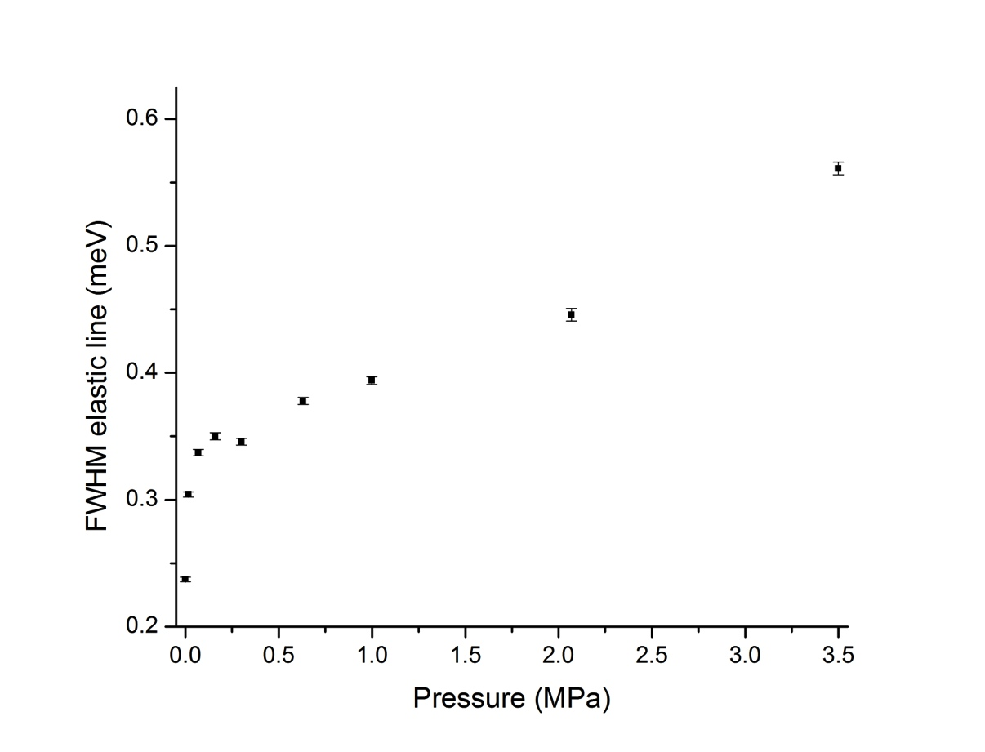

**Fig S4**: Evolution of the full width at half maximum (FWHM) of the elastic line from the background-subtracted sample at 77 K fitted with a Gaussian peak shape, as a function of normal H2 pressure. Error bars represent the errors in the fitting parameters using a Levenberg-Marquardt algorithm. The first point (0 MPa, corresponding to the elastic line from the empty cell at 77 K) is included for comparison.

**Rotor line:** Unlike the study by Egelstaff36 on the rotational transitions seen for solid and liquid hydrogen using cold neutrons and energy gain or the energy gain study by Fitzgerald *et al*. of a single H2 molecule trapped in the octahedral interstice in solid C6037, TOSCA uses thermal neutrons and tracks energy loss. In a typical spectrum for liquid hydrogen on TOSCA, the rotational line for liquid hydrogen is lost in the large recoil signal (Fig. S3 from the ISIS INS database, http://wwwisis2.isis.rl.ac.uk/INSdatabase/Theindex.asp, accessed November 2013).

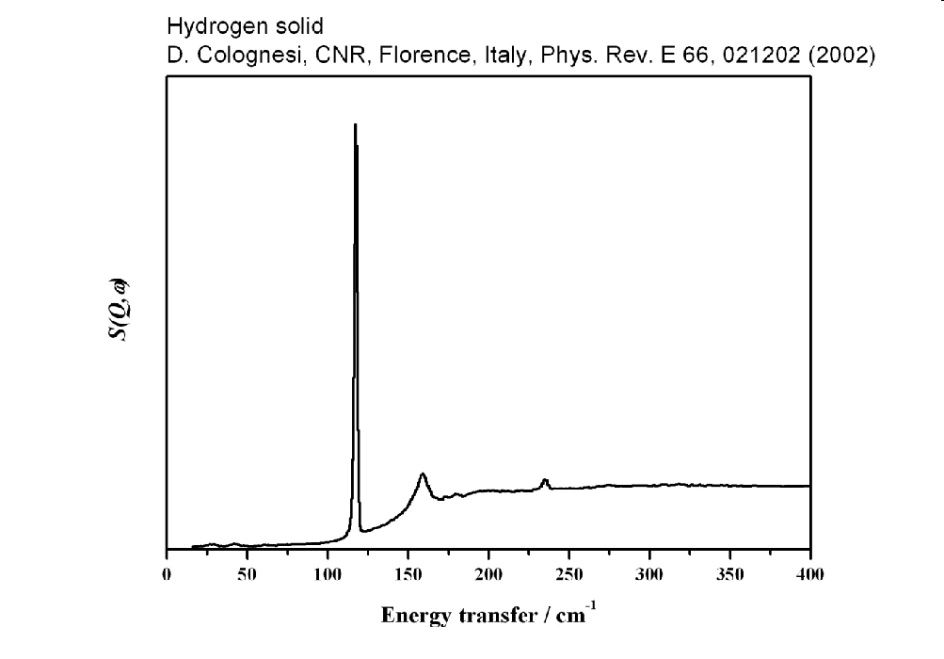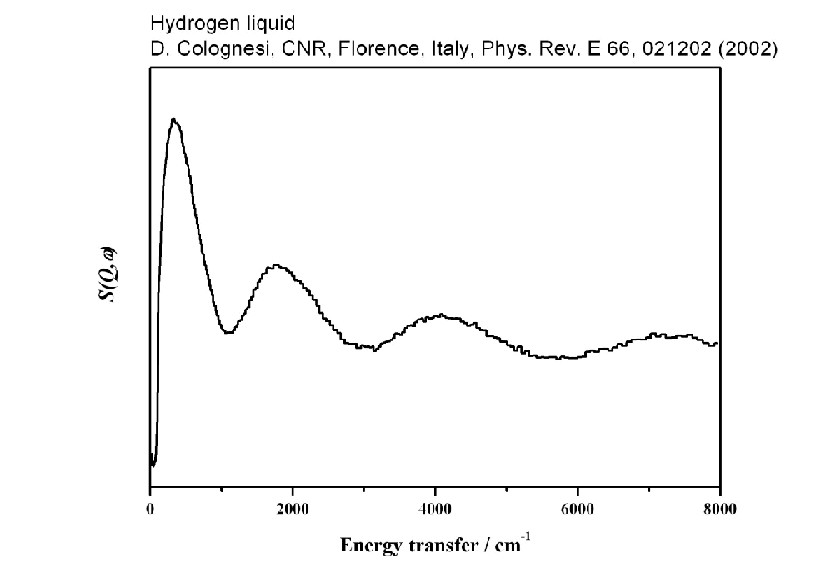

**Fig. S5.** INS energy loss spectra collected with thermal neutrons on (left) liquid *para*-H2 (after can subtraction) at *T* = 17.2 K and *P* = 0.43 bar38 and (right) solid H2 at 12.2 K and *P* = 0.43 bar39 showing the rotor line for *para*-H2 at 14.7 meV (= 118 cm–1).

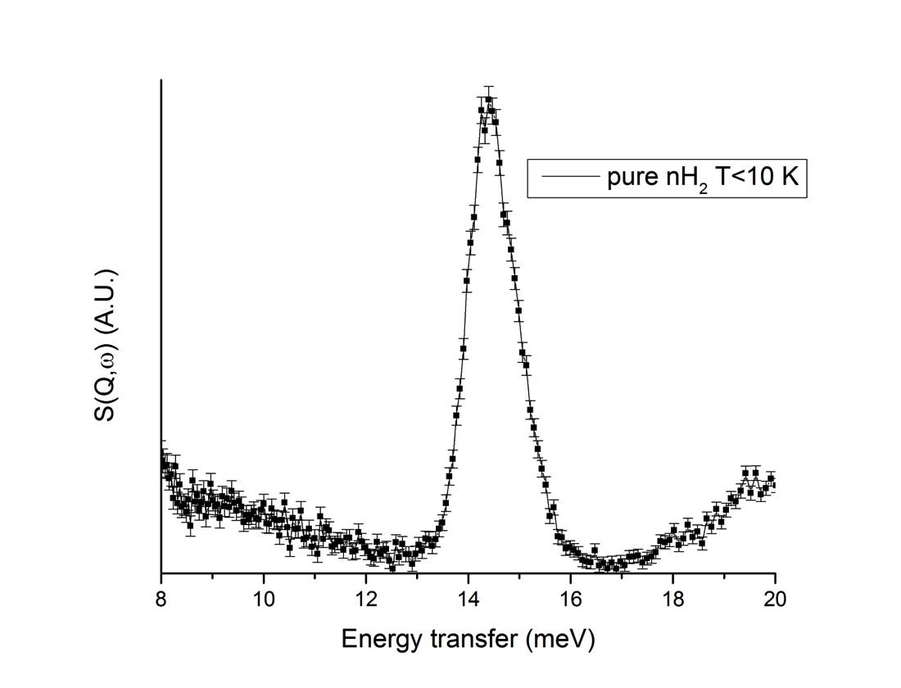

**Fig S6**: Spectrum of pure normal H2 at *T* < 10 K (solid), showing the width of the rotational line, from Colognesi, D. *et al.* *Phys. Rev. B* (2007) 23

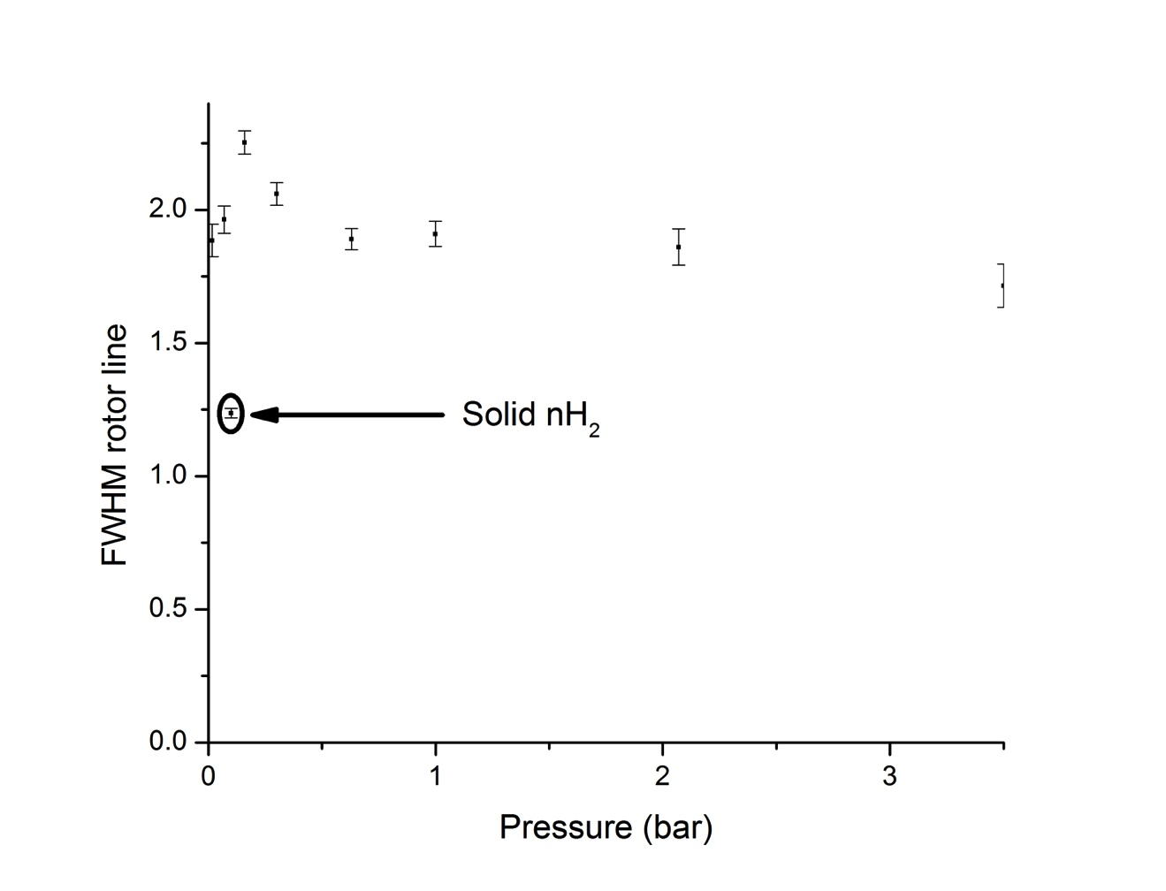

**Fig S7:** The evolution of the FWHM of the normal H2 rotor line (~14.7 meV) as function of normal H2 pressure at 77 K. The point highlighted by the circle corresponds to the width of the rotor line for pure normal H2 solid (extracted from Colognesi *et al.* *Phys. Rev. B* (2007)23).



**Fig. S8.** Background-subtracted INS data from 0.0016 MPa H2 at 77 K (black) and 100 K (red), showing the persistence of the 14.7 meV rotor line at 100 K. The sample was evacuated and dosed with 0.0016 MPa H2 and a spectrum was recorded for 700 µA h at 100 K.

**a) OLC-1750 b) TE7-20**

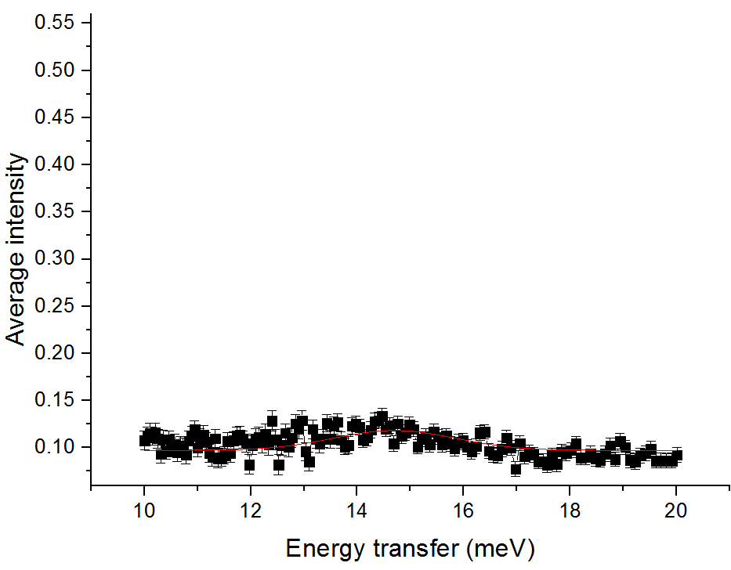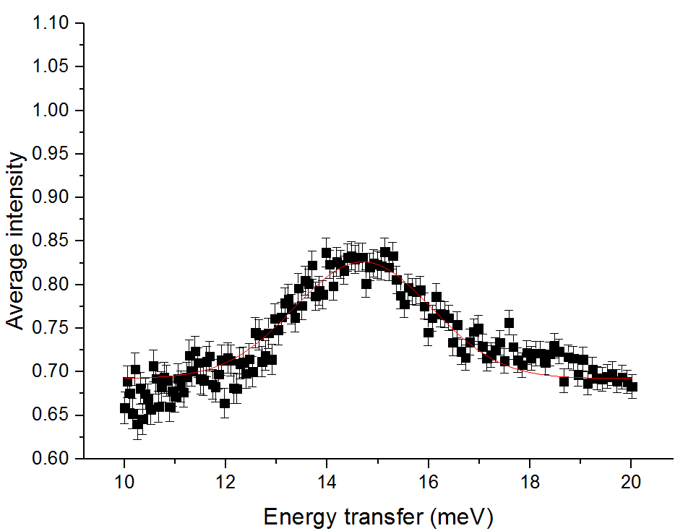

**c) TE3 d) AX-21**

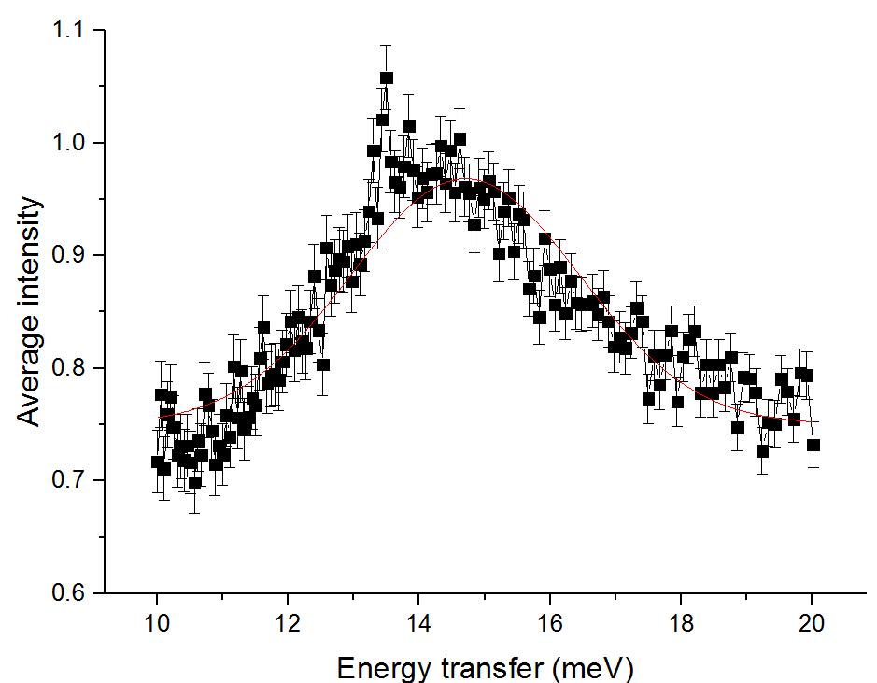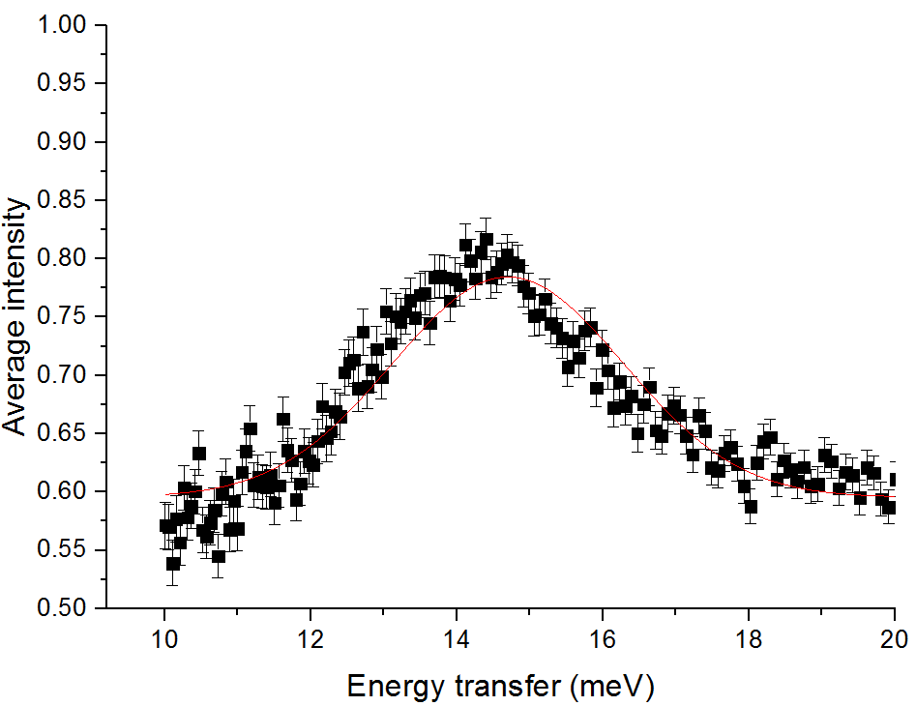

**Fig. S9.** Background-subtracted INS data from 0.1 MPa H2 at 77 K from samples of a) OLC-1750 onion-like carbon, b) TE7_20 carbon from MAST Carbon, d) TE3 carbon from MAST Carbon and d) AX-21 activated carbon from Anderson Development Company, showing the existence of the 14.7 meV rotor line for the samples with pore diameters in the range ~6-8 A (samples b, c, and d). The OLC-1750 has very low micropore volume (see Table S3) and thus has no noticable peak in the 14.7 meV region. The samples were evacuated and dosed with 0.1 MPa H2 and a spectrum was recorded for 700 µA h.

**Comparison of INS integrated intensities and the volumetric excess H2 uptake**

**Table S1**: H2 uptake with pressure, as measured on Hiden Isochema HTP-1 volumetric sorption apparatus.

|  |  |  |
| --- | --- | --- |
| H2 dosing pressure for volumetric measurements (MPa) | Gibbs excess from gas sorption measurements  (µmol) | Hydrogen uptake  (wt%, dry carbon basis) |
| 0 | 0 | 0 |
| 0.002 | 384 | 0.54 |
| 0.017 | 778 | 1.10 |
| 0.071 | 1100 | 1.56 |
| 0.167 | 1280 | 1.81 |
| 0.300 | 1394 | 1.97 |
| 0.457 | 1470 | 2.08 |
| 0.630 | 1521 | 2.15 |
| 1.000 | 1582 | 2.24 |
| 1.542 | 1616 | 2.28 |
| 2.071 | 1621 | 2.29 |
| 2.593 | 1607 | 2.27 |
| 3.505 | 1561 | 2.21 |

**Table S2**: Integrated intensity under the elastic line (–2 meV to 2 meV) with pressure, from the INS spectra up to ~3.5 MPa.

|  |  |  |
| --- | --- | --- |
| H2 dosing pressure for INS measurements  (MPa) | Integrated intensity under elastic line, background subtracted  (arb. units) | Scaled integrated intensity under elastic line  (wt%) |
| 0 | 0.000 | 0.00 |
| 0.016 | 0.234 | 1.16 |
| 0.074 | 0.319 | 1.58 |
| 0.168 | 0.370 | 1.83 |
| 0.300 | 0.403 | 2.00 |
| 0.630 | 0.432 | 2.15 |
| 0.998 | 0.451 | 2.24 |
| 2.071 | 0.462 | 2.29 |
| 3.500 | 0.508 | 2.52 |

**Table S3**

Integrated area under the 14.7 meV rotor line from INS of the materials shown in Fig S9 (0.1 MPa H2 at 77 K, background subtracted) fit with a Gaussian peak shape, and some structural characteristics of the materials, from volumetric N2 sorption analysis at 77 K. Micropore volume was determined using Dubinin-Radushkevich model, and pore size distributions were estimated using a DFT slit pore model.

|  |  |  |  |  |  |
| --- | --- | --- | --- | --- | --- |
| Material: | 14.7 meV area peak (Gaussian): | BET (m2 g-1) | Total pore volume (cm3 g-1) | Micropore volume (DR) (cm3 g-1) | Pore diameters (Å) (DFT, N2, slit) |
| TE3 | 0.9561 ± 0.0742 | 1567 ± 21 | 1.24 | 0.73 | 5, 5.9, 8.3, 12 and 15 |
| OLC-1750 | 0.0605 ± 0.0109 | 321 ± 0.66 | 1.29 | 0.13 | 11, 35, 94, 187, 334, 506, 687 and 855 |
| AX-21 | 0.4533 ± 0.0243 | 2524 ± 47 | 1.82 | 1.97 | 5, 5.9, 8.3, 12, 16, 21 |
| TE7_20 | 0.7510 ± 0.0436 | 1234 ± 7 | 1.33 | 0.52 | 6.8, 8.5, 12 and 15 |

Full reference list

(1) Leachman, J. W.; Jacobsen, R. T.; Penoncello, S. G.; Lemmon, E. W. *J. Phys. Chem. Ref. Data* **2009***, 38,* 721.

(2) Datchi, F.; Loubeyre, P.; Le Toullec, R. *Phys. Rev. B,* **2000,** *10*, 6535.

(3) Deemyad S.; Silvera I. F. *Phys. Rev. Lett.* **2008,** *100*, 155701.

(4) Schlapbach, L.; Zuttel, A. *Nature* **2001,** *414*, 353.

(5) van den Berg, A. W. C.; Arean, C. O. *Chem. Commun.*, **2008**, *44,* 668.

(6) Rouquérol, J.;Avnir, D.; Fairbridge, C. W.; Everett, D. H.; Haynes, J. M.; Pernicone, N.; Ramsay, J. D. F.; Sing, K. S. W.; Unger K. K. *Pure Appl. Chem.* **1994,** *66,* 1739.

(7) Broom, D. P. Hydrogen storage materials: The characterisation of their storage properties. (Springer, London) **2011**.

(8) Züttel, A.; Sudan, P.; Mauron, P.; Wenger, P. *Appl. Phys. A-Mater.* **2004,** *78,* 941.

(9) Rowsell, J. L. C.; Eckert, J.; Yaghi, O. M. *J. Am. Chem. Soc*. **2005***, 127,* 14904.

(10) Brown, C. M.; Liu, Y.; Neumann, D. A. *Pramana-J. Phys.* **2008,** *71*, 755.

[(11) Lee](http://pubs.acs.org/action/doSearch?action=search&author=Lee%2C+Heeju&qsSearchArea=author), H.; [Choi](http://pubs.acs.org/action/doSearch?action=search&author=Choi%2C+Yong+Nam&qsSearchArea=author), Y. N.; [Choi](http://pubs.acs.org/action/doSearch?action=search&author=Choi%2C+Sang+Beom&qsSearchArea=author), S. B; [Kim](http://pubs.acs.org/action/doSearch?action=search&author=Kim%2C+Jaheon&qsSearchArea=author), J.; [Kim](http://pubs.acs.org/action/doSearch?action=search&author=Kim%2C+Daejin&qsSearchArea=author). D.; [Jung](http://pubs.acs.org/action/doSearch?action=search&author=Jung%2C+Dong+Hyun&qsSearchArea=author), D. H.; Y. S.; K. B., *J. Phys. Chem. C*, **2013**, 117 (6), 3177.

(12) Ramirez-Cuesta, A. J.; Jones, M. O.; David, W. I. F. *Materials Today* **2009**, *12*, 54.

(13) Mitchell, P. C. H.; Parker, S. F.; Ramirez-Cuesta, A.; Tomkinson, J. Vibrational spectroscopy with neutrons : with applications in chemistry, biology, materials science and catalysis. Series on neutron techniques and applications (World Scientific, Hackensack, NJ) **2005**.

(14) Gogotsi, Y.; Portet, C.; Osswald, S.; Simmons, J. M.; Yildirim, T.; Laudisio, G.; Fischer J. E. *Int. J. Hydrogen Energ.* **2009**, *34*, 6314.

(15) Hruzewicz-Kołodziejczyk, A.; Ting, V. P.; Bimbo, N.; Mays, T. J. *Int. J. Hydrogen Energ.* **2011,** *37*, 2728.

(16) Silvera, I. F. *Rev. Mod. Phys.* **1980**, *52*, 393.

(17) Young, J. A.; Koppel, J. U. *Phys. Rev. A-Gen. Phys.* **1964,** *135*, A603

(18) Colognesi, D.; Celli, M.; Ramirez-Cuesta, A. J.; Zoppi, M. *Phys. Rev. B* **2007**, *76*, 174304

(19) Bimbo, N.; Ting, V. P.; Hruzewicz-Kolodziejczyk, A.; Mays, T. J. *Faraday Discuss.* **2011,**151, 59

(20) Sharpe, J. E; Bimbo, N.; Ting, V. P; Burrows, A.D. Jiang, D; Mays, T. J., *Adsorption*, **2013**, *19* (2-4), 643

(21) (a) Tóth, J. *Acta Chim. Hung.* **1962***, 32,* 39 [In German; first reference to the Tóth isotherm.] (b) Tóth, J. *Acta Chim. Hung.* **1971,** *69*, 311 [First reference to the Tóth isotherm in English.]

(22) Dundar, E.; Zacharia, R.; Chahine, R.; Bénard, P.; *Fluid phase equilibria* **2014** 363, 74

(23) Liu, Y.; Kabbour, H.; Brown, C. M.; Neumann, D. A.; Ahn, C. C. *Langmuir* **2008**, *24*, 4772

(24) Yildirim, T.; Hartman, M. R. *Phys. Rev. Lett.* **2005,** *95*, 215504

(25) Luo J.; Xu, H.; Liu, Y.; Zhou, Y.; Daemen, L. L.; Brown, C. M.; Timofeeva, T. V.; Ma, S.; Zhou, H.-C. *J. Am. Chem. Soc*. **2008**, *130*, 9626

(26) Ramirez-Cuesta, A. J.; Mitchell, P. C. H. *Catal. Today* **2007,** *120*, 368

(27) Jagiełło, J.; Anson, A.; Martinez, M. T. *J. Phys. Chem. B* **2006,** *110*, 4531

(28) Wang, Q. Y.; Johnson, J. K. *J. Chem. Phys.* **1999**, *110,* 577

(29) Dundar, E,; Zacharia, R.; Chahine, R.; Bénard, P. *Int. J. Hydrogen Energ*. **2012**, *37*, 9137

(30) Gallego, N. C.; He, L. L.; Saha, D.; Contescu, C. I.; Melnichenko, Y. B. *J. Am. Chem. Soc*. **2011,** *133,* 13794

(31) Peterson, B. K.; Walton, J. P. R. B.; Gubbins, K. E. *J. Chem. Soc. Faraday Trans.* **1986***, 2* **(82)**, 1789

(32) Brown, C. M.; Yildirim, T.; Neumann, D. A.; Heben, M. J.; Gennett, T.; Dillon, A. C.; Alleman, J. L.; Fischer, J. E. *Chem. Phys. Lett.* **2000,** *329,* 311

(33) Ren, Y.; Price, D. L. *Appl. Phys. Lett.* **2001**, *79*, 3684

(34) US Department of Energy, http://www1.eere.energy.gov (accessed May 2014).

(35) Farha, O. K.; Yazaydın, A. Ö.; Eryazici, I; Malliakas, C. D.; Hauser, B. G.; Kanatzidis, M. G.; Nguyen, S. T.; Snurr, R. Q.; Hupp, J. T. *Nature Chem.* **2010,** *2***,** 944

Additional references in Supplementary Information

(36)Egelstaff, P. A.; Haywood, B. C.; Webb, F. J. *Proc. Phys. Soc.* **1967,** 90, 681

(37). FitzGerald, S. A., *et al.,. Phys. Rev. B* **1999,** 60, 6439

(38) Celli, M; Colognesi, D.; Zoppi M *Phys. Rev. E* **2002,** 66, 021202

(39) Celli, M; Colognesi, D.; Zoppi M *Eur. Phys. J. B* **2000** 14, 239