Markers used within dynamic trials

- SJN - Sternum Jugular Notch
- CV7 - Cervical Vertebrae 7
- LSAJ – Left Scapula-Acromioclavicular Joint
- RSAJ – Right Scapula- Acromioclavicular Joint
- LHLE – Left Lateral Epicondyle of Humerus
- RHLE – Right Lateral Epicondyle of Humerus
- LRSP – Left Radius-Styloid Process
- LUSP – Left Ulna-Styloid Process
- RRSP – Right Radius-Styloid Process
- RUSP – Right Ulna-Styloid Process
- RASIS – Right anterior superior iliac spine
- LASIS – Left anterior superior iliac spine
- RPSIS – Right posterior superior iliac spine
- LPSIS – Left posterior superior iliac spine
- RTH1, 2, 3 ,4 – Rigid 4 marker cluster on the lateral right thigh
- LTH1, 2, 3, 4 - Rigid 4 marker cluster on the lateral left thigh
- RFLE – Right Femoral Lateral Epicondyle
- LFLE - Right Femoral Lateral Epicondyle
- RSK1, 2, 3, 4 - Rigid 4 marker cluster on the lateral right shank
- LSK1, 2, 3, 4 - Rigid 4 marker cluster on the lateral left shank
- RFAL – Right Fibula Apex of Lateral Malleolus
- LFAL – Left Fibula Apex of Lateral Malleolus
- RHAL – Right Hallux
- LHAL – Left Hallux
- RCAL – Right Calcaneus
- LCAL – Left Calcaneus
- R5MTP – Right 5th MTP
- RB5MTP – Base of the right 5th MTP
- L5MTP – Left 5th MTP
- LB5MTP – base of the left 5th MTP
- RPT – Right peroneal tubercle
- LPT – Left peroneal tubercle
- RFT1, 2, 3, 4, 5 – Tracking markers on the right foot (2 above on toe box, 2 on midfoot/laces, 5th between the heel and PT)
- LFT1, 2, 3, 4, 5 – Tracking markers on the left foot
- FL – Front left of the treadmill
- FR - Front right of the treadmill
- BL - Back left of the treadmill
- BR - Back right of the treadmill

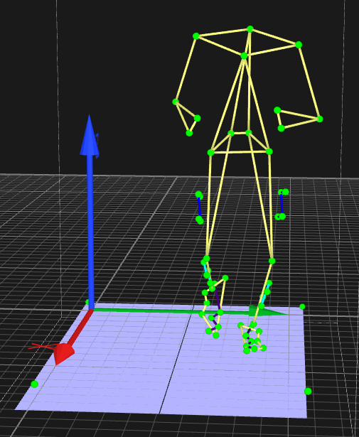

Markers only included within static trials
- RFT – Right Femur Greater Trochanter
- LFT – Left Femur Greater Trochanter
- RFME – Right Femur Medial Epicondyle
- LFME – Left Femur Medial Epicondyle
- RTAM – Right Tibia Apex of Medial Malleolus
- LTAM – Left Tibia Apex of Medial Malleolus
- L1MTP – Left 1st MTP
- LB1MTP – Base of the left 1st MTP
- LST – Left Subtalar Joint
- R1MTP – Right 1st MTP
- RB1MTP – Base of the Right 1st MTP
- RST – Right Subtalar Joint
