SUPPORTING INFORMATION

Metal influence on the iso- and hetero-selectivity of complexes of bipyrrolidine derived Salan ligands for the polymerisation of rac-lactide

Matthew D. Jones, Lauren Brady, Paul McKeown, Antoine Buchard, Pascal M. Schäfer, Lynne H. Thomas, Mary F. Mahon, Timothy J. Woodman, John P. Lowe and Matthew D. Jones

General Experimental:

For the preparation and characterisation of metal complexes, all reactions and manipulations were performed under an inert atmosphere of argon using standard Schlenk or glovebox techniques. rac-LA (Aldrich) was recrystallised from toluene prior to use. All other chemicals were purchased from Aldrich, except the pyrrolidines which were purchased from Orbiter. All solvents used in the preparation of metal complexes and polymerisation reactions were dry and obtained via SPS (solvent purification system). ¹H and ¹³C{¹H} NMR spectra were recorded on a Bruker 250, 300 or 400 or 500 MHz instrument and referenced to residual solvent peaks. Coupling constants are given in Hertz. CHN microanalysis was performed by Mr Stephen Boyer of London Metropolitan University.

Polymerisations:

For solvent-free polymerizations the monomer:initiator ratio employed was 300:1 at a
temperature of 130 °C, in all cases 1.0 g of rac-lactide was used. After the reaction time methanol (20 ml) was added to quench the reaction and the resulting solid was dissolved in dichloromethane. The solvents were removed in vacuo and the resulting solid was washed with copious amounts of methanol to remove any unreacted lactide monomer. ¹H NMR spectroscopy (CDCl3) and GPC (THF) were used to determine tacticity and molecular weights (Mn and Mw) of the polymers produced; Pm (the probability of isotactic linkages) were determined by analysis of the methine region of the homonuclear decoupled ¹H NMR spectra, the equations used to calculate Pr and Pm are given by Coates et al. ¹ The P_{r} and P_{m} values were determined by either integration/deconvolution (analogous values obtained with either method) and all methine resonances (including stereo errors) were analysed in the determination of the values.

1. B. M. Chamberlain, M. Cheng, D. R. Moore, T. M. Ovitt, E. B. Lobkovsky and G. W. Coates, J. Am. Chem. Soc., 2001, 123, 3229-3238.

For solution polymerisations the monomer:initiator ratio employed was 100:1 at a temperature stated in the tables, in all cases 0.72 g of rac-LA was used. After the reaction time the reaction was quenched with methanol. The solvents were removed in vacuo and the resulting solid was washed with copious amounts of methanol to remove any unreacted monomer. GPC (THF) was used to determine molecular weights (Mn and Mw) of the polymers produced.

DSC

The DSC analyses were recorded on a TA Instruments DSC Q20. The sample was held at 40 ºC for 1 minute, heated to 250 ºC at 10 ºC/min held at this temperature for 1 minute, cooled to 40 ºC at 10 ºC/min held at this temperature for 1 minute and finally heated to 250 ºC at 10 ºC/min - the T_{m} values are quoted for the second heating cycle.

MALDI-ToF

MALDI ToF mass spectra were determined on a Bruker Autoflex speed instrument using DCTB (trans-2-[3-(4-tert-Butylphenyl)-2-methyl-2-propenylidene]malononitrile) as the matrix and ionised using NaOAc.

Crystallography:

All data were collected on a Xcalibur, Atlas diffractometer using Cu-Kα radiation (λ = 1.54184 Å) at 150(2) K. All structures were solved by direct methods and refined on all F² data using the SHELXL-97 suite of programs. All hydrogen atoms were included in idealised positions and refined using the riding model.

Synthesis of ligands:

The general procedure is as follows: 2,2’-bipyrrolidine (1.0 g, 7.14 mmol) was dissolved in methanol (50 ml) to which 2,4-dimethyl phenol (1.8 ml, 14.8 mmol) was added together with paraformaldehyde (2.0 g) and heated to reflux for 4 hrs. Upon cooling a white precipitate was observed which was collected by filtration and washed with cold methanol and dried. Yields were approximately 40 % in all cases.²

2. M.D. Jones, S.L. Hancock, P.M. Schafer, A. Buchard, L.H. Thomas, M.F. Mahon, J.P. Lowe, Chem. Commun., 2014, 15967-15970.

Synthesis of Complexes:

Hf(O^{i}Pr)₄OH^{i}Pr (0.50 g, 1.05 mmol) was dissolved in toluene (20 ml) to which the salan-bipyrrolidine (0.430 g, 1.05 mmol) was added and the solution stirred for 1 hour. For the chiral complexes with ligands 1H₂ and 2H₂ a precipitate formed during this time and the solution was heated to re-dissolve this. After standing for 24 hours a crop of crystals was isolated. Yield: Hf(1)(O^{i}Pr)₂ = 34%, Hf(2)(O^{i}Pr)₂ = 30%. For the meso complex, Hf(3)(O^{i}Pr)₂ no such precipitate was observed. For Hf(3)(O^{i}Pr)₂ after 1 hour the toluene was removed in-vacuo and the resulting white solid recrystallised in hexane and left to stand at room temperature for 24 hours after which time a crop of crystals was isolated yield = 34%.

Hf(1)(O^{i}Pr)₂

¹H (CDCl₃) 1.05-1.21 (m, br, 2H), 1.25 (d J = 6.0 Hz, 6H, CH₃), 1.29 (d J = 6.0 Hz, 6H, CH₃), 1.52-1.66 (m, 2H), 1.67-1.80 (m, 2H), 1.89-2.03 (m, 2H), 2.20 (s, 6H, CH₃), 2.20 (s, 6H, CH₃), 2.76 (m, 2H), 2.87-2.97 (m, 2H), 3.09 (d J = 13.0 Hz, 2H CH₂), 3.20-3.32 (m, 2H), 4.55-4.67 (m, 4H, CH₂ + OCH(CH₃)₂), 6.53 (s, 2H, Ar-H), 6.92 (s, 2H, Ar-H). ¹³C{¹H} (CDCl₃) 16.8 (CH₃), 20.5 (CH₃), 20.8 (CH₂), 24.2 (CH₂), 27.1 (CH₃), 27.3 (CH₃), 52.8 (CH₂), 58.8 (CH₂), 62.9 (CH), 70.4 (CH), 123.2 (Ar), 125.0 (Ar), 126.6 (Ar), 127.5 (Ar-H), 131.4 (Ar-H), 157.3 (Ar-O). Calcd C₃₂H₄₈N₂O₄Hf₁ C, 54.65%; H, 6.88%; N, 3.98%. Found: C, 54.55%; H, 6.95%; N, 4.04%.

Figure SI 1: ¹H NMR (CDCl₃) spectrum of Hf(1)(O^{i}Pr)₂

Hf(2)(O^{i}Pr)₂

¹H (CDCl₃) 1.05-1.22 (m, br, 2H), 1.25 (d J = 6.0 Hz, 6H, CH₃), 1.29 (d J = 6.0 Hz, 6H, CH₃), 1.52-1.66 (m, 2H), 1.66-1.81 (m, 2H), 1.90-2.04 (m, 2H), 2.21 (s, 6H, CH₃), 2.22 (s, 6H, CH₃), 2.77 (m, 2H), 2.87-2.98 (m, 2H), 3.10 (d J = 13.0 Hz, 2H CH₂), 3.208-3.32 (m, 2H), 4.51-4.67 (m, 4H, CH₂ + OCH(CH₃)₂), 6.54 (s, 2H, Ar-H), 6.93 (s, 2H, Ar-H). ¹³C{¹H} (CDCl₃) 16.8 (CH₃), 20.5 (CH₃), 20.8 (CH₂), 24.4 (CH₂) 27.3 (CH₃), 27.5 (CH₃), 52.8 (CH₂), 58.8 (CH₂), 62.9 (CH), 70.4 (CH), 123.2 (Ar), 125.0 (Ar), 126.6 (Ar), 127.6 (Ar-H), 131.4 (Ar-H), 157.3 (Ar-O). Calcd C₃₂H₄₈N₂O₄Hf₁: C, 54.65%; H, 6.88%; N, 3.98%. Found: C, 54.51%; H, 6.90%; N, 3.99%.

Figure SI 2: ¹H NMR (CDCl₃) spectrum of Hf(2)(O^{i}Pr)₂

Hf(3)(O^{i}Pr)₂

¹H (CDCl₃) 1.03 (d J= 6.0 Hz, 3H, CH₃), 1.10 (d J= 6.0 Hz, 3H, CH₃), 1.24 (d J= 6.0 Hz, 6H, CH₃), 1.50-1.50 (m, 1H), 1.63-1.74 (m, 1H), 1.79-2.03 (m, 6H), 2.05 (s, 3H, CH₃), 2.20 (s, 3H, CH₃), 2.21 (s, 3H, CH₃), 2.07 (s, 3H, CH₃), 2.77-2.88 (m, 3H), 2.90-2.99 (m, 1H), 3.05-3.14 (m, 1H), 3.17-3.27 (m, 1H), 3.35 (d J = 12.5 Hz, 1H), 4.24-4.36 (m, 2H CH₂ + OCH(CH₃)₂), 4.39-4.48 (m, 1H), 4.54 (sept J = 6.0 Hz, 1H CH), 4.65 (d J = 12.5 Hz, 1H), 6.51 (s, Ar-H, 1H), 6.67 (s, Ar-H, 1H), 6.92 (s, Ar-H, 2H). ¹³C{¹H} (CDCl₃) 16.3 (CH₃), 20.5 (CH₃), 21.7 (CH₂), 23.5 (CH₂), 25.4 (CH₂), 27.3 (CH₃), 27.3 (CH₃), 27.4 (CH₃) 29.9 (CH₂), 52.2 (CH₂), 59.0 (CH₂), 60.7 (CH₂), 65.8 (CH₂), 68.2 (CH), 69.2 (CH), 70.6 (CH), 71.6 (CH), 123.0 (C), 123.5 (C), 124.0 (C), 125.1 (C), 125.8 (C), 126.7 (C), 127.8 (Ar-H), 128.3 (Ar-H), 131.3 (Ar-H), 131.9 (Ar-H), 158.1 (Ar-O), 159.0 (Ar-O). Calcd C₃₂H₄₈N₂O₄Hf₁: C, 54.65%; H, 6.88%; N, 3.98%. Found: C, 54.54%; H, 7.02%; N, 3.91%.

Figure SI 3: ¹H NMR (CDCl₃) spectrum of Hf(3)(O^{i}Pr)₂

Synthesis of the Al-Me complexes:

The ligand (816 mgs, 2mmol) was dissolved in toluene (10 ml) to which AlMe₃ (1.0 ml, 2 mmol). After effervescence the solution was left for 1 hour. After which time the solvent was removed and the white solid was recrystallised in hot hexane/toluene. The resulting crystals were isolated and dried. Al(1)Me = 18 %; Al(3)Me = 87 %.

Synthesis of the Al-O^{i}Pr complexes:

The ligand (816 mgs, 2mmol) was dissolved in toluene (10 ml) to which AlMe₃ (1.0 ml, 2 mmol). After effervescence the solution was left for 1 hour. After which time isopropanol (0.4 ml, 6 mmol) was added the solution gentle heated for 1 hour. After which time the solvent was removed and the resulting product recrystallised in hot hexane/toluene. The resulting crystals were isolated and dried. Al(1)(O^{i}Pr) = 25 %; Al(3)(O^{i}Pr) = 66 %. Al(4)(O^{i}Pr) = 44 %.

Al(1)Me

¹H (233K C₆D₅CD₃) -0.18 (s, 3H), 0.80 – 0.96 (m, br 2H), 1.17 (m, br, 1H), 1.30 – 1.42 (m, br, 2H), 1.67 (m, br 1H), 1.78 (m, br, 1H), 2.03 (m, br, 1H), 2.26 (m, br, 1H), 2.29 (s, 3H), 2.36 (m, br 1H), 2.24 (s, 3H), 2.51 (s, 3H), 2.58 (m, br 2H), 2.65 (m, br 1H), 2.68 (s, 3H), 2.76 (m, br 1H), 3.59 (d J = 13.0 Hz, 2H), 3.86 (d J = 13.0 Hz, 2H), 6.41 (s, 1H) 6.51 (s, 1H), 6.95 (s, 1H), 7.04 (s, 1H). ¹³C{¹H} (233K C₆D₅CD₃) -5.6 (CH₃), 16.9 (CH₃), 17.7 (CH₃), 20.7 (CH₃), 20.8 (CH₃), 19.4 (CH₂), 19.7 (CH₂), 23.7 (CH₂), 24.1 (CH₂), 46.6 (CH₂), 53.8 (CH₂), 56.0 (CH₂), 57.8 (CH₂), 61.9 (CH), 66.9 (CH), 117.9 (Ar), 121.0 (Ar), 122.1 (Ar), 124.6 (Ar), 126.6 (Ar-H), 127.3 (Ar), 127.5 (Ar-H), 131.8 (Ar-H), 156.5 (Ar-O), 158.8 (Ar-O). Calcd C₂₇H₃₇N₂O₂Al₁: C, 72.29%; H, 8.31%; N, 6.24%. Found: C, 77.22%; H, 8.35%; N, 5.99%.

Figure SI 4: ¹H NMR (C₆D₅CD₃) spectrum of Al(1)(Me) Top 298 K, bottom 233 K
Al(1)(O^{i}Pr)

¹H (253K CDCl₃) 0.86 (d J = 6.0 Hz, 3H), 1.02 (d J = 6.0 Hz, 3H), 1.50-1.66 (m, br 2H), 1.67-1.79 (m, br 1H), 1.80 -1.95 (m, br, 2H), 1.98-2.10 (m, br, 2H), 2.14-2.16 (m, br, 1H), 2.20 (s, 9H), 2.29 (s, 3H), 2.61-2.74 (m, br, 2H), 2.94 (m, 2H), 3.00-3.10 (m, br, 1H), 3.40 (d J = 13.5 Hz, 1H), 3.45-3.55 (m, br, 2H), 3.91-3.95 (m, br 1H), 4.04 (sept J = 6.0 Hz, 1H), 4.31 (d J = 13.5 Hz, 1H), 6.54 (s, 1H), 6.59 (s, 1H), 6.91 (s, 1H), 6.95 (s, 1H). ¹³C{¹H} (253K CDCl₃) 16.1 (CH₃), 16.8 (CH₃), 20.4 (CH₂), 20.4 (CH₂), 20.5 (CH₂), 24.8 (br CH₂), 27.7 (CH₃), 47.8 (CH₂), 54.6 (br CH₂), 58.1 (CH₂), 62.5 (CH), 67.5 (CH), 117.5 (Ar), 121.5 (Ar), 122.6 (Ar), 124.8 (Ar), 126.1 (Ar-H), 126.7 (Ar-H), 127.6 (Ar), 127.7 (Ar), 130.7 (Ar-H), 131.1 (Ar-H), 155.6 (Ar-O), 157.5 (Ar-O). Calcd C₂₉H₄₁N₂O₃Al₁: C, 70.70%; H, 8.39%; N, 5.69%. Found: C, 70.60%; H, 8.47%; N, 5.68%.

Figure SI 5: ¹H NMR (CDCl₃) spectrum of Al(1)(O^{i}Pr) Top 298 K, middle 253 K, bottom NOESY at 298 K

Al(3)Me

¹H (298K C₆D₅CD₃) -0.49 (s, 3H), 1.03-1.11 (m, br 2H), 1.19-1.23 (m, br, 4H), 1.36-1.44 (m, br, 2H), 2.28-2.31 (s, 6H + m 1H), 2.31-2.36 (m, br, 3H), 2.37 (s, 6H), 2.74-2.80 (m, br 2H), 2.82 (d, J = 13.0 Hz 2H), 3.79 (d J = 13.0 Hz, 2H), 6.49 (s, 2H) 6.95 (s, 2H). ¹³C{¹H} (298K C₆D₅CD₃) -8.2 (CH₃), 16.6 (CH₃), 20.9 (CH₃), 21.5 (CH₂), 26.4 (CH₂), 54.4 (CH₂), 60.5 (CH₂), 66.2 (CH), 121.1 (Ar), 123.9 (Ar), 126.7 (Ar-H), 128.0 (Ar), 131.7 (Ar-H), 157.1 (Ar-O). Calcd C₂₇H₃₇N₂O₂Al₁: C, 72.29%; H, 8.31%; N, 6.24%. Found: C, 72.21%; H, 8.40%; N, 6.17%.

Figure SI 6: ¹H NMR (C₆D₅CD₃) spectrum of Al(3)Me

Al(3)(O^{i}Pr)

¹H (298K CDCl₃) 1.08 (d J = 6.0 Hz, 6H), 1.79-1.89 (m, 2H), 1.92-2.02 (m, 4H), 2.07-2.15 (m, br, 2H), 2.18 (s, 6H), 2.19 (s, 6H), 2.75-2.85 (m, 2H), 3.17 (m, 2H), 3.32 (d J = 13.5 Hz, 2H), 3.35-3.45 (m, br, 2H), 4.27 (d J = 13.5 Hz, 2H), 4.31 (sept J = 6.0 Hz, 1H), 6.54 (s, 2H), 6.90 (s, 2H). ¹³C{¹H} (298K CDCl₃) 16.1 (CH₃), 20.4 (CH₃), 21.7 (CH₂), 26.4 (CH₂), 27.5 (CH₃), 54.5 (CH₂), 60.8 (CH₂), 63.1 (CH), 66.7 (CH), 120.2 (Ar), 123.8 (Ar), 126.1 (Ar-H), 128.2 (Ar), 131.0 (Ar-H), 156.6 (Ar-O). Calcd C₂₉H₄₁N₂O₃Al₁: C, 70.70%; H, 8.39%; N, 5.69%. Found: C, 68.06%; H, 9.06%; N, 5.52%.

Figure SI 7: ¹H NMR (CDCl₃) spectrum of Al(3)O^{i}Pr and NOESY at 298 K

Ti(3)(O^{i}Pr)₂

¹H (CDCl₃) 1.08 (d J= 6.0 Hz, 3H, CH₃), 1.20 (d J= 6.0 Hz, 3H, CH₃), 1.24 (d J= 6.0 Hz, 3H, CH₃), 1.36 (d J= 6.0 Hz, 3H, CH₃), 1.77-2.09 (m, 8H), 1.89 (s, 3H, CH₃), 2.24 (s, 6H CH₃), 2.28 (s, 3H, CH₃), 2.75-2.88 (m, 1H), 2.88-2.90 (m, 1H), 2.96 (d J = 13.0 Hz, 1H) 3.00-3.08 (m, 1H), 3.21-3.27 (m, 1H), 3.32 (d J = 13.0 Hz, 1H), 3.57-3.60 (m, 1H), 4.38 (d J = 13.0 Hz, 1H), 4.47 (d J = 13.0 Hz, 1H), 4.53 – 4.61 (m, 1H) 4.87 (sept J = 6.0 Hz, 1H CH), 5.00 (sept J = 6.0 Hz, 1H CH), 6.55 (s, Ar-H, 1H), 6.66 (s, Ar-H, 1H), 6.89 (s, Ar-H, 2H). ¹³C{¹H} (CDCl₃) 16.8 (CH₃), 20.5 (CH₃), 22.1 (CH₂), 23.1 (CH₂), 25.3 (CH₂), 25.7 (CH₃), 25.8 (CH₃), 25.9 (CH₃), 26.1 (CH₃) 28.0 (CH₂), 54.4 (CH₂), 61.0 (CH₂), 61.6 (CH₂), 65.1 (CH₂), 68.1 (CH), 70.6 (CH), 75.3 (CH), 123.0 (C), 124.2 (C), 124.7 (C), 124.8 (C), 125.1 (C), 125.7 (C), 127.2 (Ar-H), 127.4 (Ar-H), 130.1 (Ar-H), 131.1 (Ar-H), 159.0 (Ar-O), 159.6 (Ar-O). Calcd C₃₂H₄₈N₂O₄Ti₁: C, 67.17%; H, 8.45%; N, 4.89%. Found: C, 66.96%; H, 8.56%; N, 4.86%.

Figure SI 8: ¹H NMR (CDCl₃) spectrum of Ti(3)(O^{i}Pr)₂ at 298 K

Al(4)(O^{i}Pr)

¹H (298K CDCl₃) 1.02 (d J = 6.0 Hz, 6H), 1.26 (s, 18H), 1.44 (s, 18H) 1.78-1.91 (m, 2H), 1.98-2.08 (m, 2H), 2.01-2.17 (m, 4H), 2.78-2.88 (m, 2H), 3.18-3.26 (m, 2H), 3.31 (d J = 12.5 Hz, 2H), 3.35-3.40 (m, br, 2H), 4.47 – 4.57 ( sept and doublet CH₂ and CH), 6.72 (d J = 2.5 Hz, 2H), 7.22 (d J= 2.5Hz, 2H). ¹³C{¹H} (298K CDCl₃) 22.1 (CH₂), 26.8 (CH₂), 27.6 (CH₃), 29.9 (CH₃), 31,8 (CH₃), 33.9 (C), 35.0 (C), 54.1 (CH₂), 61.1 (CH₂), 62.3 (CH), 67.4 (CH), 120.6 (Ar), 122.9 (Ar), 123.5 (Ar-H), 136.9 (Ar), 137.9 (Ar-H), 157.9 (Ar-O). Calcd C₄₁H₆₅N₂O₃Al₁: C, 74.51%; H, 9.91%; N, 4.24%. Found: C, 74.42%; H, 9.99%; N, 4.23%.

Figure SI 9: ¹H NMR (CDCl₃) spectrum of Al(4)O^{i}Pr at 298 K

Selected Polymer Characterisation:
Figure SI 10: Homonuclear decoupled ¹H spectrum from Hf(3)(O^{i}Pr)₂ – entry 3 Table 1. sis = 1, sii = 1.96, iis= 2.3 and isi = 2.4

Figure SI 11: Homonuclear decoupled ¹H spectrum from Hf(1)(O^{i}Pr)₂ – entry 1 Table 1.

Figure SI 12Top: Homonuclear decoupled ¹H spectrum Lower ¹³C{¹H} from Hf(3)(O^{i}Pr)₂ – entry 7 Table 1

Figure SI 13: Homonuclear decoupled ¹H spectrum Hf(3)(O^{i}Pr)₂ – entry 8 Table 1. sis = 1, sii = 4, iis= 5 and isi = 5

Figure SI 14: Top: Homonuclear decoupled ¹H spectrum Lower ¹³C{¹H} from Al(3)(Me) – entry 2 Table 2.

Figure SI 15: Homonuclear decoupled ¹H spectrum from Al(3)(O^{i}Pr) – entry 4 Table 2.

Figure SI 16: Homonuclear decoupled ¹H spectrum from Al(3)(O^{i}Pr) – entry 6 Table 2 and ¹³C{¹H} NMR spectrum.

Figure SI 17: Top Methine region of ¹³C{¹H} NMR and bottom: Homonuclear decoupled ¹H spectrum from Al(3)(O^{i}Pr) – entry 7 Table 2

Figure SI 18: Top: Methine region of ¹³C{¹H} NMR and bottom homonuclear decoupled ¹H spectrum from Al(3)(O^{i}Pr) – entry 9 Table 2

Figure SI 19: Top: Methine region of ¹³C{¹H} NMR and bottom homonuclear decoupled ¹H spectrum from Al(3)(O^{i}Pr) – entry 8 Table 2

Figure SI 20: GPC for solution polymerisation with Hf(3)(O^{i}Pr)₂ solution– entry 7 Table 1.

Figure SI 21: GPC for solution polymerisation with Hf(3)(O^{i}Pr)₂ solution– entry 8 Table 1.

Figure SI 22: GPC for solution polymerisation with Al(3)(O^{i}Pr) solution at 100 ºC– entry 9 Table 2.

Figure SI 23: GPC for solution polymerisation with Al(3)(O^{i}Pr) solution at 90 ºC– entry 8 Table 2.

DSC

Figure S24: DSC of PLA from Table 1 entry 8 - Hf(3)(O^{i}Pr)₂ at 70 °C.

Figure S25: DSC of PLA from Table 1 entry 7 - Hf(3)(O^{i}Pr)₂ at 50 °C.

Selected MALDI-ToF data

Figure S26: MALDI-ToF MS for solution polymerisation with Hf(3)(O^{i}Pr)₂ – entry 8 Table 1. MALDI of Hf(3)(O^{i}Pr)₂ solution polymerisation at 50 °C The major series is for H(C₆H₈O4)_{n}O^{i}Pr the minor is the transesterification.

Figure S27: MALDI-ToF MS for solution polymerisation with Al(3)(O^{i}Pr) – entry 6 Table 2. The major series is for H(C₆H₈O₄)_{n}O^{i}Pr the minor is the transesterification.

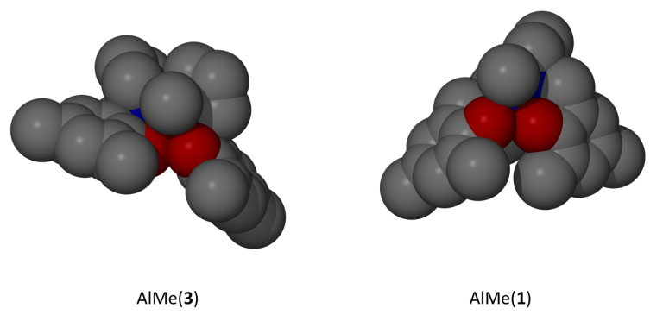

Figure S28: Space filling of Al(3)Me vs Al(1)Me.
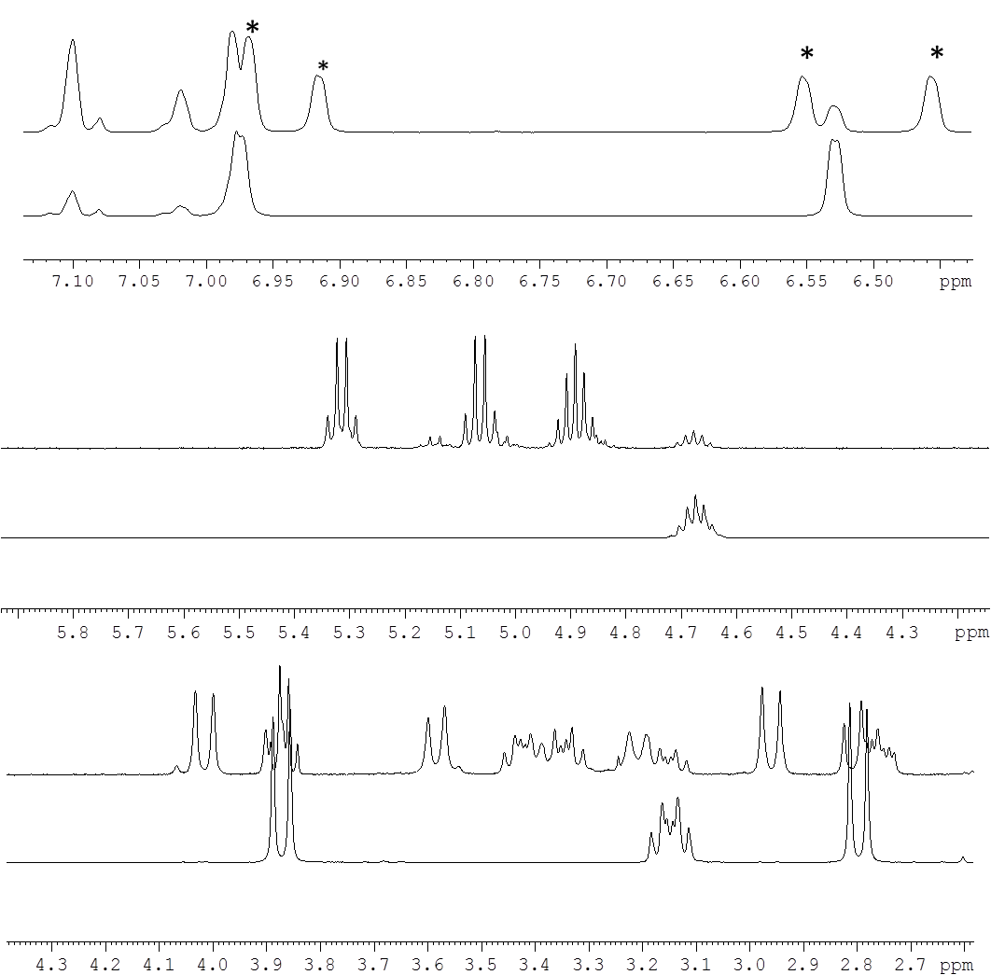

Figure S29: Regions of the ¹H NMR spectrum of Al(3)(O^{i}Pr) reacted with 1 eq of rac-LA at 80°C for 2 hrs. The bottom spectra are for the free Al(3)(O^{i}Pr) and top after addition of 1 equivalent of rac-LA after 2hrs. * new resonances.

Figure S30: ¹H NMR spectrum of Al(3)(O^{i}Pr) reacted with 3 eq of rac-LA at 80°C for 2 hrs. ¹H NMR recorded at 25 °C.

Figure S31: The ¹H NMR spectrum of Hf(3)(O^{i}Pr)₂ reacted with 1 eq of rac-LA at 25 °C for 2 hrs.

Figure S32: The NOESY NMR spectrum of Hf(3)(O^{i}Pr)₂ reacted with 1 eq of rac-LA at 25 °C for 2 hrs.

Figure S33: ¹H NMR spectrum of Al(3)(Me) reacted with 1 eq of (S)-Me-lactate.

Figure S34: Bottom ¹³C{¹H} NMR spectrum of Al(3)(Me) reacted with 1 eq of (S)-Me-lactate,. Top (S)-Me-lactate for comparison

DOSY NMR Analysis:
Pulsed gradient spin echo (PGSE)¹ experiments allow for the determination of the self-diffusion coefficient $D_{t}$. It is intuitive that $D_{t}$ is related to the size of the diffusing species, and provided that the size of the molecules under consideration is substantially greater than the size of the solvent molecules then the Stokes-Einstein equation may be reasonably be applied to gain information on the hydrodynamic radius ($r_{H}$).
$$Dt= \frac{kT}{6πηr_{H}}$$
where k is the Boltzmann constant, T is the temperature, and ƞ is the solution viscosity.² However when the molecules of interest are considerably closer in size to the solvent molecules then a modified form of the Stokes-Einstein equation must be used:
$$Dt= \frac{kT}{cπηr_{H}}$$
In this case c is a numerical factor that can be expressed as a function of $r_{H}$ and the van der Waals radius of the solvent.³
$$c= \frac{6}{[1+0.695{(\frac{r_{solv}}{r_{H}})}^{2.234}}$$
It can also be shown that
$$\frac{D_{t}^{sa}}{D_{t}^{so}}=\frac{c^{so}r_{H}^{so}}{c^{sa}r_{H}^{sa}}$$
where sa denotes sample and so solvent.⁴ As $D_{t}^{sa}$ and $D_{t}^{so}$ can be experimentally determined and $c^{so}r_{H}^{so}$ can be calculated from known values, an estimate of $c^{sa}r_{H}^{sa}$ can be achieved; using a plot of $c^{sa}r_{H}^{sa}$ versus $r_{H}^{sa}$, $r_{H}^{sa}$ may be found and thus $V_{H}$. The advantage of this method is that data can be obtained without the need for viscosity measurements using the solvent as an internal standard, combined with the known hydrodynamic radii of the solvents.
Experimental details
Data were acquired using a Bruker Avance III NMR spectrometer operating at 500.13 MHz (¹H) at 22 ºC with a BBFO+ probe. The standard Bruker pulse sequence ledgp2s⁵ was used, with d1 of 5 seconds, 64k data points and 16 scans per gradient level. Typically the gradient pulse was 1700 μs, with a diffusion time of 0.1 s. Ten gradient strengths were used between 2 and 95 %. Data were processed using DOSY methods.⁶
Diffusion coefficients $D_{t}$ (10⁻¹⁰ m² s⁻¹), hydrodynamic radii $r_{H}$ (Å), hydrodynamic volume $V_{H}$ (Å³) and c factors for solutions in toluene-d₈ or thf-d₈.
Sample | Solvent | $D_{t}^{so}$/$D_{t}^{sa}$ | $$r_{H}$$ | c | $$V_{H}$$
Al(3)(O^{i}Pr) | CDCl₃ | 0.377 | 5.28 | 5.22 | 617
Al(3)Me S-Methyl lactate | CDCl₃ | 0.425 | 5.04 | 5.15 | 536

1 P. Stilbs, Prog. Nucl. Magn. Reson. Spectrosc., 1987, 19, 1-45; W. S. Price, Concepts Magn. Reson., 1997, 9, 299–336; W. S. Price, Concepts Magn. Reson., 1998, 10, 197-237; C. S. Johnson, Jr. Prog. Nucl. Magn. Reson. Spectrosc., 1999, 34, 203-256.
2 J. T. J. Edward, Chem. Educ., 1970, 47, 261-270.
3 A. Spernol, K. Wirtz, Z. Naturforsch. A, 1953, 8, 522-532; A. Gierer, K. Wirtz, Z. Naturforsch. A, 1953, 8, 532-538; H. -C. Chen, S. -H. Chen, J. Phys. Chem., 1984, 88, 5118-5121; P. J. Espinosa, J. G. de la Torre, J. Phys. Chem., 1987, 91, 3612-3616.
4 A. Macchioni, G. Ciancaleoni, C. Zuccaccia, D. Zuccaccia, Chem. Soc. Rev., 2008,
37, 479-489.
5 A. S. Altieri, D. P. Hinton, R. A. Byrd, J. Am. Chem. Soc., 1995, 117, 7566-7567
6 H. Barjat, G. A. Morris, S. Smart, A. G. Swanson, S. C. R. Williams, J. Mag. Res. B., 1995, 108, 170-172.

DFT computational details

All calculations were performed using the Gaussian09 suite of codes (revision C.01). Geometries were fully optimised without any symmetry or geometry constraints, using the following protocol: rωb97XD functional (to account for dispersion interactions in the polymer growing chain), a temperature of 353.15 K (80 °C), a cpcm solvent model of toluene, the 6-31g(d) basis set on C and H atoms, and 6-311+g(d) on other elements (N, O, Al). The nature of all the stationary points as minima was verified by calculations of the vibrational frequency spectrum, and characterised by no imaginary mode. Free energies were calculated within the harmonic approximation for vibrational frequencies.

DFT studies:

The geometries of the different possible isomers of Al(3)(O^{i}Pr) were fully optimised. For clarity, only one enantiomer of each stereoisomer is reported below.

Fig. S35. Computed ΔG values of possible stereoisomers for Al(3)(O^{i}Pr) complexes.

In agreement with the solid state crystal structure, the most thermodynamically favourable stereoisomer bears a pseudo trigonal bipyramidal geometry, with ligand 3 coordinated in an α-cis-manner, with a strong preference for one of the two stereoconfiguration possible.

It is worth noting that if phenoxide arms are labile, another stereoisomer of the complex is possible with one phenoxide arm flipped towards the ligand backbone instead of shielding the isopropoxide arm. Albeit slightly higher in energy, this configuration would free more coordination space for lactide and was not ignored for the rest of our computational investigation.

Fig. S36. Computed ΔG values of Al(3)(OiPr) fac-mer complexes with different conformations of one phenoxide arm.

From the most stable stereoisomer of Al(3)(O^{i}Pr), the possible structures of related Schiff base Al-(S)-lactate complexes were calculated and confirmed the ²⁷Al NMR observations of a 5-coordinated environment.

Fig. S38: Computed ΔG values for the different possible stereoisomers of Al(3)(S-Lactate) fac-mer complexes (for clarity, only one enantiomer of each stereoisomer is reported.)

The Al(3)(S-Lactate) complexes were also modelled in the case of a flipped phenoxide arm, as previously described. The calculated free enthalpies also confirmed the ²⁷Al NMR observations of a 5-coordinated environment in this case.

Fig S39: Computed ΔG values for the different possible stereoisomers of Al(3)(S-Lactate) fac-mer complexes, in the case of a flipped phenoxide arm (reference: compound A from Figure S38; for clarity, only one enantiomer of each stereoisomer is reported).

To get some insight into the heterotacticity of Al(3)(O^{i}Pr) catalyst, the free Gibbs energies of the different possible fac-mer-Λ-SR Al(3) complexes with growing PLA chains (either from L-Lactide or D-Lactide) were calculated.

Like previously with the S-Lactate complexes, and in agreement with experimental observations, structures with a 5-coordinated environment around the Al centre are favoured over 6-coordinated environment. Furthermore, it was found that structures where the PLA chain is growing alongside the phenoxide were the most stable (see Figure S40).

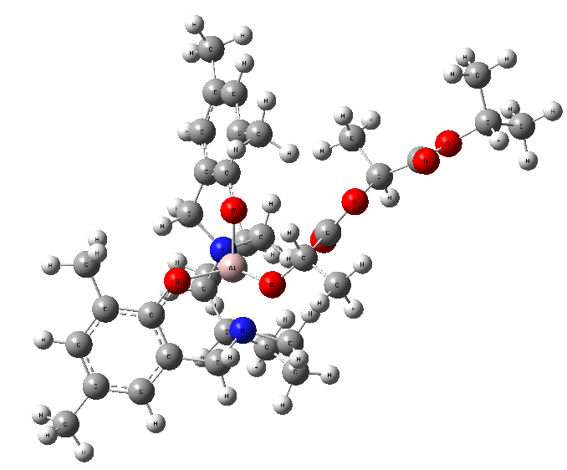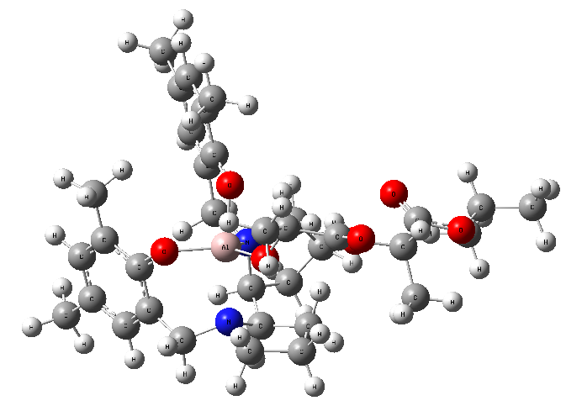

Fig S40. Example of the influence of the interaction between the growing PLA chain and the ligand on the overall stability of the catalytic species. (reference: fac-mer-Λ-SR Al(3)(O^{i}Pr) + L-Lactide molecule)

The complexity of the system is considerably increased by the possible flipping of a phenoxide arm. However, overall, no significant preference of the fac-mer Λ-SR Al(3) stereoisomer for either a growing PLLA or PDLA chain was observed. Nevertheless, in the case of a flipped phenoxide arm, which enable more space for subsequent coordination of lactide, a difference of 3.1 kcal/mol in favour of a growing PLLA chain versus of a PDLA one.
Fig. S41. Computed ΔG values for the different possible stereoisomers of fac-mer Λ-SR Al(3)(OLAOiPr) complexes (reference: Al(3)(O^{i}Pr) + Lactide molecule)

Such a difference might be a coincidence and will require a more in depth investigation but one can then imagine that the fac-mer-Λ-SR Al(3) enantiomer accommodates better a growing PLLA chain and that the fac-mer-Λ-SR Al(3) enantiomer accommodates better a growing PDLA chain.

Ref:

Gaussian 09, Revision C.01, M. J. Frisch, G. W. Frucks, H. B. Schlegel, G. E. Scuseria, M. A. Robb, J. R. Cheeseman, G. Scalmani, V. Barone, B. Mennucci, G. A. Petersson, H. Nakatsuji, M. Caricato, X. Li, H. P. Hratchian, A. F. Izmaylov, J. Bloino, G. Zheng, J. L. Sonnenberg, M. Hada, M. Ehara, K. Toyota, R. Fukuda, J. Hasegawa, M. Ishida, T. Nakajima, Y. Honda, O. Kitao, H. Nakai, T. Vreven, J. Montgomery, J. A.;, J. E. Peralta, F. Ogliaro, M. Bearpark, J. J. Heyd, E. Brothers, K. N. Kudin, V. N. Staroverov, R. Kobayashi, J. Normand, K. Raghavachari, A. Rendell, J. C. Burant, S. S. Iyengar, J. Tomasi, M. Cossi, N. Rega, J. M. Millam, M. Klene, J. E. Knox, J. B. Cross, V. Bakken, C. Adamo, J. Jaramillo, R. Gomperts, R. E. Stratmann, O. Yazyev, A. J. Austin, R. Cammi, C. Pomelli, J. W. Ochterski, R. L. Martin, K. Morokuma, V. G. Zakrzewski, G. A. Voth, P. Salvador, J. J. Dannenberg, S. Dapprich, A. D. Daniels, Ö. Farkas, J. B. Foresman, J. V. Ortiz, J. Cioslowski and D. J. Fox, Gaussian, Inc., Wallingford CT, 2009.

Computed Free Gibbs Energies and full coordinates of DFT optimised structures

Isomer of Al(3)(O^{i}Pr) | G (Hartree) | ΔG  (kcal mol⁻¹)
fac-mer-Λ-SR | -1706.718170 | 0.0 (reference)
fac-mer-Λ-SR’ | -1706.714379 | +2.4
fac-mer-Λ-RS | -1706.660286 | +36.3
fac-fac-Λ-meso | -1706.698367 | +12.4

Table S1: Computed Free Gibbs Energies of optimised Al(3)(O^{i}Pr) isomers at the rωb97XD/6-311+g(d)(N,O,Al)/6-31g(d)(C,H)/cpcm=toluene/T=353.15K level of theory

Isomer of Al(3)(S-Lactate) | G (Hartree) | ΔG  (kcal mol⁻¹)
A | -1895.265137 | 0.0 (reference)
B | -1895.25951 | +3.5
C | -1895.25668 | +5.3
D | -1895.260913 | +2.7
A’ | -1895.268467 | -2.1
B’ | -1895.264387 | +0.5
C’ | -1895.261445 | +2.3
D’ | -1895.262415 | +1.7

Table S2: Computed Free Gibbs Energies of optimised of Al(3)(S-Lactate) isomers at the rωb97XD/6-311+g(d)(N,O,Al)/6-31g(d)(C,H) /cpcm=toluene/T=353.15K level of theory

Isomer of fac-mer Λ-SR Al(3)(OLAO^{i}Pr) | G (Hartree) | ΔG  (kcal mol⁻¹)
fac-mer-Λ-SR Al(3)( O^{i}Pr) | -1706.71817 | -
L-Lactide | -534.204354 | -
D-Lactide | -534.204356 | -
Reference Al(3)( O^{i}Pr + L-Lactide | -2240.922524 | 0.0 (reference)
Reference Al(3)( O^{i}Pr + D-Lactide | -2240.922526 | 0.0
I (fac-mer-Λ-SR Al(3)(O(L-LA)O^{i}Pr)) | -2240.928678 | -3.9
II ((fac-mer-Λ-SR Al(3)(O(L-LA)O^{i}Pr)’) | -2240.929732 | -4.5
III (fac-mer-Λ-SR Al(3)(O(D-LA)O^{i}Pr)) | -2240.929445 | -4.3
IV ((fac-mer-Λ-SR Al(3)(O(D-LA)O^{i}Pr)’) | -2240.924705 | -1.4

Table S3: Computed Free Gibbs Energies of optimised fac-mer Λ-SR Al(3)(OLAO^{i}Pr) isomers at the rωb97XD/6-311+g(d)(N,O,Al)/6-31g(d)(C,H) /cpcm=toluene/T=353.15K level of theory

Full coordinates for all calculated complexes, together with their 3 lowest calculated vibrations and their computed Free Gibbs Energy are reported below. They are also available via the corresponding Gaussian 09 output files, stored in the digital repository (DOI: http://dx.doi.org/10.6084/m9.figshare.1420458)

fac-mer-Λ-SR Al(3)(O^{i}Pr)

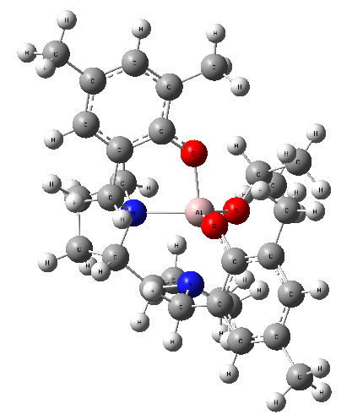
0 1
Al 0.06069200 0.24480900 0.43902400
O 0.52534200 1.05312000 1.91440300
N -1.11993400 1.33415100 -0.85356000
C -0.03629900 0.92054200 3.19398200
H -1.13503900 0.88199600 3.11528200
O -1.45315600 -0.59275200 0.98976600
N 1.64011300 1.41292100 -0.62698400
C 0.34459300 2.14450900 4.02262400
H 1.43354300 2.19520300 4.14572500
H -0.11472400 2.10821800 5.01720600
H 0.01355100 3.06084700 3.52067700
O 0.82032200 -1.23944000 -0.19455100
C 0.43006500 -0.37662000 3.85330900
H 0.12629300 -1.23532600 3.24511300
H -0.00282100 -0.49247800 4.85425800
H 1.52365500 -0.38064100 3.94319500
C -2.49925200 -1.02302500 0.30459100
C -3.41915900 -1.89405400 0.92478200
C -4.54492200 -2.30745000 0.21954300
H -5.24466800 -2.98304200 0.70956000
C -4.81338600 -1.88512600 -1.08582600
C -3.90036400 -1.01742800 -1.68054200
H -4.08348700 -0.66132000 -2.69407200
C -2.75041200 -0.59334500 -1.01465600
C -3.14809000 -2.34508500 2.33381500
H -3.12364500 -1.49366900 3.02444700
H -2.16926600 -2.83230900 2.40864200
H -3.91373800 -3.04737000 2.67787500
C -6.04541600 -2.34411200 -1.82782900
H -5.78458000 -2.93180500 -2.71633700
H -6.65035400 -1.49509100 -2.16769500
H -6.67941300 -2.97013200 -1.19206600
C -1.76908800 0.29819700 -1.73040000
H -2.26916900 0.79720100 -2.56980800
H -0.94776500 -0.29476300 -2.15251200
C -2.14757500 2.14862100 -0.13497100
H -1.67274500 2.60466800 0.73665300
H -2.94883600 1.50191500 0.22016100
C -2.59611700 3.19722700 -1.14649000
H -3.03314000 4.07139700 -0.65833400
H -3.35725900 2.77804300 -1.81253200
C -1.31003500 3.53227900 -1.92122700
H -0.84647600 4.43895500 -1.52489700
H -1.50378800 3.70603300 -2.98202400
C -0.37789800 2.31358600 -1.71437800
H -0.19420900 1.81788000 -2.67100400
C 0.98427200 2.65333800 -1.09836400
H 1.59794300 3.10817600 -1.89372600
C 1.01599800 3.57503200 0.12632100
H 0.96297500 4.62680800 -0.16474600
H 0.18218200 3.36262100 0.79643300
C 2.33639700 3.22135700 0.82934900
H 2.19121400 3.16008500 1.90792100
H 3.10581600 3.97161800 0.62518200
C 2.75558700 1.86069800 0.25233100
H 3.66381200 1.95749100 -0.35749200
H 2.93603500 1.10819100 1.01934300
C 2.16387400 0.60146300 -1.75327200
H 1.31997200 0.32361900 -2.39482100
H 2.84828100 1.21840800 -2.35440700
C 2.85189800 -0.63907500 -1.26510700
C 2.09720600 -1.51432100 -0.47178100
C 2.68367000 -2.69113700 0.02293100
C 4.01275600 -2.95783700 -0.30219700
H 4.46686900 -3.87113100 0.07936500
C 4.78237900 -2.09918100 -1.09214700
C 4.17868700 -0.93393900 -1.56553900
H 4.75121900 -0.24183400 -2.18182800
C 6.22773600 -2.40553300 -1.40304000
H 6.45771200 -3.45962300 -1.21884300
H 6.90601300 -1.80661300 -0.78268400
H 6.46624400 -2.18766600 -2.44993400
C 1.86391900 -3.61403400 0.88248600
H 0.97388600 -3.96425300 0.34771500
H 1.50406000 -3.09743200 1.77984700
H 2.44737300 -4.48559200 1.19493200

Sum of electronic and thermal Free Energies= -1706.718170

Frequencies -- 19.9222 26.9383 43.5849
fac-mer-Λ-SR Al(3)(O^{i}Pr)’

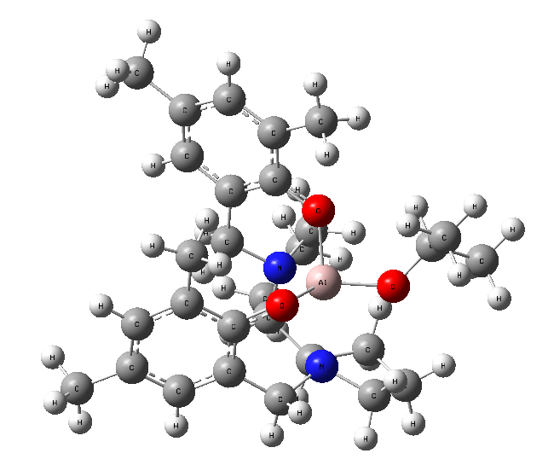

0 1
Al 0.90185400 -0.48974900 -0.62169600
O 2.34207600 -1.44930200 -0.85501300
N 0.41051800 0.07464400 1.31158700
C 2.47738500 -2.84542900 -0.91464700
H 1.77742900 -3.31768900 -0.20644100
O -0.27595100 -1.85371500 -0.41985400
N 2.27596300 1.27152700 -0.41325100
C 3.90099600 -3.21262500 -0.50357600
H 4.62257300 -2.77432700 -1.20410300
H 4.04407300 -4.29937300 -0.49370900
H 4.11754200 -2.82565000 0.49888000
O -0.00706500 0.43432000 -1.86924800
C 2.14004600 -3.35861600 -2.31290300
H 1.10430600 -3.10580700 -2.56260500
H 2.25537200 -4.44739800 -2.37565400
H 2.80409100 -2.89567900 -3.05356700
C -1.51294000 -1.80699200 0.05198300
C -2.43145800 -2.79548000 -0.37506800
C -3.73178700 -2.77433600 0.10736500
H -4.43084900 -3.53525900 -0.23735800
C -4.17475800 -1.80908700 1.02159200
C -3.25780800 -0.85444600 1.44088000
H -3.57119100 -0.09209100 2.15364600
C -1.94118700 -0.82948500 0.96754100
C -1.96036300 -3.82501900 -1.36487100
H -1.10390100 -4.38572800 -0.97360900
H -1.61953500 -3.34784200 -2.29116400
H -2.75844500 -4.53247800 -1.61053800
C -5.59632400 -1.82016300 1.52786400
H -6.31446900 -1.67754800 0.71146300
H -5.76354600 -1.02381100 2.26019600
H -5.84201900 -2.77358000 2.01042100
C -1.06332900 0.31632500 1.41594800
H -1.29743700 0.56116400 2.46112500
H -1.28168300 1.20853500 0.82218900
C 0.79575400 -1.03344500 2.25384000
H 1.54500400 -1.66573800 1.77383100
H -0.08334700 -1.65667100 2.42236000
C 1.32737000 -0.37768000 3.54381100
H 2.35140000 -0.70520400 3.74026400
H 0.72542400 -0.66275600 4.40987700
C 1.26750700 1.14186800 3.29975800
H 2.14872800 1.66517500 3.68082200
H 0.39579300 1.57922600 3.79468200
C 1.13126100 1.29703400 1.78039400
H 0.50977300 2.15736800 1.52289900
C 2.46430000 1.45611900 1.04545900
H 2.82265200 2.48040700 1.23971900
C 3.58586400 0.47244600 1.39749400
H 4.07733600 0.74687900 2.33449200
H 3.19643900 -0.54013700 1.49849000
C 4.52126400 0.52317300 0.18431500
H 4.92714000 -0.46431200 -0.03977600
H 5.35857500 1.20439300 0.36349200
C 3.64853100 1.04596500 -0.96462600
H 4.03764800 2.00459800 -1.33060000
H 3.57896100 0.34820700 -1.79835000
C 1.70598500 2.45791700 -1.10808800
H 2.22228900 3.36048200 -0.74919700
H 1.96934300 2.32727100 -2.16352800
C 0.21648000 2.63758900 -1.04045600
C -0.57953500 1.60117400 -1.54738100
C -1.96992500 1.78500900 -1.68128700
C -2.51975700 2.98603500 -1.24064400
H -3.59580300 3.12708100 -1.33225600
C -1.75000200 4.01371300 -0.68110600
C -0.37266100 3.82364200 -0.60206600
H 0.26146500 4.61548300 -0.20532800
C -2.39942500 5.29157600 -0.20900400
H -3.14882000 5.09715400 0.56709000
H -2.91175300 5.80507800 -1.03115900
H -1.65986300 5.98368900 0.20571300
C -2.81740900 0.68682500 -2.26306100
H -2.84046400 -0.18630700 -1.60163600
H -2.41131100 0.34690500 -3.22175800
H -3.84530500 1.02775700 -2.41948600

Sum of electronic and thermal Free Energies= -1706.714379

Frequencies -- 15.9030 31.3962 34.0891
fac-mer-Λ-RS Al(3)(O^{i}Pr)
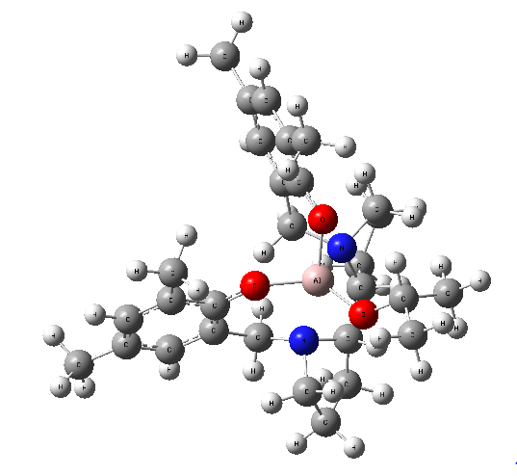
0 1
O 0.36012000 2.22365700 1.74378500
N -0.77057500 1.31329100 -1.13553800
N 1.86774000 1.02332000 -0.30582400
O -1.75200700 0.40908000 1.20721700
O 0.56250100 -0.82370800 1.18953100
C -2.44051600 -0.46986900 0.48452000
C -3.56582200 -1.09642800 1.06182600
C -4.31197700 -1.99141100 0.30451300
H -5.17808400 -2.46583200 0.76411400
C -3.99508800 -2.30045300 -1.02284300
C -2.88906200 -1.66914300 -1.58281600
H -2.62533200 -1.87419700 -2.61981200
C -2.10623400 -0.77133700 -0.85368400
C -3.91630500 -0.77533600 2.48881200
H -4.08443000 0.29927400 2.62272400
H -3.09717000 -1.04868500 3.16402300
C 0.23610900 2.19738800 -1.82054700
C 1.58842100 2.22977800 -1.10331300
H -4.81778900 -1.31041200 2.80310000
C -4.82004500 -3.28911100 -1.80987200
H -4.58476400 -4.32331100 -1.52898500
H -4.63785400 -3.19162000 -2.88507100
H -5.89182400 -3.14238600 -1.63645500
C -0.89589400 -0.14472400 -1.51957200
H -0.96818900 -0.26629900 -2.60475100
H -0.00929700 -0.68979100 -1.20479400
C -1.99647100 1.95782800 -1.69382900
H -2.15432300 2.91098700 -1.18532900
H -2.87229300 1.33428100 -1.52714000
C -1.65438900 2.14854300 -3.20824900
H -2.02530800 3.11407300 -3.56105100
H -2.13242600 1.37634100 -3.81639600
C -0.09824400 2.07366200 -3.30238300
H 0.32555900 2.89978700 -3.87793500
H 0.25218000 1.13969800 -3.75200900
H -0.14506800 3.19586800 -1.57943700
H 1.43266000 2.98109300 -0.32122900
C 2.91255200 2.60887700 -1.76032300
H 3.11723200 2.01404200 -2.65615600
H 2.93020800 3.66215800 -2.05053800
C 3.90249600 2.29255100 -0.60225400
H 4.76922600 1.73097500 -0.96011800
H 4.27930600 3.20999400 -0.14372700
C 3.07489300 1.47660300 0.43862300
H 2.73664200 2.09867600 1.26890400
H 3.60282300 0.60952400 0.83962500
C 2.27774900 -0.14104800 -1.13219300
H 1.61377100 -0.20871600 -1.99876000
H 3.27385700 0.03740700 -1.55273800
C 2.32362400 -1.42831500 -0.34304500
C 3.25393200 -2.40022400 -0.73237200
H 3.91551600 -2.18041600 -1.56989900
C 3.36098400 -3.62447600 -0.08804500
C 2.50408000 -3.86029700 0.99497400
H 2.56755100 -4.81149900 1.52164200
C 1.57666300 -2.92277100 1.42394800
C 1.47682700 -1.68193100 0.75048100
C 4.35517000 -4.66983600 -0.52962000
H 3.85203000 -5.54504500 -0.95838900
H 4.96065400 -5.02601100 0.31172700
H 5.03765200 -4.27520000 -1.28910300
C 0.65302300 -3.18634600 2.58171600
H 0.79142300 -2.44107600 3.37332300
H 0.82545900 -4.18047600 3.00525100
H -0.39527600 -3.11458500 2.26962000
C -0.49509400 3.09123600 2.44333200
H -1.42610500 2.56611300 2.70884100
C 0.19163600 3.53810800 3.72985300
H 0.44410000 2.66804200 4.34463300
H 1.11952200 4.07410700 3.49512400
H -0.45539300 4.20174900 4.31494400
C -0.85816400 4.28216000 1.55652200
H -1.36879200 3.93647700 0.65031900
H -1.52239900 4.98196700 2.07646000
H 0.05081800 4.81936400 1.25786500
Al -0.03232700 0.81253800 0.80983600

Sum of electronic and thermal Free Energies= -1706.660286

Frequencies -- 16.0383 22.0527 29.2962

fac-fac-Λ-meso Al(3)(O^{i}Pr)

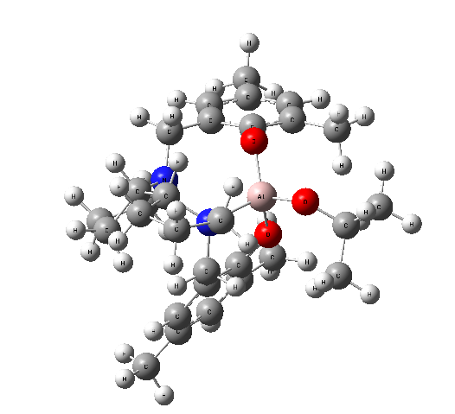
0 1
N 0.22793300 -1.42440000 -1.46640900
N -1.79039200 0.81741300 -0.98037200
O -0.53699800 3.20886700 0.14399700
O 0.01139400 0.65010000 1.33636900
O 1.29170600 1.42262800 -1.18949600
C 5.93755600 -1.62988300 -0.06352900
C -0.53272200 5.41279900 1.05645800
C 4.68506300 -0.83331600 -0.33702200
C 3.67824500 -1.32992200 -1.16573200
C -1.81848300 3.53974400 2.16369600
C -0.78346300 -3.59908700 -1.35769400
C 0.31573100 -2.71554100 -0.75804600
C -0.57589700 3.91838400 1.35656500
C 4.50812600 0.43738500 0.21447800
C 2.53458800 -0.58673600 -1.44587200
C 1.40499200 -1.11808800 -2.28235500
C -1.85696900 -2.58584700 -1.76076600
C -1.01864100 -1.39139000 -2.23411500
C -1.65584500 0.00071600 -2.25351900
C 3.37971100 1.21451000 -0.04701600
C 2.39053000 0.69399900 -0.89617900
C 1.29415900 -1.02705300 3.12981000
C 3.18662800 2.56801900 0.58351600
C -0.07165100 -1.34587900 2.58678700
C -0.65173000 -0.46289400 1.65490400
C -3.04757400 0.04511200 -2.90621200
C -2.58950200 0.19997400 0.14259800
C -0.76750700 -2.49318500 2.94681300
C -1.89502700 -0.76170200 1.08091900
C -2.58501300 1.97970700 -1.52193600
C -3.66158200 1.37636400 -2.43120800
C -2.56512100 -1.92130500 1.48352400
C -2.02311400 -2.80336100 2.41108700
C -2.75081700 -4.05883200 2.82441500
H 5.76145900 -2.70354000 -0.18562800
H 6.30482100 -1.46072100 0.95413700
H 6.74476600 -1.35008900 -0.75208100
H -0.53183700 5.99998400 1.98192400
H 3.78175000 -2.32222500 -1.60320400
H -1.40729000 5.70185800 0.46105900
H -1.85913500 4.08963700 3.11097500
H -2.72526500 3.77319200 1.59093100
H 1.31388800 -3.14922700 -0.88273500
H -1.15003100 -4.35004000 -0.65224500
H -0.41000900 -4.12019100 -2.24777000
H 0.36873700 5.65840100 0.48596100
H 1.73150400 -2.00520000 -2.85445200
H 5.27510400 0.83886600 0.87520900
H 0.15393100 -2.56782500 0.31225700
H -1.81148300 2.46792300 2.39149900
H 0.30978600 3.66701600 1.96511200
H 2.02931800 -0.96292400 2.31816700
H 1.11626700 -0.35093800 -3.00849100
H -0.79922400 -1.57835300 -3.30216300
H -2.51209200 -2.95348300 -2.55561400
H -2.47872300 -2.33442000 -0.90285200
H 1.30301500 -0.05589100 3.63680400
H 4.10228800 2.90780300 1.07652200
H 1.62419800 -1.79215700 3.83875200
H 2.39337900 2.53941700 1.34304100
H -0.98343600 0.62531900 -2.85406500
H 2.88918800 3.31548500 -0.15920900
H -3.47874400 -0.28027200 -0.27786400
H -2.95331700 -0.01712300 -3.99321600
H -3.65532900 -0.80669800 -2.58682100
H -0.31582000 -3.17521900 3.66557500
H -1.89964500 2.60680700 -2.09818600
H -2.94328400 1.05577300 0.72896900
H -3.88752900 2.05581100 -3.25608500
H -2.96117300 2.58663900 -0.70012200
H -4.59338100 1.21036200 -1.88323600
H -2.17788200 -4.95630500 2.56227600
H -3.54369100 -2.13803000 1.05694500
H -2.91724800 -4.08713300 3.90748100
H -3.72670800 -4.13279500 2.33457900
Al -0.11236600 1.55465300 -0.16060100

Sum of electronic and thermal Free Energies= -1706.698367

Frequencies -- 19.5018 37.3047 38.4236

A
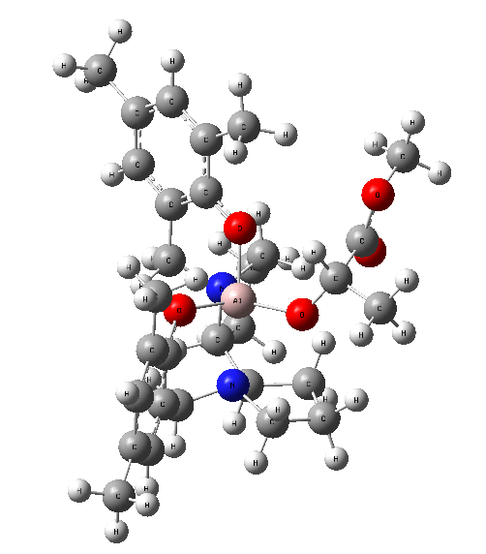
0 1
Al -0.23418100 -0.21538600 0.05574700
N 0.79610100 -0.42504900 -1.71973500
O 1.30567400 0.41519800 0.77784200
N -1.86511400 -1.02485100 -1.19747900
O -1.13953900 1.31854200 0.18908600
C 2.15072000 1.29951100 0.26542500
C 3.09569700 1.91299300 1.11650300
C 4.01060000 2.81034000 0.58023200
H 4.73269000 3.27887600 1.24778500
C 4.04284100 3.12681700 -0.78319500
C 3.11655200 2.50110200 -1.61029900
H 3.12662700 2.71181500 -2.67925800
C 2.16878900 1.60478400 -1.10934900
C 3.07626800 1.57127300 2.58116100
H 3.21662200 0.49601800 2.73920100
H 2.10871400 1.82416300 3.03049400
H 3.86110400 2.10961400 3.12181400
C 5.04092500 4.11974200 -1.32693500
H 4.72145300 5.15292300 -1.14149700
H 5.16835700 4.00473300 -2.40828900
H 6.02321100 3.99570800 -0.85792300
C 1.16678200 0.99324100 -2.05777400
H 1.56024000 1.02811900 -3.08094400
H 0.23063700 1.56489800 -2.05125500
C 2.02279600 -1.28290200 -1.64828400
H 1.79749500 -2.16261800 -1.04549600
H 2.82365000 -0.73918800 -1.14929300
C 2.32927300 -1.64770700 -3.09572500
H 2.94907000 -2.54498100 -3.16198100
H 2.87140400 -0.83512000 -3.59089500
C 0.93815600 -1.84341600 -3.71818400
H 0.65696700 -2.89956200 -3.70124900
H 0.89856000 -1.51408400 -4.75898100
C -0.02163000 -1.01494700 -2.83089300
H -0.43198200 -0.17980100 -3.40449600
C -1.19416300 -1.81507100 -2.25580700
H -1.90620700 -1.99991500 -3.07710600
C -0.88650200 -3.14511700 -1.55806300
H -0.75273300 -3.95508200 -2.27874500
H 0.02063600 -3.07225900 -0.95427000
C -2.09416900 -3.36792900 -0.63252900
H -1.76993600 -3.74294400 0.33867800
H -2.79677000 -4.08730500 -1.06327500
C -2.76052000 -1.98999700 -0.49862600
H -3.73771900 -1.97767400 -0.99951100
H -2.89551200 -1.67668100 0.53533900
C -2.65936300 0.09854900 -1.75517500
H -1.98498500 0.74194000 -2.33025200
H -3.40888000 -0.30365000 -2.45228800
C -3.31050300 0.90302200 -0.66960600
C -2.46239200 1.48607500 0.27917200
C -3.00587900 2.25251000 1.32647800
C -4.38740800 2.41353900 1.38176600
H -4.80943100 3.00689200 2.19187900
C -5.25282000 1.83920500 0.44268700
C -4.69031600 1.07961100 -0.58019800
H -5.33425100 0.61463900 -1.32536100
C -6.74543200 2.03671000 0.54989200
H -7.00775100 3.10104900 0.55999900
H -7.14269200 1.59680700 1.47239600
H -7.26815900 1.57183700 -0.29196900
C -2.08118400 2.85869200 2.34663000
H -1.36736900 3.54324900 1.87481800
H -1.48661000 2.08407800 2.84501700
H -2.64059900 3.41072200 3.10803300
O -0.51651400 -1.52919500 1.18899300
C 0.18252900 -1.75810100 2.35970000
H 0.36151400 -0.82825100 2.91789400
C 1.56094600 -2.35204500 2.06904300
C -0.59804800 -2.72927800 3.25125800
O 1.85693000 -2.98759800 1.08448100
O 2.41577300 -2.11988700 3.06953100
H -0.08083100 -2.90890300 4.19923700
H -1.58087300 -2.29764000 3.46203800
H -0.74150200 -3.68428800 2.73442600
C 3.73994800 -2.62971500 2.91188800
H 4.27203600 -2.34852600 3.81966900
H 3.72320500 -3.71654500 2.79859800
H 4.21449200 -2.17918400 2.03618300

Sum of electronic and thermal Free Energies= -1895.265001

Frequencies -- 22.5975 28.3888 31.3194
B
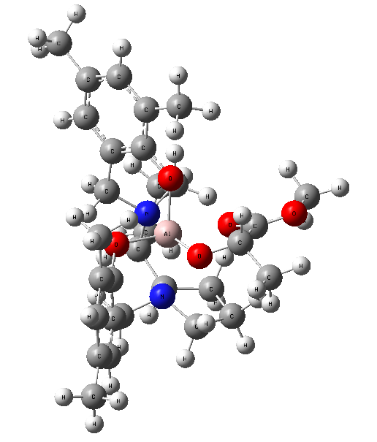
0 1
Al 0.14548100 0.15249500 0.21112600
N -1.14720700 0.81671600 -1.37183300
O -1.37145000 -0.38594300 1.06715700
N 1.64705200 1.07957900 -1.21019300
O 0.59658900 -1.46496800 -0.49198100
C -2.42617500 -1.02149600 0.58245900
C -3.31552600 -1.64319600 1.49016400
C -4.44869000 -2.28460700 1.00796600
H -5.12128700 -2.76150300 1.72022000
C -4.75745800 -2.33651500 -0.35668400
C -3.88020800 -1.71161800 -1.23556100
H -4.09591300 -1.72552200 -2.30370000
C -2.72049000 -1.06667200 -0.79571200
C -2.99223900 -1.59492600 2.95869800
H -2.92147400 -0.56063900 3.31618100
H -2.02006700 -2.05976800 3.16067200
H -3.75444000 -2.11436600 3.54809100
C -5.99387000 -3.05162500 -0.84425700
H -5.91609400 -4.13515300 -0.69164100
H -6.15641400 -2.88017400 -1.91329000
H -6.89060500 -2.71429900 -0.31137000
C -1.79327500 -0.46260100 -1.82094300
H -2.34597100 -0.28330400 -2.75207400
H -0.97510400 -1.15305300 -2.04484800
C -2.20885300 1.81094800 -1.03052400
H -1.77169900 2.58812200 -0.40723000
H -2.99524900 1.32289600 -0.45436900
C -2.67295400 2.37717900 -2.36919700
H -3.14836100 3.35423700 -2.25088000
H -3.40389900 1.71259200 -2.84040500
C -1.37506500 2.44788600 -3.19145300
H -0.94852900 3.45395300 -3.14971400
H -1.53978200 2.21204700 -4.24533300
C -0.41656600 1.42621900 -2.52759700
H -0.20139400 0.61449700 -3.22685900
C 0.92946200 2.02705500 -2.09502400
H 1.52213600 2.16434700 -3.01432000
C 0.92339700 3.36300800 -1.33185200
H 0.99651500 4.19906000 -2.03163700
H 0.00399600 3.49338900 -0.76140000
C 2.13888300 3.29258200 -0.38392200
H 1.83829000 3.48351200 0.64860000
H 2.89594200 4.03799900 -0.63932200
C 2.70884900 1.87740100 -0.55073700
H 3.59029500 1.90153900 -1.20658500
H 2.98658500 1.39180300 0.38467600
C 2.26386500 -0.00613500 -2.02521700
H 1.48331500 -0.40671200 -2.67860100
H 3.04027700 0.43792300 -2.66511700
C 2.81387100 -1.12949000 -1.20348500
C 1.87189900 -1.85305800 -0.46286600
C 2.28337000 -2.96313900 0.29621600
C 3.63316600 -3.30373800 0.28697200
H 3.95671700 -4.16160100 0.87587200
C 4.59222900 -2.58473300 -0.43889500
C 4.15909200 -1.49154100 -1.18628300
H 4.87461000 -0.91489400 -1.77152400
C 6.04666600 -2.98826400 -0.40159500
H 6.17960100 -4.04109700 -0.67673700
H 6.47304900 -2.86126300 0.60105800
H 6.64405900 -2.38462800 -1.09251200
C 1.26156900 -3.71706800 1.10130200
H 0.46796400 -4.11524100 0.45871100
H 0.77464200 -3.05075000 1.82250000
H 1.71934100 -4.54978100 1.64457400
O 1.31296800 0.14888000 1.60348700
C 1.04880600 0.91243300 2.70950300
H 0.47437100 0.35331800 3.47227300
C 0.13647900 2.04202900 2.26092700
C 2.32025200 1.46025200 3.36527900
O -0.26094000 2.06663700 1.10197500
O -0.19438000 2.95422700 3.13958900
H 2.09321700 2.02820500 4.27258200
H 2.96239800 0.61529900 3.62690700
H 2.86783200 2.10422700 2.66852600
C -1.09238300 3.98681400 2.70097100
H -1.24867500 4.62163400 3.57058600
H -0.63831300 4.55287600 1.88466500
H -2.03297600 3.54281800 2.36860300

Sum of electronic and thermal Free Energies= -1895.259510

Frequencies -- 15.0483 24.0519 35.9910
C
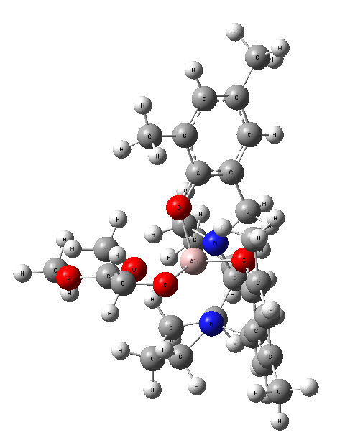
0 1
O -1.32763600 -0.12211900 1.58471900
N 1.09402200 0.96095700 -1.33278700
N -1.70462600 1.27526400 -1.01434300
O 1.36051700 -0.51134200 0.95662200
O -0.65452500 -1.35887800 -0.75457100
C 2.43554900 -1.04882900 0.40204200
C 3.34885600 -1.74058400 1.23141000
C 4.49975700 -2.28739400 0.67809200
H 5.18992100 -2.82014700 1.33132700
C 4.80345500 -2.17468700 -0.68315500
C 3.90277500 -1.48062000 -1.48360400
H 4.11542200 -1.36151000 -2.54574700
C 2.72480200 -0.92921700 -0.97208000
C 3.03838700 -1.86738100 2.69765400
H 2.94488300 -0.88201000 3.17031300
H 3.82011400 -2.42794800 3.21999200
C 0.29975300 1.62609400 -2.40511500
C -0.97866800 2.26190700 -1.84999400
H 2.08120800 -2.37890700 2.85313300
C 6.05322600 -2.79647100 -1.25721400
H 5.92307300 -3.87218100 -1.43076000
H 6.90611800 -2.67900400 -0.57953500
H 6.32005700 -2.34007200 -2.21611800
C 1.77716500 -0.23921100 -1.92046600
H 0.98157300 -0.92469400 -2.22566300
H 2.32997600 0.07035200 -2.81817600
C 2.12964700 1.95897000 -0.89884900
H 3.06855300 1.42781200 -0.73720900
H 1.83413700 2.38664900 0.05565800
C 2.24324800 3.03512300 -1.99811000
H 3.25989500 3.09863500 -2.39373500
H 1.99353000 4.01980300 -1.59319400
C 1.24588000 2.61902300 -3.09092900
H 1.76355000 2.12351200 -3.91751000
H 0.70304700 3.46805600 -3.51624500
H -0.00214300 0.84775200 -3.10986000
H -1.60693600 2.52097600 -2.71858400
C -0.84611000 3.50960000 -0.97077900
H 0.04833200 3.46401900 -0.35186000
H -0.78435400 4.41235400 -1.58402000
C -2.09965200 3.48517400 -0.07809700
H -1.85520200 3.74799400 0.95450300
H -2.84429700 4.20714200 -0.42363800
C -2.66209300 2.05470900 -0.18526600
H -3.63793900 2.06847000 -0.68591100
H -2.78956600 1.54993900 0.77248100
C -2.43817200 0.32154700 -1.89733100
H -3.26763600 0.85962200 -2.37830400
H -1.74396700 0.01493100 -2.68451300
C -2.92284700 -0.91499600 -1.20632300
C -4.26614500 -1.27455400 -1.12369600
H -5.02356000 -0.60846800 -1.53577200
C -4.64735100 -2.47601300 -0.52974300
C -3.63826400 -3.30558000 -0.02393700
H -3.92029400 -4.24707600 0.44651900
C -2.28792500 -2.97134400 -0.08266000
C -1.92922300 -1.75204800 -0.68385300
C -6.09741600 -2.88562700 -0.43389300
H -6.29028700 -3.81450400 -0.98417200
H -6.75712300 -2.11372000 -0.84313300
H -6.39512900 -3.06044100 0.60683000
C -1.21331600 -3.84380600 0.50480400
H -0.66907000 -3.30466900 1.28907900
H -0.47302400 -4.12763100 -0.25167500
H -1.63581600 -4.75645000 0.93699300
C -1.14757800 0.55371400 2.76180000
C -0.47502700 -0.29404300 3.85141400
H -1.11081100 -1.16167000 4.04716400
H 0.49470500 -0.64711000 3.48961300
H -0.34471200 0.26760300 4.78231100
Al -0.17269800 0.11630400 0.19708600
H -2.10511300 0.93924900 3.15732500
C -0.29801100 1.77190200 2.44517100
O 0.16789700 1.90105000 1.31796900
O -0.10121100 2.65183100 3.39346400
C 0.72461900 3.78473000 3.07761700
H 0.28514200 4.34890000 2.25205900
H 0.74864300 4.38478500 3.98487200
H 1.72816400 3.44927000 2.80789100

Sum of electronic and thermal Free Energies= -1895.256680

Frequencies -- 19.7462 30.9085 38.8121

D
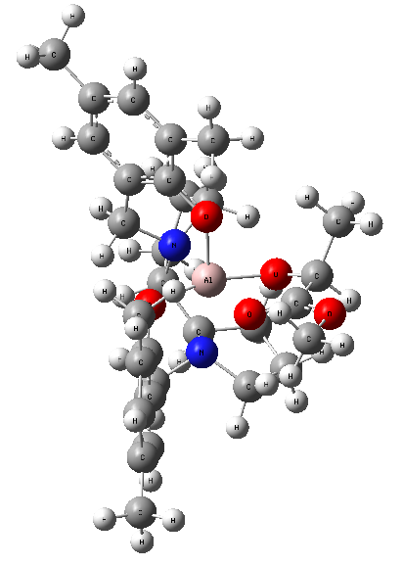
0 1
Al 0.00502500 0.30147100 0.33502000
N -1.35036000 1.58468400 -0.56658200
O -1.37654000 -0.79252100 0.82260700
N 1.46972200 1.84519400 -0.51932600
O 0.46287800 -0.69783700 -1.12548900
C -2.46778000 -1.10158400 0.14417700
C -3.26520600 -2.17980100 0.59773200
C -4.44164500 -2.49330600 -0.06963200
H -5.04096900 -3.32759200 0.29379800
C -4.88618500 -1.77297700 -1.18472400
C -4.09726200 -0.71300600 -1.61557400
H -4.41782000 -0.12787000 -2.47730400
C -2.89687400 -0.37218600 -0.98493600
C -2.80652500 -2.95717500 1.80158500
H -2.74053400 -2.31401200 2.68735000
H -1.80484900 -3.37437400 1.64397000
H -3.49409400 -3.77906500 2.02503800
C -6.16960700 -2.14426000 -1.88677600
H -6.08502300 -3.11449700 -2.39174300
H -6.43805100 -1.40031900 -2.64367900
H -7.00519900 -2.21976000 -1.18101700
C -2.07177100 0.74357100 -1.57696500
H -2.71757800 1.38777900 -2.18822900
H -1.29560600 0.33229900 -2.22971600
C -2.32308800 2.19427500 0.38738300
H -1.77899100 2.47089300 1.28983000
H -3.07202000 1.45162800 0.66464100
C -2.89644800 3.40747100 -0.34174600
H -3.26034300 4.16183400 0.36030800
H -3.74183500 3.11289300 -0.97178400
C -1.72428200 3.91880400 -1.20141100
H -1.25954500 4.79751000 -0.74741400
H -2.05441500 4.21209800 -2.20088000
C -0.71612300 2.74393900 -1.27081800
H -0.57563100 2.43552700 -2.30979000
C 0.67314100 3.08354000 -0.70440900
H 1.17190100 3.70880400 -1.46406300
C 0.74692900 3.82296700 0.63712100
H 0.68554700 4.90371300 0.48513300
H -0.06319300 3.52053200 1.29774200
C 2.09359200 3.39772200 1.24616600
H 1.97248000 3.14228200 2.30001100
H 2.83209600 4.20216900 1.18194000
C 2.56462600 2.18627300 0.42452600
H 3.46602500 2.43790700 -0.14987800
H 2.80458200 1.31544900 1.03720600
C 2.02430900 1.39532900 -1.82079500
H 1.20032400 1.38141800 -2.54110800
H 2.76143900 2.13305500 -2.17180500
C 2.61715600 0.02223100 -1.75088100
C 1.72699600 -1.00407100 -1.41080400
C 2.18540400 -2.33457000 -1.36129200
C 3.52324600 -2.58487400 -1.65313700
H 3.88088400 -3.61353400 -1.61230300
C 4.42898000 -1.56965900 -1.98903400
C 3.95206600 -0.26132800 -2.03314800
H 4.62586100 0.55272000 -2.29825000
C 5.87160500 -1.89553800 -2.29257200
H 5.95574800 -2.61460800 -3.11599300
H 6.37416700 -2.33973200 -1.42480100
H 6.43002700 -0.99756300 -2.57591000
C 1.22587500 -3.42463000 -0.97227700
H 0.39198100 -3.48988400 -1.68072100
H 0.78499700 -3.21473400 0.00884800
H 1.72462400 -4.39841600 -0.93486500
O 0.10629800 1.23960100 1.90153900
C 0.54441300 0.60610100 3.03679500
H 1.24032200 1.24662600 3.60863800
C 1.34702100 -0.60389200 2.58473100
C -0.59617100 0.17032400 3.96807700
O 1.38146100 -0.88173100 1.39198100
O 1.97632500 -1.30311700 3.49279600
H -0.21673500 -0.33176600 4.86393000
H -1.15206300 1.06205700 4.27146800
H -1.27246700 -0.49544300 3.42428800
C 2.70593400 -2.45630000 3.03282400
H 3.16444200 -2.87919500 3.92416500
H 2.01790600 -3.16791900 2.57259200
H 3.46341500 -2.15268900 2.30786500

Sum of electronic and thermal Free Energies= -1895.260913

Frequencies -- 21.4541 29.3242 39.3830
A’
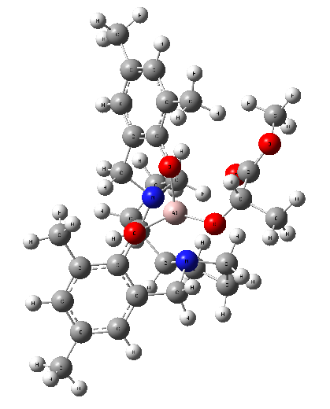
0 1
N 0.08274600 -0.61839100 1.19527800
N -1.62657600 1.42015200 0.59993100
O 1.43767000 -0.22436000 -1.23883100
O -1.28134400 -0.54746000 -1.40668700
C 2.30321800 -1.10556000 -0.76382600
C 3.61310000 -1.15979000 -1.28948700
C 4.51612900 -2.07202300 -0.75252500
H 5.52373000 -2.10790600 -1.16547000
C 4.18105300 -2.94634300 0.28828300
C 2.87990200 -2.89163200 0.77885300
H 2.57775500 -3.56535900 1.58010500
C 1.94247700 -1.99844100 0.25908300
C 3.98643200 -0.25490600 -2.43241800
H 3.92515700 0.80213100 -2.15252700
H 3.29936600 -0.39144900 -3.27541800
C -1.26601700 -0.73439000 1.82217500
C -2.01350400 0.61880900 1.80850000
H 5.00469100 -0.45844000 -2.77823900
C 5.19187700 -3.92588800 0.83336600
H 5.42732400 -4.70850600 0.10172000
H 4.81848200 -4.41937400 1.73636200
H 6.13494000 -3.42910200 1.08872500
C 0.52614900 -1.98287000 0.74976400
H 0.40720000 -2.69788700 1.57146800
H -0.16308100 -2.27198000 -0.04988800
C 0.94554700 -0.14121600 2.31025300
H 0.81761500 0.93631000 2.40455500
H 1.99182300 -0.31838800 2.06326900
C 0.45417200 -0.89105800 3.55927100
H 0.52707900 -0.25854400 4.44798300
H 1.06659300 -1.77812300 3.74434300
C -1.00718400 -1.28862100 3.23819800
H -1.72041700 -0.88399700 3.95976400
H -1.13080500 -2.37452100 3.25003900
H -1.84602600 -1.43142200 1.21153500
H -3.07556300 0.37213000 1.71716600
C -1.86179400 1.55688200 3.02627500
H -2.62885800 1.35207600 3.77725800
H -0.88991300 1.44961800 3.51537300
C -1.97884700 2.94961200 2.41086500
H -3.02842800 3.20461200 2.22300500
H -1.54882900 3.73407100 3.03879400
C -1.21753800 2.76825000 1.10548700
H -0.13962200 2.76614600 1.28263100
H -1.42235800 3.51664800 0.33991700
C -2.78094200 1.58909500 -0.34010600
H -3.53488400 2.23662200 0.12679300
H -2.37531700 2.11361100 -1.21132600
C -3.40984000 0.28563600 -0.74026000
C -4.78112100 0.06655900 -0.59453000
H -5.39725900 0.85745100 -0.16846400
C -5.37336400 -1.13000300 -0.98602500
C -4.54167200 -2.11842100 -1.52597100
H -4.98312900 -3.06366300 -1.83945200
C -3.17054600 -1.94373200 -1.67756700
C -2.59194200 -0.72033900 -1.27822000
C -6.85789200 -1.36216500 -0.84475400
H -7.06920800 -2.27302400 -0.27246400
H -7.33943600 -1.47753400 -1.82328000
H -7.34377100 -0.52502400 -0.33349900
C -2.28935200 -3.01617500 -2.25785300
H -1.72033600 -2.63664900 -3.11334800
H -2.88008000 -3.87739200 -2.58480100
H -1.55218200 -3.36765600 -1.52604200
Al -0.08844100 0.49950100 -0.56580100
O 0.08106800 2.07693000 -1.38788300
C 1.28557600 2.66675200 -1.69045700
H 1.76358900 2.19642500 -2.56568300
C 2.26940600 2.47032400 -0.53659900
O 1.96161700 1.99149100 0.53485100
O 3.50558700 2.86186900 -0.82350100
C 1.10230800 4.16237900 -1.96997000
H 2.04707300 4.64105200 -2.24433700
H 0.39332100 4.27810700 -2.79445400
H 0.68838500 4.66310700 -1.08771800
C 4.51053100 2.58963300 0.15842600
H 5.43827300 2.97481400 -0.26172200
H 4.27573500 3.09408800 1.09828100
H 4.58320400 1.51117300 0.32501700

Sum of electronic and thermal Free Energies= -1895.268467

Frequencies -- 18.3253 23.6321 31.7450

B’
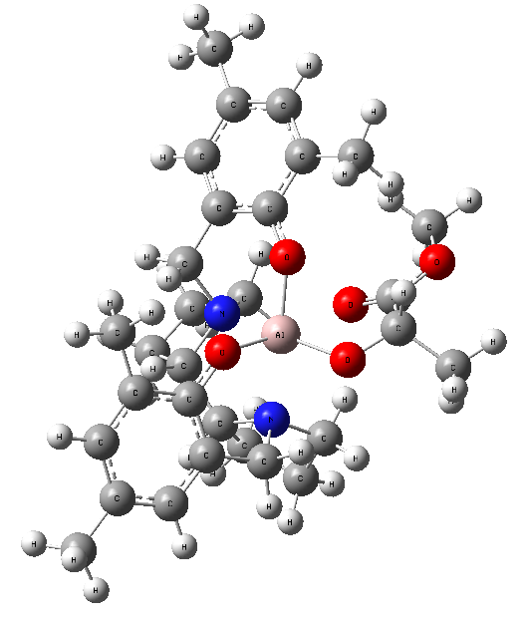
0 1
N 0.17360300 -0.67813400 1.16344000
N -1.58780600 1.36971800 0.65754100
O 1.42307000 -0.23172200 -1.36569000
O -1.25275500 -0.57163200 -1.34536500
C 2.35583800 -1.02810200 -0.87516900
C 3.67470500 -0.96734600 -1.37909100
C 4.64374800 -1.80605200 -0.83658000
H 5.65659400 -1.75309900 -1.23497700
C 4.36880000 -2.71345600 0.19315000
C 3.06311300 -2.76217400 0.67406500
H 2.80978300 -3.45762200 1.47387200
C 2.06181000 -1.94424000 0.15063500
C 3.98873400 -0.01027000 -2.49729500
H 3.88373600 1.03414200 -2.18013700
H 3.29643000 -0.14968100 -3.33486700
C -1.17265300 -0.84139500 1.78095700
C -1.94182100 0.50027200 1.83180100
H 5.01103900 -0.15138500 -2.86187900
C 5.44567600 -3.62080800 0.73660100
H 5.70511400 -4.40983100 0.01988000
H 5.12322000 -4.10967300 1.66160300
H 6.36668100 -3.06759900 0.95356300
C 0.65110400 -2.00876900 0.65560300
H 0.56930300 -2.76230000 1.44750800
H -0.03771000 -2.28237100 -0.14908600
C 1.02226900 -0.23931100 2.30335200
H 0.87364800 0.82977200 2.44919900
H 2.07297300 -0.38737600 2.05516500
C 0.54146700 -1.05174900 3.51671500
H 0.60226500 -0.45927400 4.43370200
H 1.16750800 -1.93653200 3.66336700
C -0.91183500 -1.45652700 3.17166000
H -1.63421000 -1.09916500 3.90886500
H -1.01748100 -2.54366100 3.12974900
H -1.74339400 -1.51831000 1.14089800
H -2.99941300 0.23642800 1.73713900
C -1.80825000 1.38687000 3.08910200
H -2.55528500 1.11729500 3.83963900
H -0.82556000 1.29868900 3.56053000
C -1.99399300 2.79946100 2.53859500
H -3.05557600 3.01375900 2.36928700
H -1.59463200 3.57426700 3.19805500
C -1.23581600 2.70901300 1.22090000
H -0.16059900 2.74834400 1.40297500
H -1.47932700 3.48088900 0.48940900
C -2.76196700 1.54524400 -0.26190200
H -3.51524300 2.16985100 0.23637900
H -2.37537000 2.09644000 -1.12467900
C -3.38531500 0.24740100 -0.68434400
C -4.75673600 0.02292000 -0.54763700
H -5.37671400 0.80590900 -0.11221800
C -5.34434900 -1.16936800 -0.95820800
C -4.50644900 -2.14835500 -1.50654900
H -4.94349400 -3.09109600 -1.83399400
C -3.13534000 -1.96832400 -1.64801900
C -2.55937000 -0.74747400 -1.23150000
C -6.82859100 -1.40843100 -0.82474300
H -7.03916400 -2.32189200 -0.25603100
H -7.30616400 -1.52272800 -1.80541600
H -7.32018300 -0.57497100 -0.31269000
C -2.24746400 -3.03331300 -2.23148400
H -1.65994800 -2.64034500 -3.06818900
H -2.83454500 -3.88658600 -2.58505400
H -1.52602400 -3.40088600 -1.49155600
Al -0.04049600 0.52907300 -0.56715500
O -0.06430600 2.04112100 -1.57041100
C 1.10990800 2.73059200 -1.74841100
H 1.67881100 2.35988300 -2.61945800
C 1.99986600 2.46078100 -0.54152800
O 1.60096600 1.76745500 0.38331000
O 3.20525500 2.98198500 -0.57084000
C 0.87520800 4.23479500 -1.91832300
H 1.81376700 4.77110800 -2.08876400
H 0.21856600 4.38755200 -2.77892400
H 0.38185600 4.64663800 -1.03112600
C 4.10500100 2.59231200 0.47896300
H 5.04167200 3.10102600 0.25950800
H 3.71238300 2.90522700 1.44844500
H 4.23892700 1.50730600 0.46053600

Sum of electronic and thermal Free Energies= -1895.264387

Frequencies -- 25.5840 37.3051 39.1622

C’
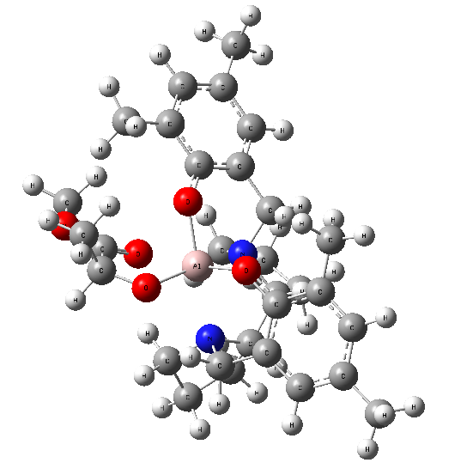
0 1
N -0.11897800 -0.63818100 1.17895600
N 1.61880900 1.42499100 0.68087600
O -1.44268800 -0.17266300 -1.31084500
O 1.24365100 -0.48189500 -1.36249700
C -2.34416300 -0.99754800 -0.80490800
C -3.68519800 -0.95343400 -1.25110000
C -4.61464100 -1.82746300 -0.69363700
H -5.64365000 -1.78338500 -1.04935900
C -4.28281500 -2.75607700 0.29840100
C -2.95936100 -2.78490500 0.72856000
H -2.66037500 -3.49130700 1.50252700
C -1.99734400 -1.93142000 0.18937700
C -4.08012000 0.02290400 -2.32510500
H -3.93039300 1.06103300 -2.00705600
H -5.13317900 -0.09953200 -2.59706300
C 1.23232700 -0.79309700 1.78784300
C 1.98833400 0.55382700 1.84669800
H -3.47227500 -0.11578700 -3.22635200
C -5.31721900 -3.70313200 0.85611600
H -5.55466500 -4.50283100 0.14346900
H -6.25574100 -3.18484100 1.08319800
H -4.96477000 -4.17802300 1.77748700
C -0.57466800 -1.97084400 0.65780900
H 0.10265800 -2.21172000 -0.16656300
H -0.45624800 -2.73607700 1.43368400
C -0.96687200 -0.22190400 2.32782200
H -2.01735500 -0.37784900 2.08389400
H -0.82815500 0.84737600 2.48351700
C -0.47131100 -1.04188700 3.52950200
H -1.08551000 -1.93642200 3.66695600
H -0.53617800 -0.46141500 4.45384400
C 0.98562800 -1.42412000 3.17418300
H 1.10592600 -2.50931900 3.12332400
H 1.70642700 -1.06278400 3.91100400
H 1.80592600 -1.45797700 1.13758700
H 3.04839100 0.30115000 1.74629200
C 1.85230700 1.43072600 3.11009800
H 0.87015600 1.33543300 3.58159100
H 2.60106900 1.15962900 3.85836900
C 2.03223200 2.84697400 2.56685000
H 1.63413500 3.61742200 3.23218800
H 3.09262200 3.06427600 2.39374200
C 1.26845000 2.76087800 1.25185900
H 1.50599200 3.53757000 0.52335300
H 0.19429300 2.79656000 1.44232100
C 2.78195800 1.60235000 -0.24979700
H 2.38987700 2.16611100 -1.10154000
H 3.54739000 2.21391100 0.24674300
C 3.38813000 0.30419800 -0.69663200
C 4.75758000 0.06214200 -0.57034400
H 5.38765800 0.82970500 -0.12211200
C 5.33121800 -1.12747900 -1.00770700
C 4.48139400 -2.08502000 -1.57500600
H 4.90761400 -3.02409400 -1.92648100
C 3.11167800 -1.88771800 -1.70715100
C 2.54936000 -0.67139100 -1.25946200
C 6.81314100 -1.38526300 -0.88330600
H 7.01531100 -2.30869500 -0.32778200
H 7.31597400 -0.56455100 -0.36160600
H 7.28593900 -1.49162700 -1.86716500
C 2.21197600 -2.92910300 -2.31498800
H 1.62688600 -2.50937700 -3.14038800
H 1.48818900 -3.30880600 -1.58364200
H 2.79005600 -3.77868800 -2.69145000
Al 0.04098100 0.59499300 -0.53871600
O 0.08529900 2.12817800 -1.50993000
C -1.03903900 2.91019100 -1.61713000
C -1.72161600 2.78283100 -2.98164600
H -0.79004800 3.97641500 -1.45329700
C -1.96580300 2.55157900 -0.45986100
H -1.02441800 3.13596400 -3.74641400
H -1.94692100 1.73137600 -3.17356300
H -2.64018500 3.37542500 -3.03844200
O -1.58218300 1.80113800 0.42744100
O -3.16162300 3.09299500 -0.46001300
C -4.06319200 2.66970100 0.57558400
H -3.66043200 2.92980700 1.55645600
H -4.99221100 3.20325600 0.38466900
H -4.21508500 1.58909900 0.50775900

Sum of electronic and thermal Free Energies= -1895.261445

Frequencies -- 26.2808 40.1968 43.1236
D’
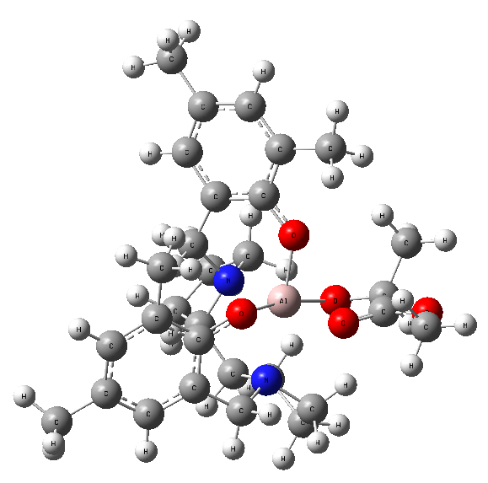
0 1
N -0.09807500 -0.43612000 1.45189400
N -2.03801800 1.39008800 0.33466000
O 1.82905300 0.34999000 -0.46040100
O -0.55200700 -0.23084300 -1.44851000
C 2.45415300 -0.77043300 -0.15877100
C 3.78566200 -0.94141500 -0.61457100
C 4.48446400 -2.09466400 -0.28651900
H 5.50428200 -2.20870200 -0.65307800
C 3.92680700 -3.11268500 0.49608900
C 2.61845000 -2.93736500 0.92928500
H 2.15060900 -3.71486800 1.53287800
C 1.86844400 -1.80053700 0.60792700
C 4.40021700 0.13500400 -1.46762700
H 4.50093200 1.07732000 -0.91648800
H 3.77231600 0.35116900 -2.33991900
C -1.53624200 -0.58260300 1.82283500
C -2.33054200 0.71952900 1.64112400
H 5.39387900 -0.16107300 -1.81895000
C 4.72729300 -4.33883400 0.86171300
H 5.20895700 -4.78028300 -0.01844400
H 4.09199500 -5.10709200 1.31451800
H 5.52202100 -4.10218900 1.58031500
C 0.41963300 -1.77422600 1.02826000
H 0.27982600 -2.48345500 1.85483100
H -0.22123200 -2.11234300 0.21154700
C 0.60150400 -0.02234600 2.70841500
H 0.66768900 1.06283700 2.71930100
H 1.62170500 -0.40960900 2.67296700
C -0.22331200 -0.57993100 3.88676100
H -0.41036800 0.20783900 4.62180600
H 0.30784200 -1.38394600 4.40299500
C -1.53935400 -1.09981100 3.27054800
H -2.42537800 -0.76512900 3.81646800
H -1.56356600 -2.19297700 3.27220800
H -1.97071500 -1.31715500 1.14295000
H -3.39129500 0.42136800 1.64640800
C -2.16520000 1.82515700 2.68754700
H -2.65657400 1.57153700 3.63022800
H -1.11095500 2.03301300 2.87971000
C -2.79958900 3.01482600 1.97572700
H -3.89278900 2.92989300 1.99850600
H -2.52571400 3.97813600 2.41317600
C -2.27177800 2.86081400 0.54977500
H -1.32739500 3.38670300 0.43689200
H -2.97344700 3.23458500 -0.20007300
C -2.95554000 0.93897400 -0.74777600
H -3.98790900 1.19998800 -0.47028100
H -2.68611900 1.53163500 -1.63013100
C -2.87197500 -0.51503400 -1.09921100
C -3.98844400 -1.34811400 -1.09150700
H -4.94561300 -0.94845000 -0.75779600
C -3.90197500 -2.67461000 -1.51194900
C -2.65826600 -3.13516500 -1.95769500
H -2.57254700 -4.16411700 -2.30521600
C -1.51831100 -2.33358600 -1.97466800
C -1.62210100 -1.00476400 -1.51143200
C -5.11634200 -3.57123900 -1.53109300
H -4.85241200 -4.60818400 -1.29698100
H -5.59779900 -3.57418700 -2.51720300
H -5.86542900 -3.24244700 -0.80325500
C -0.19335300 -2.84012100 -2.48003700
H 0.13811100 -2.25949200 -3.34888100
H -0.26253100 -3.89198000 -2.77436900
H 0.59743300 -2.74172700 -1.72743100
Al 0.10522400 0.87949900 -0.15007200
O 0.57363000 2.30376900 0.92446500
C 1.24067400 3.34940400 0.33773800
H 0.81628100 4.32154500 0.65491700
C 0.97421600 3.26343400 -1.15996500
O 0.30362800 2.33310600 -1.60053400
O 1.45734800 4.20999500 -1.91916200
C 2.74461300 3.36225900 0.63787000
H 3.24905000 4.19951900 0.14464200
H 2.87851700 3.45820900 1.71894300
H 3.18444700 2.41647100 0.31202400
C 1.20887600 4.11446900 -3.33327000
H 0.13443300 4.14339000 -3.52371900
H 1.70290300 4.98013900 -3.76931700
H 1.63200000 3.18639200 -3.72162900

Sum of electronic and thermal Free Energies= -1895.262415

Frequencies -- 19.6981 24.8888 39.6830

L-Lactide

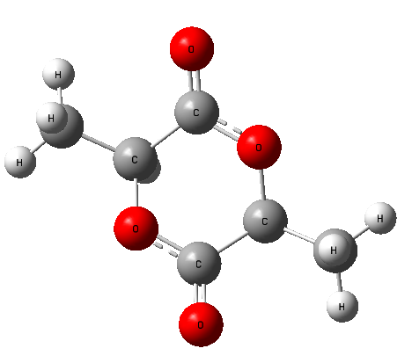
0 1
C 1.25984100 -0.46155400 0.43311100
C -1.25984600 0.46156100 0.43308800
C 2.61510500 -1.00564000 0.03998100
H 1.15352100 -0.45974700 1.52699200
C -2.61510800 1.00565900 0.03996100
H -1.15352600 0.45973500 1.52696900
H 3.39966400 -0.37689600 0.46559400
H 2.72436700 -2.02244300 0.42385000
H 2.72347300 -1.01599500 -1.04719700
H -3.39967000 0.37690600 0.46555500
H -2.72437000 2.02245300 0.42385500
H -2.72346900 1.01604100 -1.04721600
C 1.02529500 0.96644500 -0.05729000
C -1.02528900 -0.96641700 -0.05737400
O -0.25933700 1.34134800 -0.11281300
O 0.25934000 -1.34133900 -0.11281200
O 1.89879300 1.72439200 -0.37021000
O -1.89879200 -1.72444900 -0.37007300

Sum of electronic and thermal Free Energies= -534.204354

Frequencies -- 64.3306 135.5099 136.5806

D-Lactide

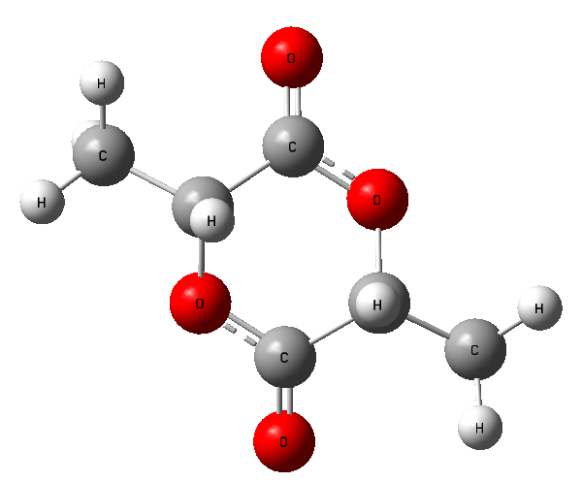

0 1
O -0.25927700 -1.34157600 -0.11243700
O 0.25926100 1.34158300 -0.11237200
C -1.25983100 -0.46160400 0.43329600
C 1.25989700 0.46156900 0.43314200
C -1.02528500 0.96644300 -0.05730800
O -1.89891000 1.72417600 -0.37015600
C 1.02527600 -0.96644100 -0.05753600
O 1.89885200 -1.72413900 -0.37060400
C 2.61508800 1.00555700 0.03968000
H 2.72443100 2.02236600 0.42344700
H 3.39980000 0.37675900 0.46493100
H 2.72318500 1.01589100 -1.04755300
C -2.61508100 -1.00556300 0.03999600
H -2.72436600 -2.02240200 0.42370000
H -3.39973000 -0.37679900 0.46541300
H -2.72334000 -1.01581200 -1.04722200
H 1.15384600 0.45951600 1.52703700
H -1.15361400 -0.45963700 1.52717500

Sum of electronic and thermal Free Energies= -534.204356

Frequencies -- 64.1881 135.4450 136.6150

I
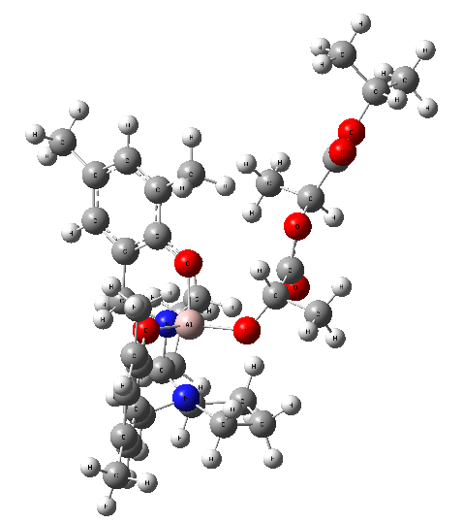
0 1
Al 1.35056100 -0.06631400 0.13338900
N 1.04686000 1.25886600 1.69820400
O -0.11795700 0.65183100 -0.64619900
N 3.05899300 -0.63290600 1.40352700
O 2.49988600 0.48858400 -1.11606500
C -0.49208100 1.91852500 -0.74535400
C -1.50101500 2.26381700 -1.67104300
C -1.94323200 3.57978100 -1.72795900
H -2.72328000 3.83606500 -2.44381100
C -1.42372600 4.58555600 -0.90363900
C -0.42442900 4.22903800 -0.00450000
H -0.00270500 4.98709700 0.65469900
C 0.05706700 2.92016500 0.07805700
C -2.03805800 1.19905900 -2.58925900
H -2.31809200 0.29611100 -2.03752300
H -1.27368400 0.89164100 -3.31396700
H -2.90882300 1.56023200 -3.14566000
C -1.91915700 6.00716500 -1.01029300
H -1.49747300 6.51239300 -1.88817400
H -1.64046000 6.59342500 -0.12853500
H -3.00971700 6.04520500 -1.10862000
C 1.18048300 2.60211300 1.03372000
H 1.24249400 3.38060700 1.80382700
H 2.14342400 2.58998300 0.50790400
C -0.28147000 1.15306400 2.38086000
H -0.52529700 0.09959700 2.51333200
H -1.04830000 1.59793000 1.74790300
C -0.09565600 1.86254800 3.71677800
H -0.83386000 1.53400200 4.45194900
H -0.21087900 2.94468200 3.59544000
C 1.34295300 1.50154600 4.12144200
H 1.34862100 0.65229800 4.80959000
H 1.84893100 2.32879800 4.62440000
C 2.05596400 1.12995700 2.79915300
H 2.85248500 1.84898300 2.59033900
C 2.67021000 -0.27304300 2.78792000
H 3.57203500 -0.24629000 3.42171000
C 1.79259200 -1.45139500 3.22550000
H 1.74814200 -1.53819400 4.31358000
H 0.77318000 -1.34455000 2.85071400
C 2.44903300 -2.67197500 2.55940700
H 1.69101700 -3.34101400 2.15100400
H 3.05723100 -3.23462600 3.27348200
C 3.33730300 -2.09709900 1.44528600
H 4.40068900 -2.23946300 1.67929000
H 3.13796800 -2.53423500 0.46801500
C 4.26742800 0.10673000 0.95693500
H 4.04894800 1.17883000 1.00843800
H 5.09026600 -0.09968200 1.65644100
C 4.64831900 -0.25780500 -0.44660700
C 3.68724000 -0.03316000 -1.43949600
C 3.97656600 -0.35082900 -2.77866500
C 5.22919600 -0.88125300 -3.07645300
H 5.45545900 -1.12532600 -4.11357700
C 6.20279000 -1.11556100 -2.09855800
C 5.88988000 -0.79608800 -0.77923700
H 6.62355700 -0.96653300 0.00738900
C 7.53495100 -1.72210800 -2.46696800
H 7.95047600 -1.25829400 -3.36826400
H 7.44098200 -2.79629300 -2.66876600
H 8.26507300 -1.60139300 -1.66029300
C 2.93066900 -0.11374200 -3.83359400
H 2.66559600 0.94792100 -3.89472500
H 2.00589800 -0.65277200 -3.59747800
H 3.28204900 -0.44025500 -4.81715900
O 0.79190800 -1.73413500 0.18307700
C -0.37909000 -2.20681700 -0.38704300
H -0.54695700 -1.78536400 -1.38697800
C -1.58890800 -1.80592400 0.45681100
C -0.33806700 -3.73389200 -0.48545500
O -1.59559600 -1.70532900 1.66151500
O -2.67413300 -1.61207600 -0.30201800
H -1.25368200 -4.13020700 -0.93700900
H 0.51439600 -4.02421000 -1.10671500
H -0.20962700 -4.17205800 0.51001800
C -3.87536600 -1.21887800 0.35131100
H -3.95940700 -1.74922200 1.30563300
C -3.89146200 0.28908800 0.59420800
C -5.02466400 -1.66697600 -0.54447200
H -3.03890400 0.56142200 1.22008100
H -3.82146200 0.83657300 -0.34946500
H -4.81194400 0.57460900 1.10826200
O -4.90982300 -2.20064600 -1.61664500
O -6.18419900 -1.37968200 0.04463700
C -7.41387500 -1.68924100 -0.66313800
H -7.26222200 -2.64142200 -1.17934200
C -8.48404300 -1.82927000 0.40341700
C -7.70611900 -0.58785700 -1.67062200
H -9.43568300 -2.09760600 -0.06542200
H -8.21777500 -2.60943800 1.12196600
H -8.61793100 -0.88501400 0.94141000
H -7.81107600 0.37584400 -1.16117700
H -6.90889400 -0.51370800 -2.41484700
H -8.64309100 -0.80653100 -2.19259500

Sum of electronic and thermal Free Energies= -2240.928678

Frequencies -- 14.0842 19.8251 23.1686

II
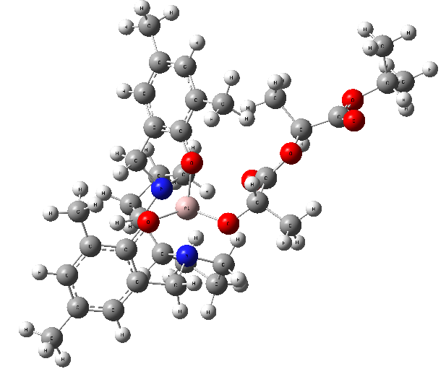
0 1
N -1.34453800 -0.65116200 1.24273700
N -2.22949700 1.80928100 0.45118400
O -0.03224800 -0.98913300 -1.20215900
O -2.69143400 -0.31551500 -1.37315300
C 0.42621500 -2.11943200 -0.69112100
C 1.55306900 -2.73938000 -1.27329100
C 2.05477100 -3.89957400 -0.69384200
H 2.92759100 -4.36969700 -1.14549000
C 1.48250000 -4.48510000 0.44227000
C 0.35173500 -3.87743100 0.98022200
H -0.13363300 -4.31789300 1.85050200
C -0.18835700 -2.71841800 0.42028500
C 2.16333100 -2.13459300 -2.50763900
H 2.52745100 -1.11869300 -2.32003900
H 1.42107500 -2.05616100 -3.31035900
C -2.60374100 -0.19806300 1.90213400
C -2.80746200 1.32610700 1.74954300
H 3.00256300 -2.73802300 -2.86794500
C 2.07573600 -5.73216200 1.05138100
H 2.22551200 -6.51341200 0.29728900
H 1.42448000 -6.14089000 1.83067500
H 3.05296300 -5.53249600 1.50811900
C -1.45999500 -2.11905500 0.94467500
H -1.78015300 -2.65388700 1.84569300
H -2.25851300 -2.20824200 0.20105200
C -0.30198000 -0.42367300 2.28027300
H -0.01359200 0.62619400 2.25104400
H 0.58654200 -1.00585100 2.03477300
C -0.96113300 -0.80661400 3.61586600
H -0.61063200 -0.15787300 4.42287200
H -0.70635100 -1.83346900 3.89305600
C -2.48295700 -0.66620600 3.36708000
H -2.95569200 0.04202800 4.05084400
H -2.99251400 -1.62327100 3.50398800
H -3.43180800 -0.68947400 1.38384600
H -3.89032000 1.47893000 1.70842400
C -2.25471900 2.25591900 2.85124300
H -2.99439800 2.41067300 3.64079900
H -1.35368900 1.85300900 3.32157300
C -1.91089900 3.53260900 2.08804800
H -2.81240900 4.12702700 1.89762000
H -1.19392400 4.16755200 2.61462600
C -1.34250800 2.96678300 0.79449400
H -0.32616000 2.59719200 0.94440500
H -1.31744300 3.66246200 -0.04417400
C -3.30177900 2.28414900 -0.48097600
H -3.75688800 3.19526000 -0.07067800
H -2.78953200 2.55062800 -1.41171500
C -4.36359400 1.25164000 -0.72933700
C -5.71500400 1.53167000 -0.51927700
H -5.99663400 2.51797700 -0.15238700
C -6.70276200 0.58451300 -0.77209500
C -6.29377400 -0.66970800 -1.24007500
H -7.04932500 -1.42692900 -1.44547900
C -4.95736700 -0.99156100 -1.45263100
C -3.97378200 -0.01554300 -1.19070800
C -8.16592700 0.89468900 -0.57060200
H -8.66959300 0.10313200 -0.00430200
H -8.68900900 0.98925900 -1.53009200
H -8.30186200 1.83554400 -0.02792100
C -4.53531900 -2.34399600 -1.95933200
H -3.93878500 -2.25235500 -2.87344400
H -5.40541400 -2.97224400 -2.17303300
H -3.90732200 -2.86942700 -1.23023200
O -0.40571500 1.60741400 -1.53233400
C 0.91667200 1.62840700 -1.91422100
H 1.13228700 0.88103900 -2.69406300
C 1.81526700 1.26232500 -0.73130800
O 1.42748400 1.15025000 0.41074800
O 3.08994000 1.08987300 -1.08597500
C 1.30710100 3.01615100 -2.43524300
H 2.34861800 3.04164200 -2.76908400
H 0.65778300 3.26668600 -3.27875500
H 1.16078200 3.76949700 -1.65302700
C 4.01973500 0.76145000 -0.05475600
H 3.75962300 1.31531600 0.85178000
C 4.01682100 -0.73877500 0.23063400
H 3.01066100 -1.05969900 0.51152300
H 4.32532800 -1.30080900 -0.65545900
H 4.70353700 -0.96119600 1.05106500
C 5.38798900 1.22586400 -0.53785700
O 5.66002500 1.55490200 -1.66269700
O 6.24928100 1.18419200 0.47729700
C 7.64766800 1.47311300 0.21094900
H 7.68036600 2.25924900 -0.54815700
C 8.22843200 1.97380900 1.52018900
H 9.28469700 2.22308300 1.38017200
H 7.70239100 2.86931200 1.86274200
H 8.15485500 1.20351500 2.29492700
C 8.32343900 0.21358500 -0.30887000
H 8.25962400 -0.58682300 0.43576100
H 7.85864300 -0.12623500 -1.23847200
H 9.38014400 0.41703600 -0.50880000
Al -1.18130000 0.28677800 -0.62030400

Sum of electronic and thermal Free Energies= -2240.929732

Frequencies -- 13.9410 18.9838 23.8493
III
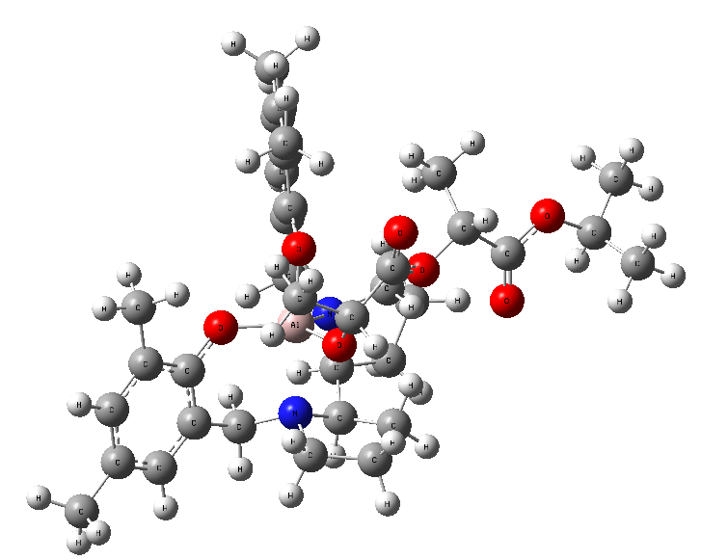

0 1
Al -1.09396400 -0.05029700 0.03901200
N 0.01356000 -0.04415900 -1.69903400
O -0.13738100 1.38352900 0.59659300
N -2.08851300 -1.72758900 -1.03283200
O -2.64900400 0.83143600 0.00157800
C 0.33333000 2.42127800 -0.07256300
C 0.84484600 3.52384000 0.64816800
C 1.40961600 4.58402900 -0.04822400
H 1.80488900 5.42725700 0.51694200
C 1.48854900 4.60963700 -1.44696500
C 0.96223200 3.52591800 -2.14096500
H 1.00394700 3.51648500 -3.22965000
C 0.37593500 2.44313200 -1.47964800
C 0.72507300 3.51968400 2.14752500
H 1.11406800 2.59214200 2.57968300
H -0.32775200 3.57880500 2.45096900
H 1.25668000 4.36742700 2.59065900
C 2.12553600 5.77529500 -2.16333700
H 1.62027000 6.71829800 -1.92327500
H 2.08355300 5.64362500 -3.24929400
H 3.17907200 5.89346900 -1.88289700
C -0.23322500 1.32096200 -2.28185700
H 0.15284900 1.34941000 -3.30816400
H -1.32329000 1.43455300 -2.34364000
C 1.47641200 -0.26152400 -1.48318900
H 1.60759500 -1.04650600 -0.74131800
H 1.92029600 0.64911900 -1.08663700
C 2.02800200 -0.67184900 -2.84268900
H 2.95712100 -1.23678300 -2.73646500
H 2.24427300 0.21178900 -3.45223300
C 0.89397400 -1.50593000 -3.46218200
H 1.08622300 -2.57452700 -3.33791100
H 0.78343900 -1.31911900 -4.53275000
C -0.38398900 -1.09778000 -2.68942000
H -1.10506900 -0.63908000 -3.37127500
C -1.08358300 -2.26084600 -1.97881500
H -1.59443300 -2.85855200 -2.75190200
C -0.23291800 -3.20098200 -1.11510100
H 0.25335500 -3.96737400 -1.72322500
H 0.54549100 -2.65539100 -0.58083500
C -1.23085900 -3.79162300 -0.10351900
H -0.80026100 -3.79927400 0.89816700
H -1.50462000 -4.81721700 -0.36717900
C -2.46474100 -2.87922000 -0.16764200
H -3.31214000 -3.39932400 -0.63456000
H -2.78105600 -2.51160700 0.80784000
C -3.28608900 -1.20372600 -1.73618600
H -2.96436500 -0.39534900 -2.40208200
H -3.71162900 -2.00189500 -2.36195600
C -4.30500900 -0.67905200 -0.76979000
C -3.89561500 0.35791900 0.07802300
C -4.80633900 0.90747700 0.99824600
C -6.09802200 0.38700100 1.04332300
H -6.80397100 0.81160200 1.75586300
C -6.52187100 -0.65690000 0.21390200
C -5.60323200 -1.17808300 -0.69507900
H -5.90000400 -1.98729700 -1.36100400
C -7.91908900 -1.21722400 0.32442700
H -8.64766200 -0.43271800 0.55452100
H -7.98611100 -1.96762800 1.12210300
H -8.22901900 -1.70185000 -0.60716600
C -4.36454800 2.03494200 1.89092600
H -4.03631600 2.89816800 1.30066200
H -3.51021300 1.73728100 2.50864500
H -5.17518900 2.35491000 2.55264900
O -0.68398400 -1.18114100 1.31590800
C -0.27471800 -0.93825300 2.61226000
C 1.17580800 -0.45861600 2.74345100
O 1.62882000 0.03805400 3.74907400
O 1.92172700 -0.73388600 1.66892700
C 3.30564300 -0.41313200 1.73777500
C 4.01247300 -1.35415900 0.76570500
O 3.48284400 -2.22875100 0.12686300
O 5.31383000 -1.08248500 0.73887700
C 6.17443400 -1.90099400 -0.09659700
H 5.61234900 -2.14534700 -1.00258800
C 7.37438000 -1.03583800 -0.43469200
C 6.53788900 -3.17363400 0.65250400
H 8.05497700 -1.59271900 -1.08589800
H 7.06387500 -0.12454200 -0.95366100
H 7.91643400 -0.75557600 0.47437600
H 7.06916100 -2.93215800 1.57904100
H 5.64359000 -3.75397500 0.89515500
H 7.19068200 -3.79340900 0.02974800
H -0.26422300 -1.90372800 3.14929100
C -1.20911800 0.00892400 3.36963400
H -0.92587800 0.09190600 4.42199300
H -1.18261800 1.00362100 2.91451100
H -2.22882400 -0.38433100 3.30500400
C 3.55935000 1.06313300 1.44427900
H 3.12454300 1.35604000 0.48566200
H 3.10264200 1.66938300 2.22812300
H 4.63320300 1.26092000 1.42762700
H 3.67836400 -0.64974100 2.74153600

Sum of electronic and thermal Free Energies= -2240.929445

Frequencies -- 10.8546 15.4417 20.1236

IV
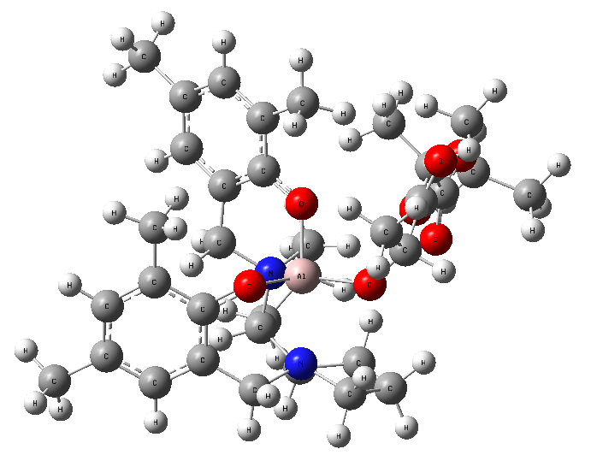

0 1
N -0.60760900 -0.48160800 -1.03587400
N -1.49717800 -2.66641100 0.49176500
O -0.15363200 1.07359000 1.12874300
O -2.52434800 -0.21028700 1.50260800
C -0.43545400 2.13158700 0.38187400
C -0.17718200 3.41691200 0.91262300
C -0.43568100 4.53951200 0.13845000
H -0.23812700 5.52282500 0.56335300
C -0.94801600 4.45105000 -1.16205800
C -1.20374100 3.18215800 -1.66551100
H -1.61163000 3.07973100 -2.67070600
C -0.96946900 2.02404500 -0.91635900
C 0.32164100 3.52601700 2.32752400
H 1.18544700 2.87779000 2.50448400
H -0.45174100 3.20200300 3.03532500
C -1.08109900 -1.70900600 -1.74620300
C -0.92055100 -2.93600800 -0.84656000
H 0.59522900 4.55748000 2.57046000
C -1.20426500 5.69511500 -1.97696700
H -1.84906300 6.39882900 -1.43787100
H -1.69242500 5.45581500 -2.92705500
H -0.27084800 6.22341000 -2.20655200
C -1.38372000 0.70245900 -1.52250200
H -1.27460700 0.75991400 -2.61387800
H -2.43970100 0.50406900 -1.31770800
C 0.83406000 -0.30104300 -1.42746500
H 1.47310700 -0.62915400 -0.60989800
H 1.00847200 0.76599800 -1.56678400
C 1.07278000 -1.10844200 -2.71659700
H 1.85995500 -1.84757900 -2.55054000
H 1.40133000 -0.46171000 -3.53379900
C -0.27233000 -1.78062600 -3.04580100
H -0.15624600 -2.81246700 -3.38930000
H -0.79569400 -1.23634700 -3.83749500
H -2.14702300 -1.57938200 -1.94574300
H -1.47252600 -3.76496700 -1.31863200
C 0.51243000 -3.40308000 -0.54362800
H 0.89535500 -4.03248800 -1.35082100
H 1.19443500 -2.56104500 -0.43285500
C 0.41381200 -4.13818000 0.80333900
H 0.48757900 -5.22198000 0.67909700
H 1.21046100 -3.81445500 1.47425100
C -0.96050700 -3.75610300 1.35936400
H -0.93077600 -3.40527900 2.39017600
H -1.64795100 -4.61065700 1.29288600
C -2.98299700 -2.76856400 0.54997400
H -3.28942300 -3.68631200 0.02710800
H -3.21699600 -2.90455600 1.61198100
C -3.78071000 -1.59607900 0.05597700
C -4.78692700 -1.73480800 -0.89904900
H -4.94295500 -2.70518400 -1.36874400
C -5.59889300 -0.65807900 -1.25121800
C -5.38192200 0.56323200 -0.60335800
H -6.01159600 1.41378400 -0.86062900
C -4.38033900 0.74321400 0.34858400
C -3.55505400 -0.35299400 0.66318600
C -6.70491600 -0.81110400 -2.26691600
H -6.48838900 -1.61788300 -2.97456800
H -6.84897900 0.11116600 -2.83930900
H -7.66110200 -1.04592400 -1.78292500
C -4.13173900 2.07202300 1.00855900
H -4.14812000 1.97586100 2.09969200
H -4.88761700 2.80504900 0.71134300
H -3.14413400 2.46513700 0.74127100
O 0.30301900 -1.36643400 2.11888800
C 1.08362600 -0.81877300 3.11910600
C 2.23740900 0.05818000 2.61962000
O 2.81818800 0.86496300 3.30792500
O 2.61424000 -0.23478700 1.36947800
C 3.71648700 0.49018700 0.83878300
C 4.29143800 -0.36691700 -0.28438500
O 3.83550700 -1.41239600 -0.67482000
O 5.37971500 0.21558300 -0.77874000
C 6.07909700 -0.43261900 -1.87387500
H 5.32410000 -0.90401700 -2.50945500
C 6.78924500 0.67708000 -2.62711100
H 7.31755000 0.25650400 -3.48823900
H 6.07348800 1.42108600 -2.98827100
H 7.51949500 1.17571100 -1.98160100
C 7.02400200 -1.48523400 -1.31561700
H 7.75914200 -1.02290400 -0.64867100
H 6.47400400 -2.25201500 -0.76340800
H 7.55880500 -1.97134600 -2.13774800
Al -0.83661700 -0.60061100 1.02588600
C 0.26460800 -0.06520600 4.16839900
H 0.89384800 0.27803700 4.99352400
H -0.22374700 0.80013500 3.71061600
H -0.50256500 -0.73931600 4.56156900
C 3.29800900 1.87890100 0.35912300
H 2.48458000 1.81365300 -0.36672300
H 2.95126300 2.46646000 1.21043100
H 4.15095000 2.38666800 -0.09697000
H 1.60605400 -1.64871600 3.62889100
H 4.48853400 0.58793900 1.61018300

Sum of electronic and thermal Free Energies= -2240.924705

Frequencies -- 15.6145 17.2617 20.7344

