

A survey on conservation professionals' views in energy retrofits of listed buildings

Dear participant,
Welcome, and huge thanks to your attention!
I am Tianyu Xiang, a PhD candidate at the University of Bath. I am conducting a survey on conservation professionals' views in the balance of preserving her in energy efficiency retrofits of historic buildings.
By conservation professionals, I mean people with work experience involved in the conservation and enhancement of historic buildings in the UK.
This survey has two parts: the first part would take around 5 minutes to complete, while the second part would take around 20 minutes. You can decide whether you’d like to finish both parts or only the first part.
You can finish the survey with this paper copy or online (by scanning the QR code at the top-left of the page).
This research has been granted ethical approval by the University of Bath and is conducted in compliance with UK and the University’s research policies. Your participation will be strictly anonymous. More information about this research is available in the Participant Information Sheet attached.
Before filling in the questionnaire, please sign the attached consent form to confirm that you are aged above 18 and are willing to participate.

Best wishes,

Tianyu Xiang, MSc (tx329@bath.ac.uk)
Department of Architecture and Civil Engineering, University of Bath
Claverton Down, Bath, Somerset, BA2 7AY, United Kingdom

Research lead supervisor: Dr Ricardo Codinhoto, rc784@bath.ac.uk

About you
First, we'd like to know a little bit about your background and your experience in the conservation and enhancement of historic buildings. In the following questions, please tick the option that best describes your experience.
- How long you worked or have been working in the conservation and enhancement of historic buildings?
- 0-5 years
- 5-10 years
- 10-20 years
- 20 years and above

- Which of the following option can best describe your background, i.e. the field you received most training?
- Architecture and design
- Arts and Humanities (literature, history, archaeology, etc.)
- Building surveying
- Engineering (civil engineering, structural and architectural engineering, environmental engineering, etc.)
- Science (geography, urban planning, earth science, chemistry, environmental science, etc.)
- Other (please specify) ____________________________________________

- What is the highest level of qualification you received in this field?
- RQF 5 and below (GCSE, A level, etc.)
- Bachelor’s degree or equivalent (RQF level 6)
- Master’s degree or equivalent (RQF level 7)
- Doctoral degree or equivalent (RQF level 8)
- Other (please specify) ___________________________________________

- Which of the following option can best describe your role in the conservation and enhancement of historic buildings? If you had been in multiple roles, please select the role in which you have most experience.
- Architect
- Builder
- Building surveyor
- Building conservation engineer or consultant
- Building material supplier
- Conservation officer in a Local Authority
- Engineer or consultant in other fields (structure, building services, etc.)
- Energy assessor or consultant
- Manager
- Member of a governmental or not-for-profit organisation, for example Historic England, Historic Environment Scotland, National Trust, local conservation trusts
- Researcher
- Other (please specify) ___________________________________________

- Please specify in which part of the UK you work/worked the most in the conservation and enhancement of historic buildings?
- England
- Wales
- Scotland
- North Ireland
- Other parts of the UK

Part 1. Your stance in the energy efficiency retrofit of historic buildings
Our listed buildings must continue to change and evolve if they are to both contribute to a greener future and be fit for purpose for the people who live in, experience and care for them. Therefore, energy retrofitting listed buildings is one of the major concerns for the professionals involved in their conservation and enhancement today.
As a professional who involves/involved in the conservation and enhancement of listed buildings, you may have worked in or heard of some cases of energy retrofit in your professional experiences, as well as some common energy efficiency measures adopted (e.g. draughtproofing, secondary glazing, wall insulation).
In this survey, we'd like to understand your stance in the balance of the needs in preserving heritage significance and reducing carbon emission in a listed building. In the following questions, please tick the option that best describes your views.

- In general, which of the following options best describes your stance in evaluating the acceptability of an energy efficiency measure when intervening grade II and II* listed buildings?

Assume that the measure is properly planned and installed to ensure that it: is as reversible as possible; is distinguishable from the historic fabric while being aesthetically integrated; has minimal impact on the fabric as possible.

- Any intervention not for the conservation and enhancement of the cultural significance of the building is unacceptable; therefore, no energy efficiency measure can be considered acceptable.
- An energy efficiency measure is acceptable only if it does not alter the fabric of the building in any way.
- An energy efficiency measure is acceptable as long as it does not harm elements that contribute to the building’s cultural significance. Changes to elements that do not contribute to the significance are acceptable if they help reduce carbon emissions (e.g. replacing a 1960s' timber frame single-glazed sash window with a slim-profile double-glazed replica).
- An energy efficiency measure is acceptable as long as it does not significantly harm the cultural significance of the building. Changes to elements that contribute to the significance could be acceptable if they can be justified by a substantial reduction in carbon emissions (e.g. replacing a historical but very inefficient single-glazed sash window with a slim-profile double-glazed replica).
- Any intervention for reducing carbon emissions is acceptable; therefore, any energy efficiency measure can be considered acceptable.
- I can't answer this question because it is/was not my responsibility and concern to decide whether an energy efficiency measure is acceptable or not.
- None of the above (please specify) ______________________________________________________________________________________________________________________________

- (skip this question if you chose a, e, f, or g in the previous question)
When evaluating the acceptability of an energy efficiency measure, would you account for the amount of carbon emissions that could be saved from applying it?

For example, imagine two energy efficiency measures, A and B. Both would result in the same level of changes to the building's fabric and overall cultural significance, making them equally acceptable from a heritage perspective (without accounting for any other factor). However, measure A would save more carbon emissions than measure B.

Do you think measure A will be more acceptable overall than measure B (accounting for the factor of carbon emissions reduction)? Please tick the option that best reflects your stance below.

- Yes, measure A is more acceptable
- No, measure A and B have the same level of acceptability
- I can't answer this question with limited information provided
- I don't know
- None of the above (please specify) ______________________________________________________________________________________________________________________________

- (answer this question only if you chose a in the previous question)
Thank you! We now understand that you believe carbon emissions should be considered when assessing the acceptability of an energy efficiency measure. We'd like to further explore whether the factor of carbon emissions reduction could shift a measure from being unacceptable (from a heritage perspective) to acceptable (overall).

For instance, consider an energy efficiency measure (Measure C) that harms a building’s fabric and overall cultural significance — changes you would typically find unacceptable. However, this measure would significantly reduce the building’s carbon emissions.

Would a significant potential in reducing carbon emissions makes Measure C acceptable to you overall? Please tick the option that best reflects your stance below.

  - Yes, measure C will be acceptable if it saves a significant amount of carbon emissions that could offset its impact to the building's fabric and significance
  - No, measure C will be unacceptable no matter how much carbon emissions it will help to save
  - I can't answer this question with limited information provided
  - I don't know
  - None of the above (please specify) ______________________________________________________________________________________________________________________________

Part 2. Your perception to the acceptability of individual energy efficiency measures - the case of the Herschel Museum of Astronomy, Bath
(Skip this part and jump to the last page if you chose a, e, f, or g in question 6)
Thank you very much for your patience! In this second part of the survey, you are requested to rate a series of typical energy efficiency measures to be applied in the Herschel Museum of Astronomy (with details provided below), in three dimensions:
- their acceptability only accounting for impact to aesthetics, fabric and overall heritage significance;
- their potentials in reducing carbon emission from this building;
- their overall acceptability accounting for the above two dimensions together.
This part is going to take around 20 minutes to finish. We deeply appreciate your time and effort devoted - thank you very much! However, if you are unable to finish this part due to any reason, feel free to leave the unfinished questions blank and jump to the last page.

The case: The Herschel Museum of Astronomy, Bath
19 New Kings Street is a Georgian terrace house on New King Street, in Bath. It was built in around 1764-1770. William and Caroline Herschel, siblings who were musicians and deeply involved in astronomy, lived here from 1777 to 1784. William Herschel discovered Uranus in the backyard of this building in 1781, using a telescope he built in the workshop in this building.
It has three storeys, a habitable attic, and a basement. There's a historic extension (used as Herschel's telescope workshop) and a modern extension at the rear of the building on basement level. The total floor area is 340m² (3,660 ft²).
This building was converted into the Herschel Museum of Astronomy in 1981. Today, the ground floor, first floor, basement floor and backyard (on basement level) are used as museum, while the second and third (attic) floor are used as flats.
The building is now Grade II* listed, and located in the Bath World Heritage Site. The elements with architectural and historical interest include: the front façade decorated with cornices, architraves, modillion brackets and various other components, aesthetically integrated in the Georgian streetscape; historic (likely 18th Century) flagstone floors in the basement and historic workshop; Regency-era fireplaces and plasterworks in upper floors. Other elements, including windows, doors and internal finishes (wallpapers, wainscotings, carpets) are aesthetically integrated with the 18th Century context of the building but don't carry any actual architectural or historical interest.
Currently, the building is heated with electric room heaters. It has no central heating system. windows in upper floors are single-glazed, with internal shutters; windows in the basement and attic are single-glazed without shutters. External and party walls are solid walls without cavity or insulation. The annual energy consumption in this building is around 143MWh (143,820kWh) per year; the annual carbon emission is around 24 ton per year.
Photographs below are provided to give you a better understanding of the building's current condition.
(The section of the house from: BANES Planning Office. (2025). Planning application for William Herschel House, 19 New King Street [Planning application with drawings attached]. Bath Record Office)
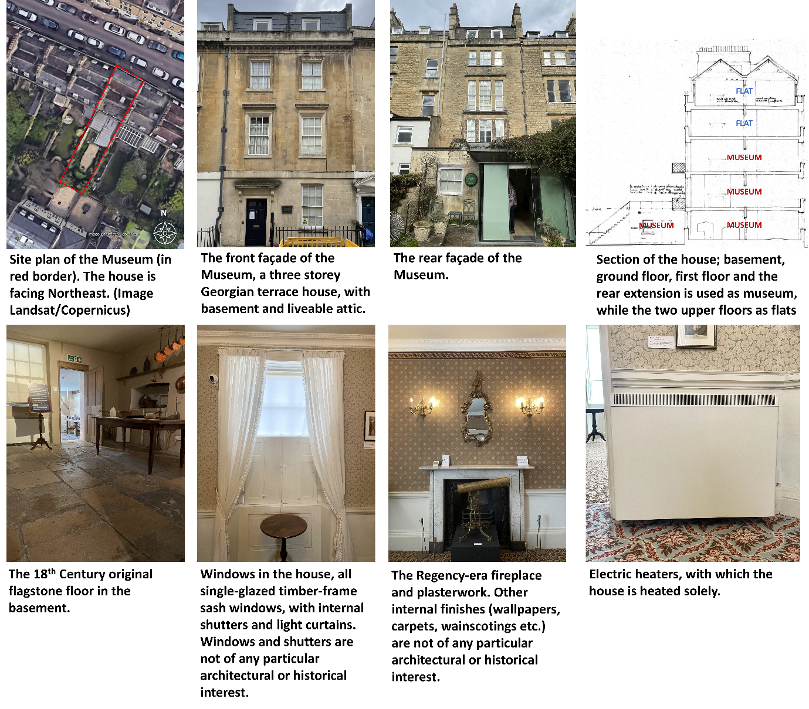

- Given the above information, please rate the acceptability of the following energy efficiency measures in the building, only accounting for their impact to the fabric and overall cultural significance of the building, by ticking a box under rating 1-5 or “I don’t know”.
The scales 1-5 represent:
1 – Absolutely unacceptable
2 – Likely to be unacceptable
3 – Neutral
4 – Likely to be acceptable
5 – Absolutely acceptable
6 – I don’t know
Please consider each measure independently (not implemented together with any other measure).
Measure | 1 | 2 | 3 | 4 | 5 | 6
Draught proofing for windows.
Replacement of current single-glazed timber frame sash windows with their slim profile double glazing replicas, on the front and rear elevation.
The original windows don't carry any particular architectural or historical interest, but contribute to the aesthetic integrity of the building.
Installation of secondary glazing for windows on the front and rear elevation.
The original windows remain unchanged; the secondary glazing are designed to visually aligned to the originals.
This may have a slight effect on the aesthetic integrity of the building when viewing from inside.
Installation of heavy curtains with thermal interlining in window sills.
Installation of PV panels, on the South-West side of the pitched slate roof (rear side of the building). size approx. 7m².
Internal solid wall insulation, applying insulation panels to the interior of the external walls on the front and rear elevation.
This would affect Regency-era plasterworks, and other internal elements without particular architectural or historical interest but contributing to the aesthetic integrity of the building, like wainscotings and wallpapers.
Installation of central gas boiler system, with modern radiators in rooms to replace current electric room heaters.
This would involve a significant amount of piping work that may affect building fabrics without particular architectural/historical interest.
External solid wall insulation, applying insulation panels to the exterior of the external walls on the front and rear elevation.
This would affect various features on the façade, e.g. cornices, architraves, modillion brackets, and harm the aesthetic integrity of the building and the conservation area.
Solid floor insulation. Build a new layer of floor on top of the original.
The new floor will cover the original 18th Century flagstone floor.

- (skip this question if you chose b, d, or e in question 7)
Now, please guess how much carbon emissions could be saved by applying each measure in this building, by ticking a box under rating 1-5 or “I don’t know”.
The rates 1-5 represent:
1 – Very small or negative saving
2 – Small saving
3 – Medium saving
4 – Large saving
5 – Very large saving
6 – I don’t know
Please consider each measure independently (not implemented together with any other measure).
We understand this may be a rough guess, and that’s absolutely fine — we value your perception of carbon emissions in historic buildings. Your response is completely anonymous, so please feel free to make your guess.

Measure | 1 | 2 | 3 | 4 | 5 | 6
Draught proofing for windows.
This would reduce air infiltration rate.
Replacement of current single-glazed timber frame sash windows with their slim profile double glazing replicas, on the front and rear elevation. This would bring windows' total U-value to 2W/m²K.
Installation of secondary glazing for windows on the front and rear elevation.
The original windows remain unchanged. This would bring windows' total U-value to 2.4W/m²K.
Installation of heavy curtains with thermal interlining in window sills.
This would bring window's total U-value to 4.4W/m²K.
Installation of PV panels, on the South-West side of the pitched slate roof (rear side of the building).
Size approx. 7m². System size 1 kWp.
Internal solid wall insulation, applying insulation panels to the interior of the external walls on the front and rear elevation.
This would bring external walls' total U-value to 0.3W/m²K.
Installation of central gas boiler system, with modern radiators in rooms to replace current electric room heaters.
External solid wall insulation, applying insulation panels to the exterior of the external walls on the front and rear elevation.
This would bring external walls' total U-value to 0.3W/m²K.
Solid floor insulation. Build a new layer of floor on top of the original, to bring the floor's total U-value to 0.25W/m²K.

- (Skip this question if you chose b, d, or e in question 7)
Please rate each measure again according to their overall acceptability, accounting for the above two dimensions: how much do you think each measure is acceptable considering not only their impact to the fabric and overall cultural significance, but also their potentials in reducing carbon emissions from this building? Please respond by ticking a box under rating 1-5 or “I don’t know”.
The rates 1-5 represent:
1 – Absolutely unacceptable
2 – Likely to be unacceptable
3 – Neutral
4 – Likely to be acceptable
5 – Absolutely acceptable
6 – I don’t know
Please consider each measure independently (not implemented together with any other measure).
Measure | 1 | 2 | 3 | 4 | 5 | 6
Draught proofing for windows.
This would reduce air infiltration rate.
Replacement of current single-glazed timber frame sash windows with their slim profile double glazing replicas, on the front and rear elevation.
This would bring windows' total U-value to 2W/m2K. The original windows don't carry any particular architectural or historical interest, but contribute to the aesthetic integrity of the building.
Installation of secondary glazing for windows on the front and rear elevation.
The original windows remain unchanged; the secondary glazings are designed to be visually aligned to the originals.
This would bring windows' total U-value to 2.4W/m²K.
This may have a slight effect on the aesthetic integrity of the building when viewing from inside.
Installation of heavy curtains with thermal interlining in window sills.
This would bring window's total U-value to 4.4W/m²K.
Installation of PV panels, on the South-West side of the pitched slate roof (rear side of the building).
Size approx. 7m². System size 1 kWp.
Internal solid wall insulation, applying insulation panels to the interior of the external walls on the front and rear elevation.
This would bring external walls' total U-value to 0.3W/m²K.
This would affect Regency-era plasterworks, and other internal elements without particular architectural or historical interest but contributing to the aesthetic integrity of the building, like wainscotings and wallpapers.
Installation of central gas boiler system, with modern radiators in rooms to replace current electric room heaters.
This would involve a significant amount of piping work that may affect building fabrics without particular architectural/historical interest.
External solid wall insulation, applying insulation panels to the exterior of the external walls on the front and rear elevation.
This would bring external walls' total U-value to 0.3W/m²K.
This would affect various features on the façade, e.g. cornices, architraves, modillion brackets, and harm the aesthetic integrity of the building and the conservation area.
Solid floor insulation. Build a new layer of floor on top of the original, to bring the floor's total U-value to 0.25W/m²K.
The new floor will cover the original 18th Century flagstone floor.

- Do you think the above ratings you made apply to other buildings of the kind (Georgian terrace houses) in general?
- Yes, they apply to other Georgian terrace houses in general
- No, they don't apply to other Georgian terrace houses in general
- Other (please specify) ____________________________________________

The end - thank you!
This is the end of the survey. Thank you very much for your invaluable contribution to our research project!
If you want to know about the outcome of our research, please leave your email address below. We will send you a debriefing report when we finish our research.
Your email address: ___________________
How would you like to be addressed in the correspondence: ___________________
Again, thank you very much for your patience! Wish you have a nice day!

