# Methodologies

Full details of the methods used to create the datasets are provided in:

Spadea, S., Orr, J., Nanni, A., and Yang, Y. (2016). "Wound FRP shear reinforcement for concrete structures." Journal of Composites for Construction, ASCE, under review.

#Data Files
All the raw and processed data are presented in the following excel files:

‘Tensile tests wet layup’
‘Tensile tests prepreg’
‘Stirrups tests’
‘Flexural tests’

# Dataset variables

In: ‘Tensile tests wet layup’
‘Tensile tests prepreg’

F_{u} ultimate load (kN)
F_{25%} 25% of ultimate load (kN)
F_{50%} 50% of ultimate load (kN)
ε_{25%} strain measured at 25% of ultimate load (%)
ε_{50%} strain measured at 50% of ultimate load (%)
ε_{u} strain measured at ultimate load (%)
E_{25-50%} modulus of elasticity based on (ε_{25%,}F_{25%}) and (ε_{50%,}F_{50%})data points (GPa)
E_{100%} modulus of elasticity based on (0,0) and (ε_{u,}F_{u}) data points (GPa)
E_{LR} modulus of elasticity based on Linear Regression on data between 25% and 50% of ultimate load (GPa)

In: ‘stirrups tests’

w_{f} width(mm)
t_{f} thickness (mm)
A_{f} cross section area (mm²)
t_{fi} equivalent thickness (mm)
d_{fe} equivalent diameter (mm)
F_{u} ultimate load on straight reinforcement (one leg)(kN)
F_{b} ultimate load on bent reinforcement (two legs)(kN)
f_{fb}/f_{fu} bent reinforcement to straight reinforcement stress ratio
ε₁ ultimate strain USG1 (%)
ε₂ ultimate strain USG2 (%)

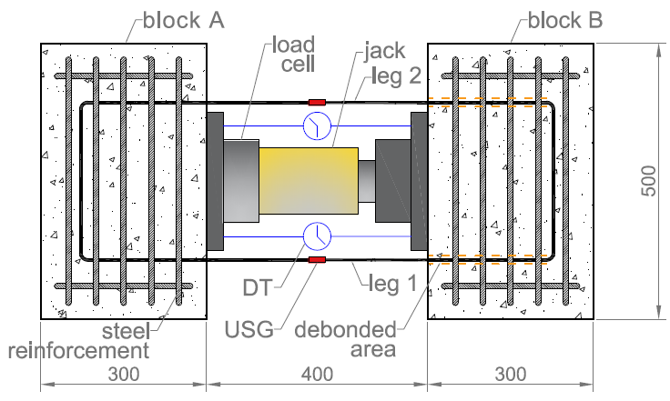

In: ‘Flexural tests’

F₁ Point Load at jack 1(kN)
F₂ Point Load at jack 2(kN)
F Total Load (kN)
d₁ displacement at jack 1(mm)
d₂ displacement at jack 2(mm)
d midspan displacement (mm)
USG1 strain measured by USG 1 (%)
USG2 strain measured by USG 1 (%)
USG3 strain measured by USG 1 (%)

