# Appendix A – the kits

Table 1: Content of USK and content of TDK

|  |  |  |  |
| --- | --- | --- | --- |
| Content of USK |  | Content of TDK |  |
| Item | Amount | Item | Amount |
| Tarpaulin | 2 pcs | 6-8mm Rope | 60m |
| Borak bamboo | 4 pcs | Steel peg or | 6 pcs |
| Muli bamboo | 60 pcs | Sand bag | 10 pcs |
| 6mm rope | 1kg |  |  |
| 3mm rope | 1kg |  |  |
| GI Wire | 0.5 kg |  |  |

# Appendix B – Household Level Assessment questionnaire

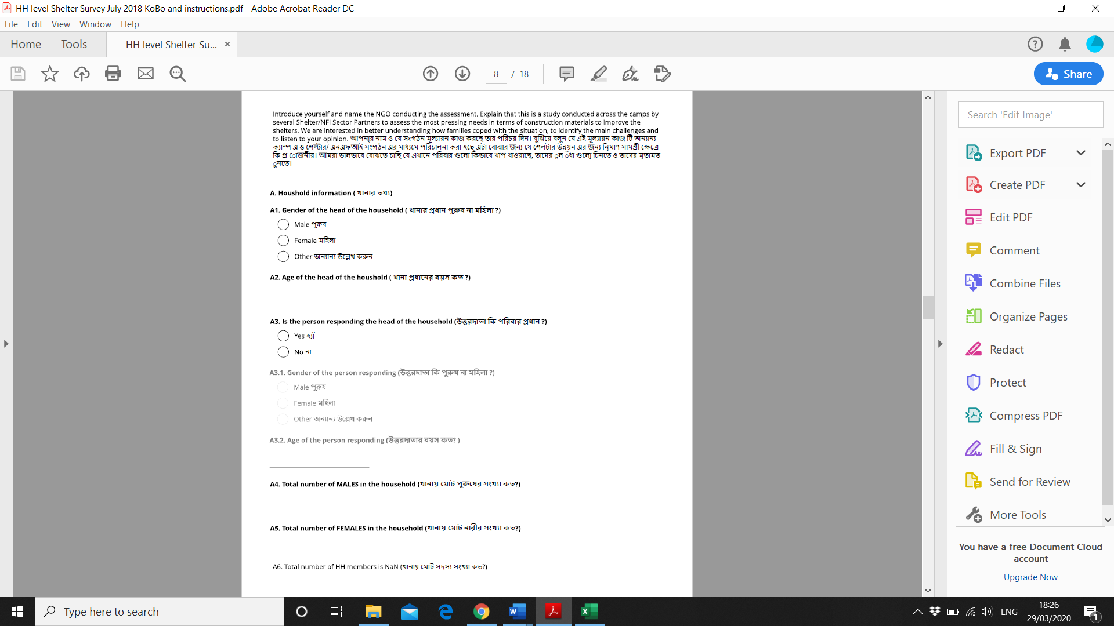

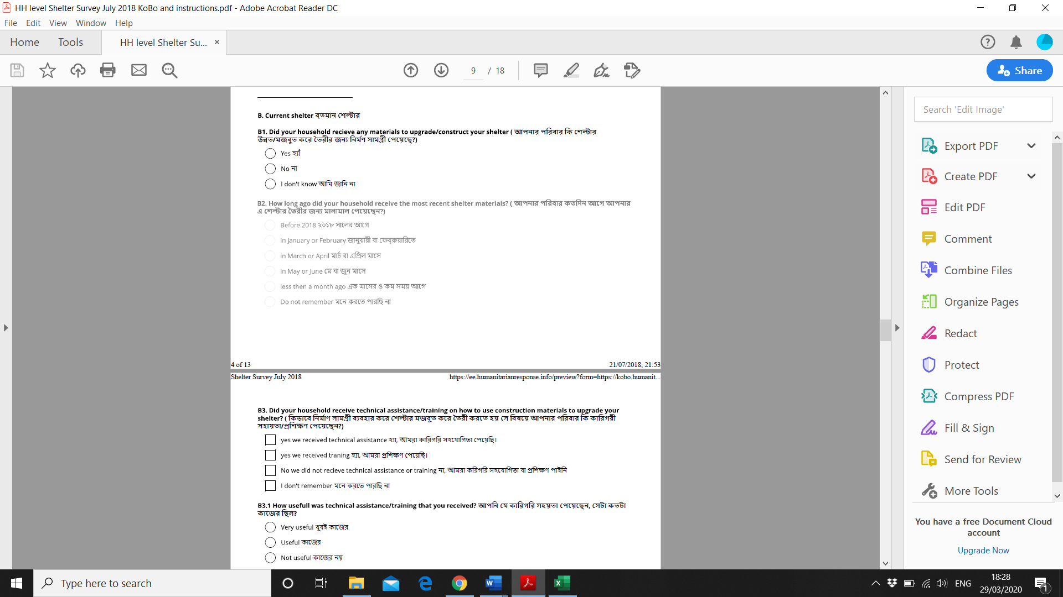

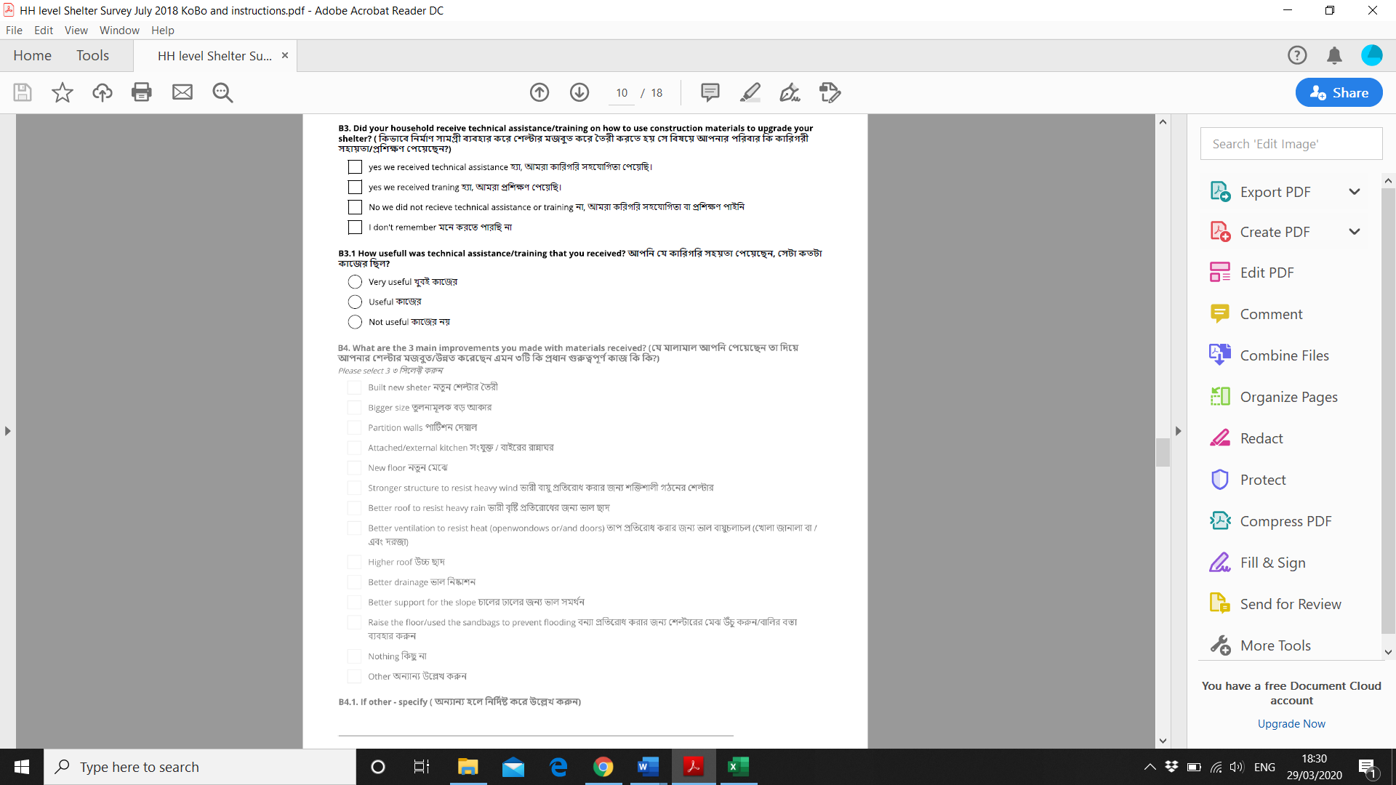

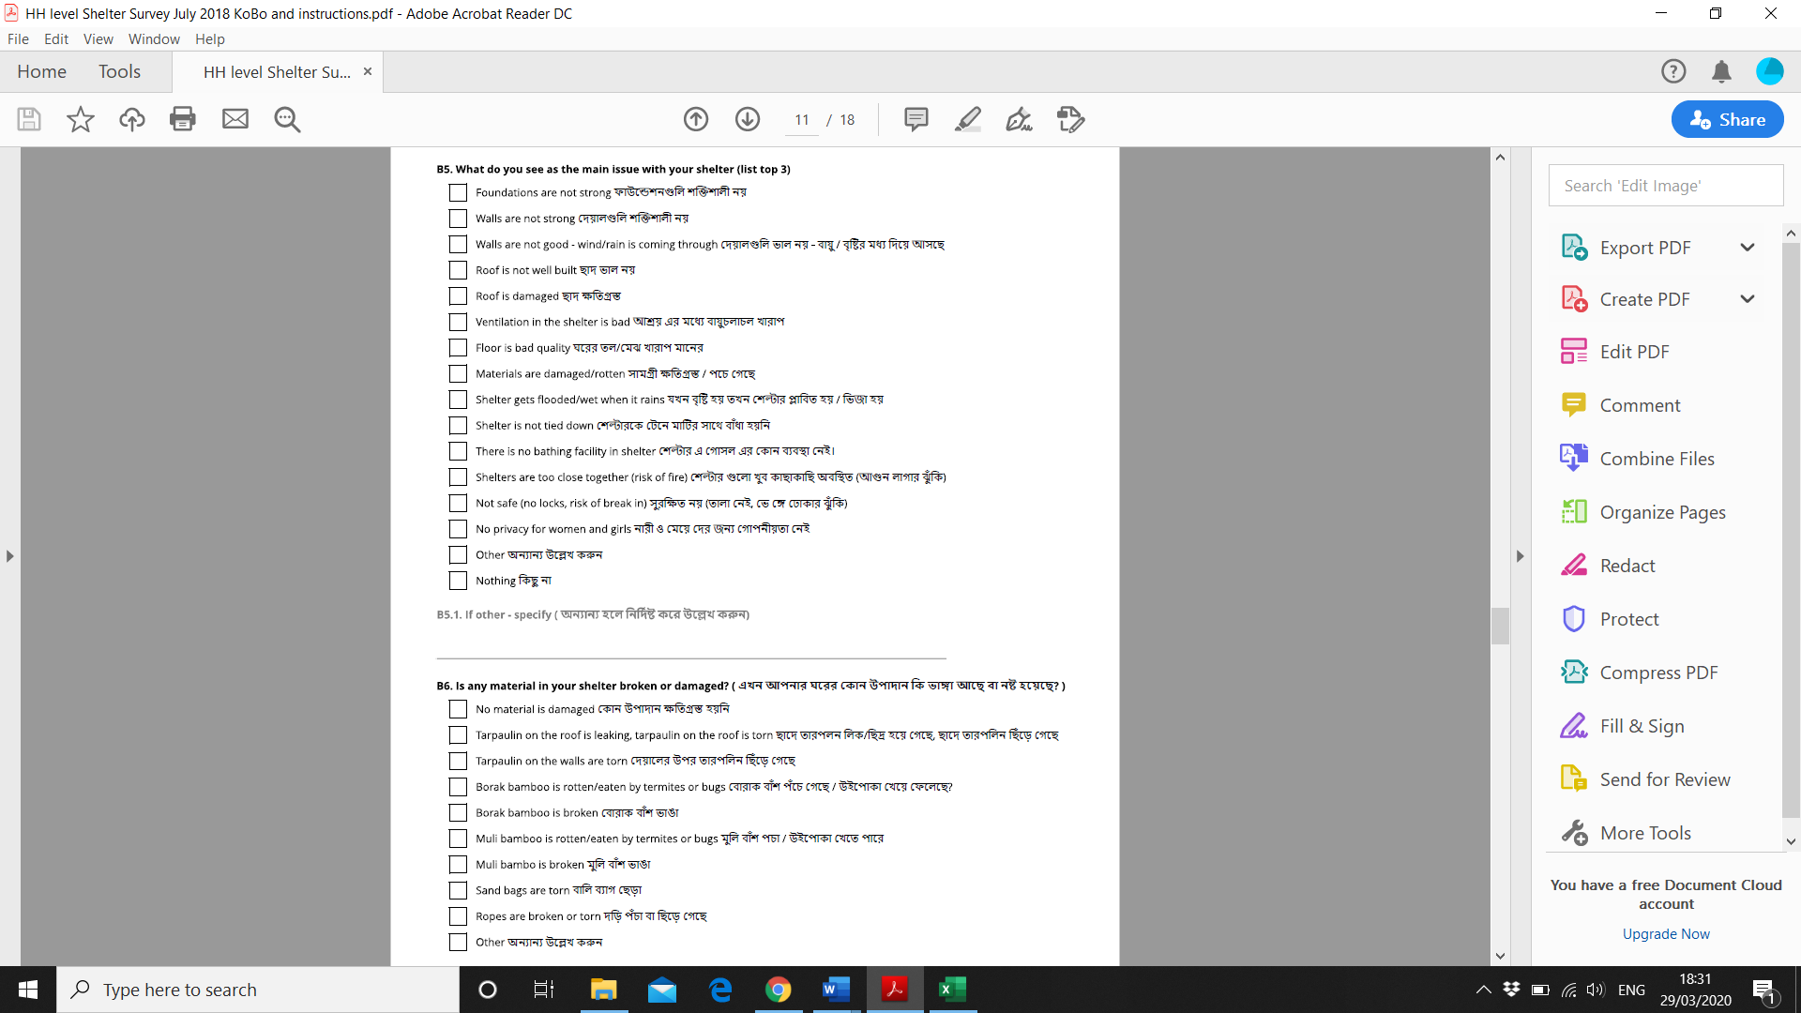

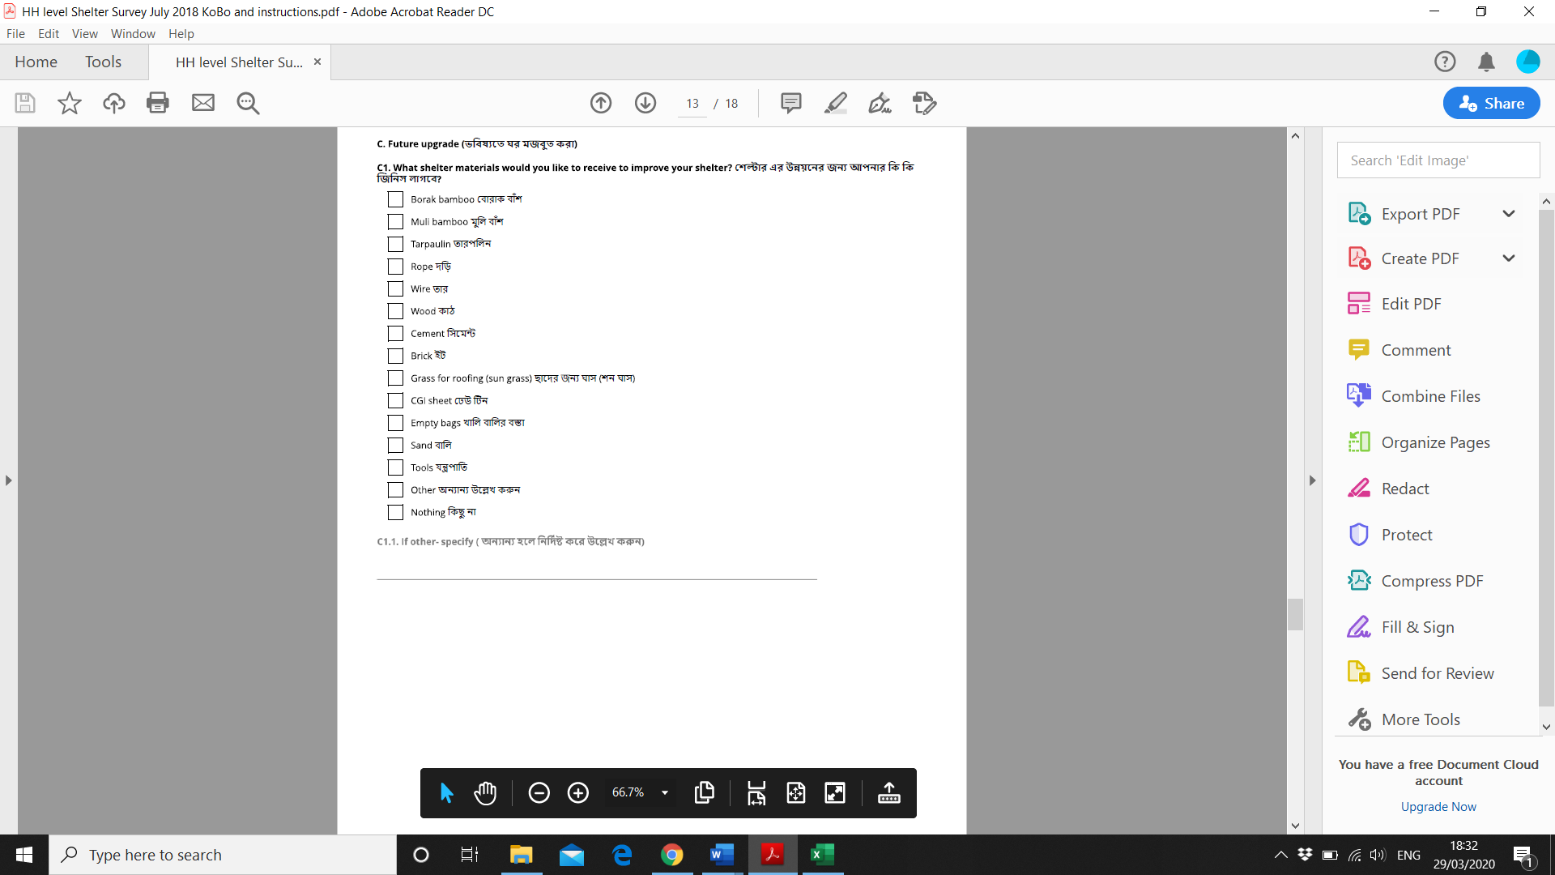

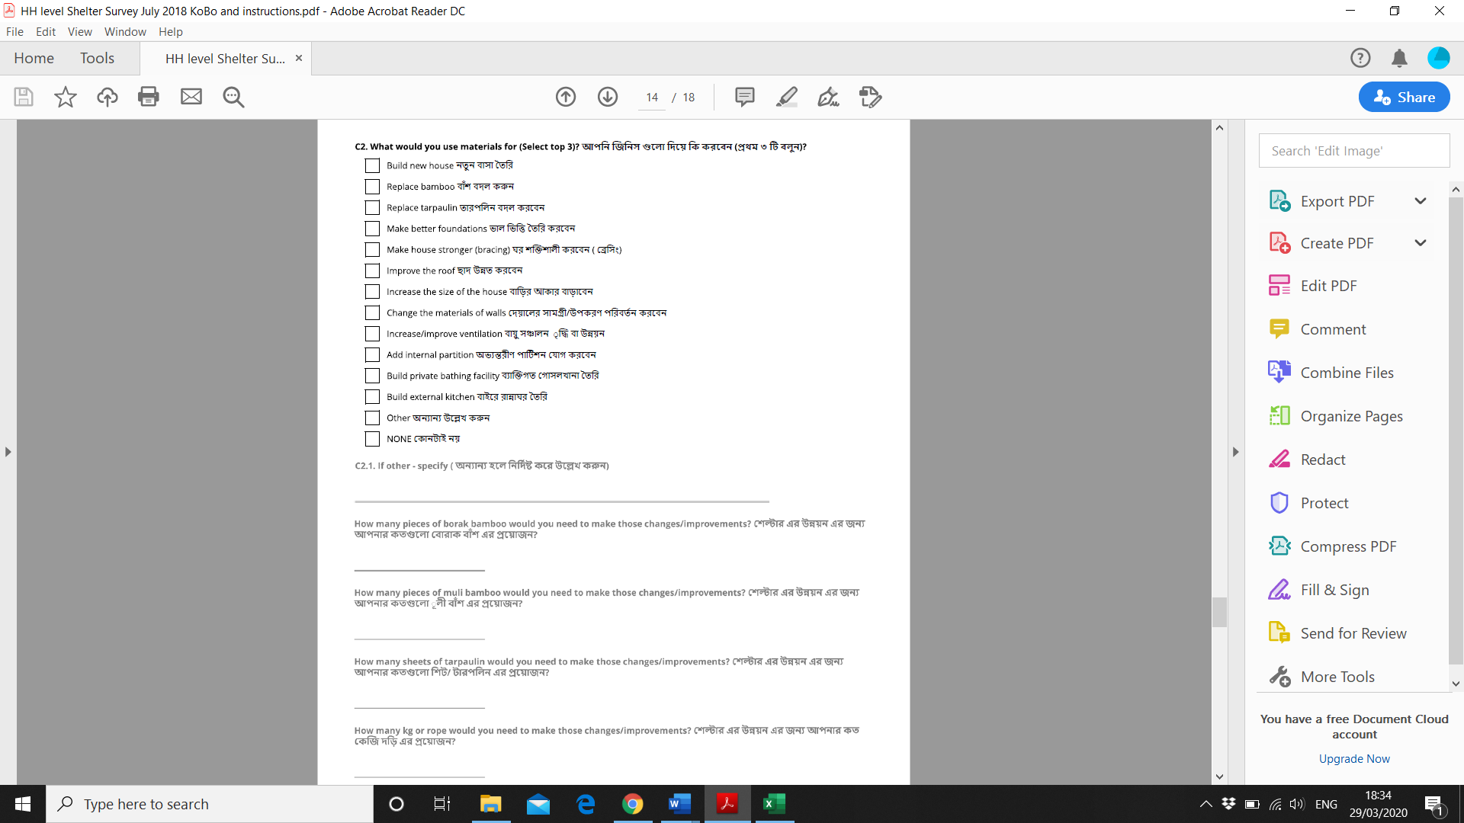

# Appendix C –Semi-Structured Interviews questionnaire

## Section 1: Background info about the participant and shelter:

Number of people living in the shelter:

Size:

Ask/observe: General description of original shelter; materials, amenities available etc

Ask/observe: General description of adaptation made:

Why have you made these adaptations? i.e. establish motives

What other adaptations would you like to make to your shelter if you could?

## Section 2: Design questionnaire: About your shelter

1. How satisfied are you with the **PRIVACY** your shelter provides?

Satisfied – neither – unsatisfied

Why?

1. How satisfied are you with the **STRUCTURAL SAFETY** i.e. fire risk, strength of constructionyour shelter provides?

Satisfied – neither – unsatisfied

Why?

1. How satisfied are you with the amount of **SPACE** your shelter provides? i.e. is it big enough?

Satisfied – neither – unsatisfied

Why?

1. How satisfied are you with the light levels in your shelter?

Satisfied – neither – unsatisfied

Why?

1. How satisfied are with the protection your shelter provides against wind and rain?

Satisfied – neither – unsatisfied

Why?

1. How satisfied are you with the thermal conditions in your shelter?

In summer (rainy season):

Satisfied – neither – unsatisfied

Why?

In winter (dry season):

Satisfied – neither – unsatisfied

Why?

1. How satisfied are you with the air quality of your shelter?

Satisfied – neither – unsatisfied

Why?

1. Do you feel comfortable receiving guests in your shelter?

Yes – no

Why?

1. Is it possible to change/adapt the shelter to suit your needs?

Yes – no

Why?

1. Where do you cook? Are you happy with kitchen facilities?

Yes – no

Why?

1. Where is your bathroom? Are you happy with bathroom facilities?

Yes – no

Why?

1. Do you feel safe inside your shelter during the day?

Yes – no

Why?

1. Do you feel safe inside your shelter during the night?

Yes – no

Why?

## Section 3: Design questionnaire: your thoughts on a better shelter

1. Please rank the following aspect of design in order of importance:

|  |  |
| --- | --- |
| Appearance (form and material) |  |
| Flexibility/ adaptability (e.g. to change layout of shelter) |  |
| Security |  |
| Privacy |  |
| Thermal Conditions |  |
| Space (is there enough space for your family and guests) |  |
| Private Bathroom |  |
| Private Kitchen |  |
| Air quality |  |
| Lighting Level |  |

1. Could you tell us a little bit about your house in your country of origin; what was it made of; size etc
2. Discuss any aspects that the participant would like to discuss in further detail.

# Appendix D – Focus Group Discussions with technical staff



# Appendix E – Focus Group Discussions with households

