Original micrographs in the manuscript

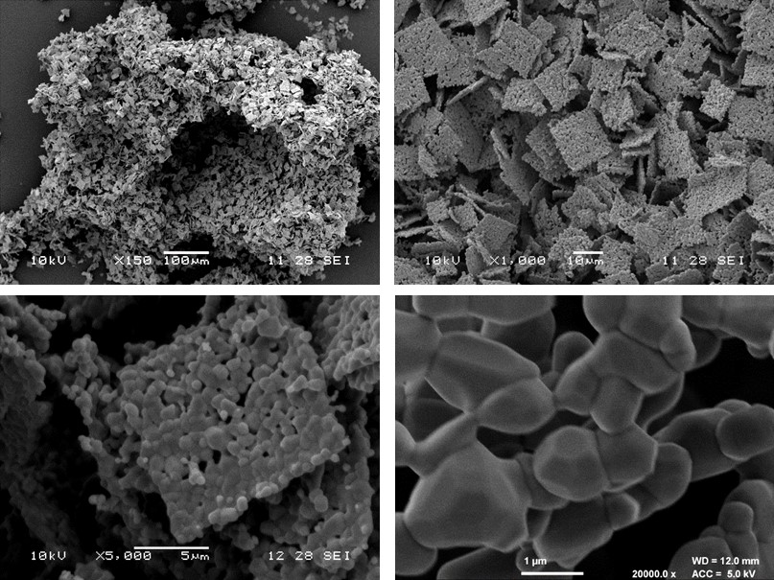
Figure 2: FESEM micrographs of ZnO foam (I-IV) sintered at 900 ºC for 12 h at 5 ºC min⁻¹.
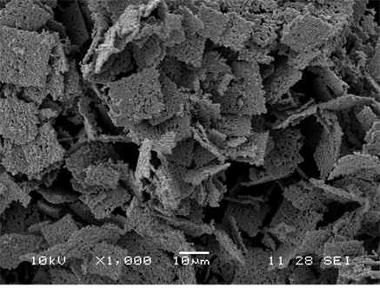
Figure 7: (II) FESEM micrograph of the ZnO foam after photocatalytic degradation experiments.

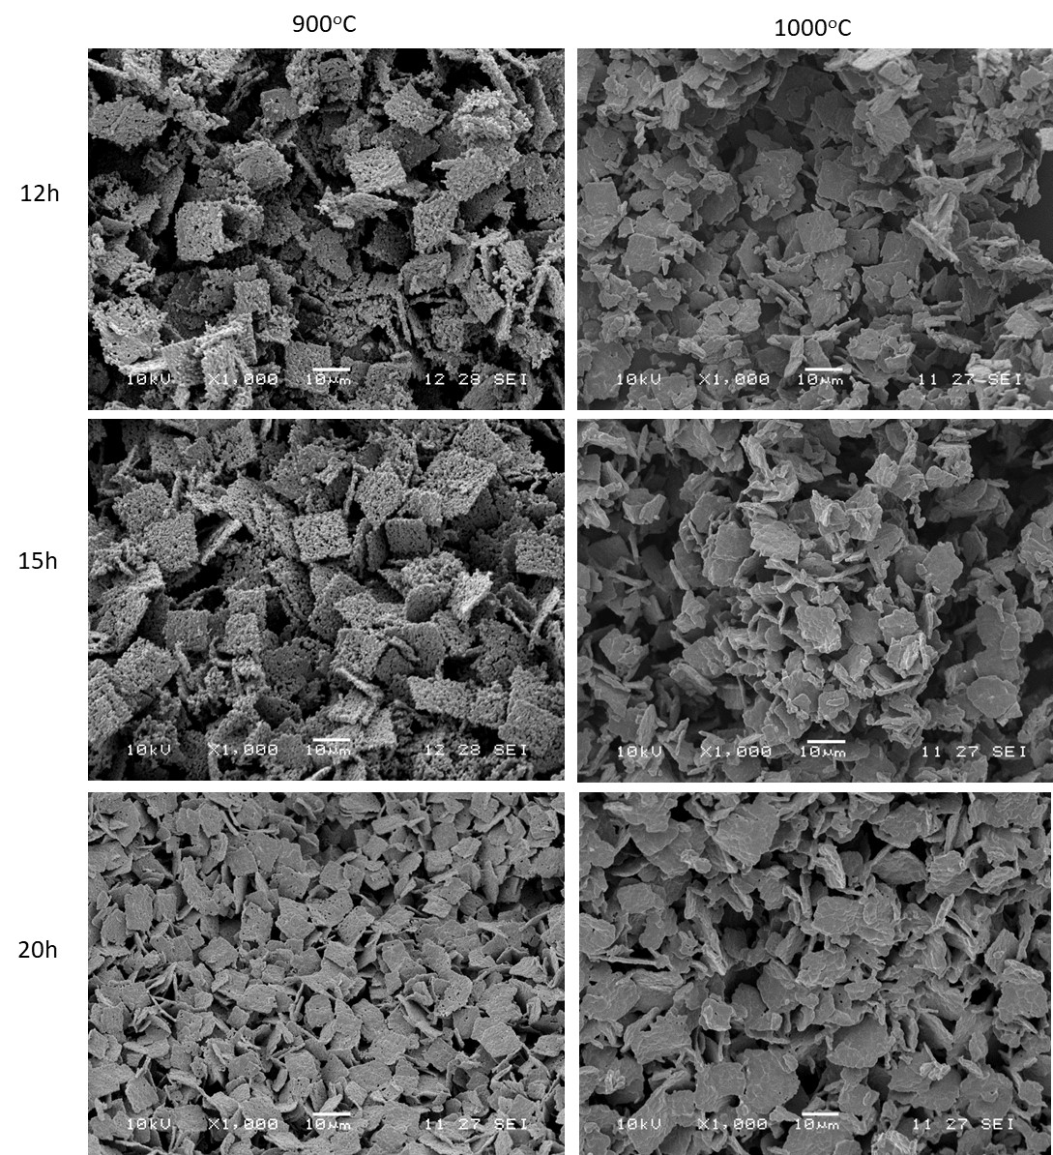
Figure S.1: FESEM micrographs of ZnO foams sintered at 900ºC (b,c,d) and 1000 ºC (e,f,g) for 12 (b,e), 15 (c,f) and 20 h (d,g).

Figure S2: FESEM micrographs of ZnO foam sintered at 900 ºC for 20 hours at 5 ºC min⁻¹.

